Doghouse Activity Name:______________________________________
The hats that Addy and Kelsey found in Izzy’s doghouse are pictured below.
Draw lines to help them match the hat with the person it might belong to. There may be more than one person for each hat. Color the doghouse and the hats!
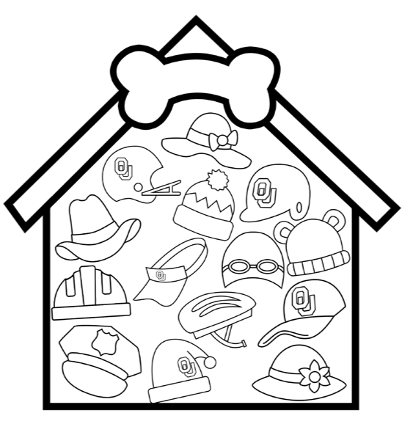
- football player
- baseball player
- biker
- Santa
- beachgoer
- a mom
- skier
- cowboy
- swimmer
- gardener
- police officer
- construction
worker
- a baby
- batter

