PAINTING A PICTURE IMAGE PACKET
Image Set 1 – Part of the Catalan Atlas, created in 1375 at the request of the King of France. Mansa Musa is pictured in the bottom of the second panel and an up-close image of Mansa Musa is shown below the atlas.

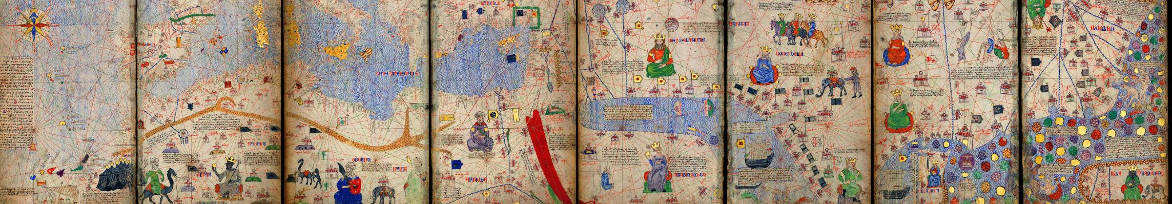
Figure 1: 1375 Atlas Catalan Abraham Cresques
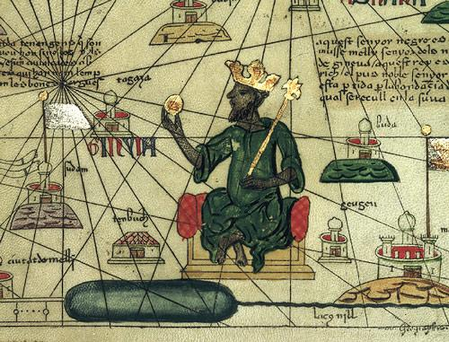
Figure 2: Mansa Musa

Image Set 2 – The Djinguereber Mosque and the Sankore Mosque, previously Sankore University in Timbuktu, Mali.
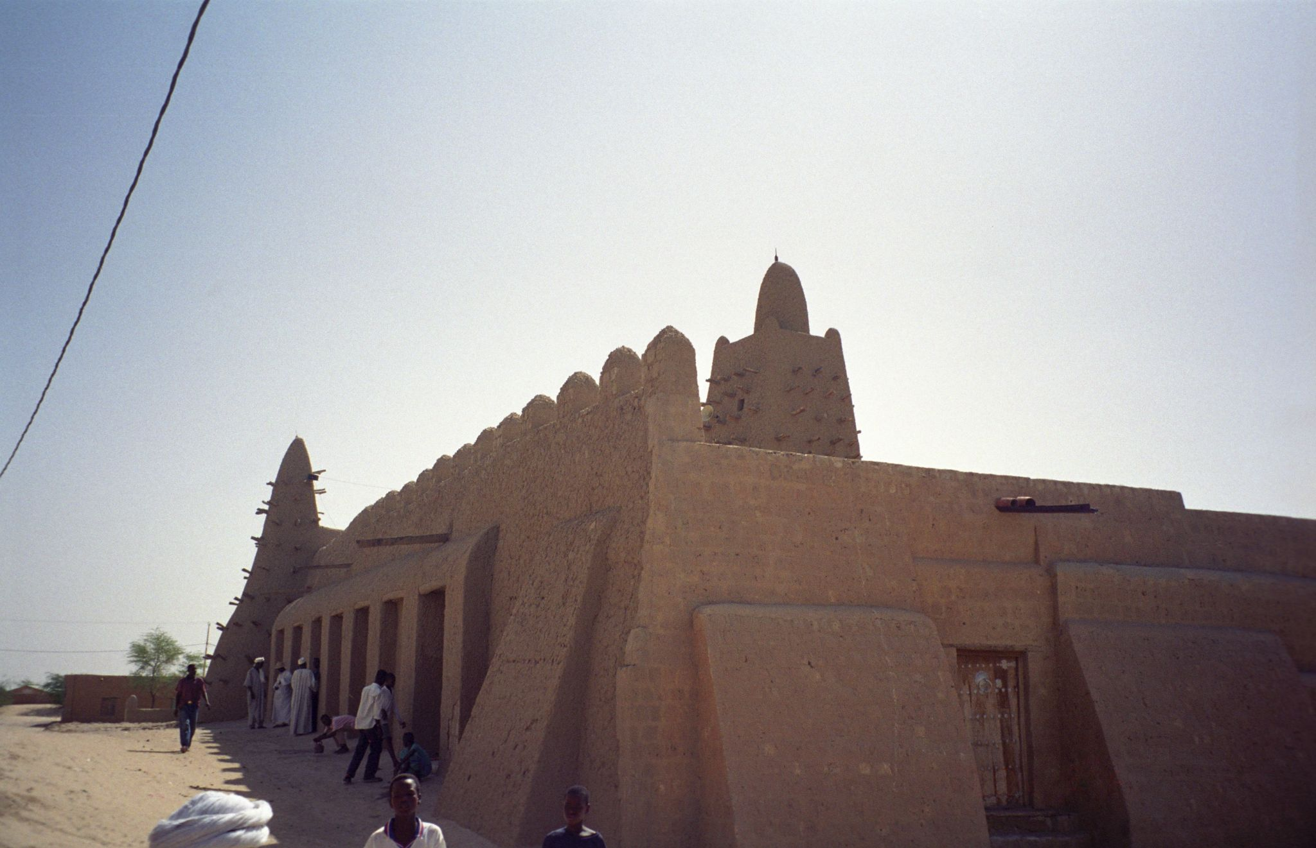
Figure 3: Upyenoz. Djinguereber in Timbuktu
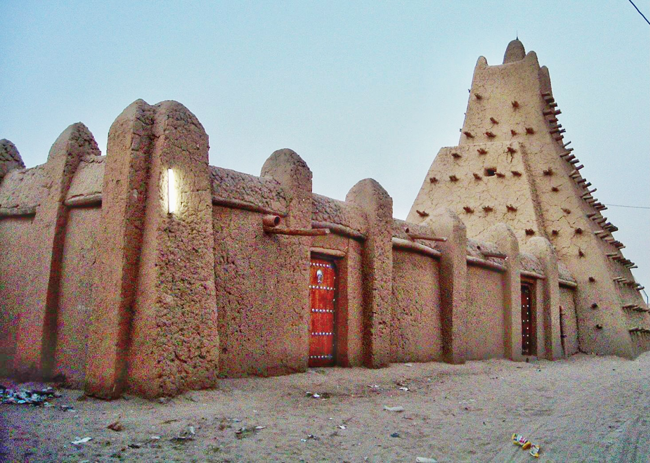
Figure 4: 2007 Sankore Mosque Timbuktu

Image Set 3 – Manuscripts in Timbuktu from the Mali Empire.

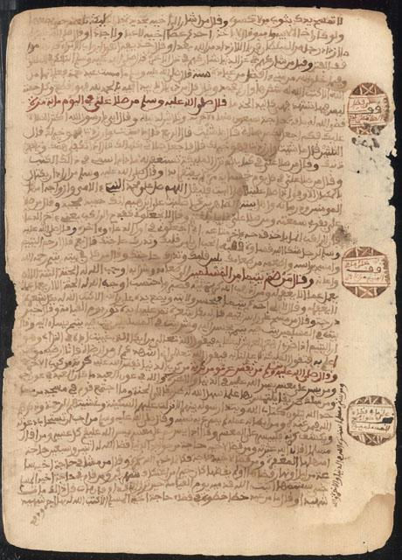 | 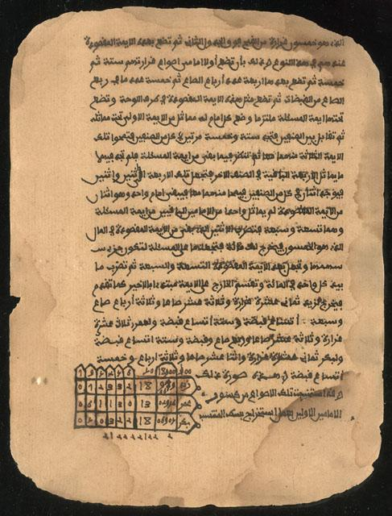
Manuscript discusses history and development of math, the rules of addition, subtraction, multiplication, and division. | Manuscript discusses diagnosing and treating illnesses.
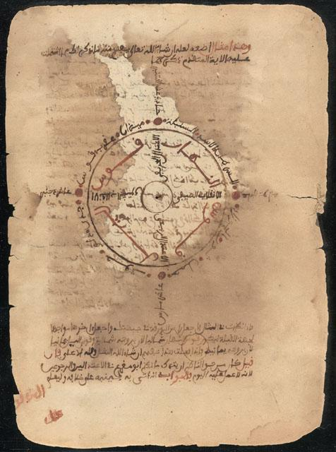 | 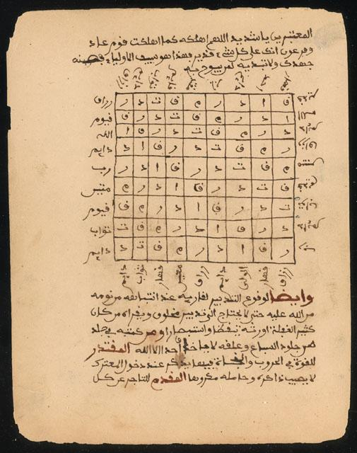
Manuscript discusses astronomy and how to use the stars to calculate the seasons. | Manuscript discusses the benefit of trades, craft work, and agriculture of society.
Figure 5: Ancient Manuscripts from the Desert Libraries of Timbuktu Exhibition

Sources
Figure 1: Wikimedia. (2020). 1375 Atlas Catalan Abraham cresques. [Digital image]. https://commons.wikimedia.org/wiki/File:1375_Atlas_Catalan_Abraham_Cresques_ZU2020.jpg
Figure 2: Wikimedia. (2008). Mansa Musa. [Digital image]. https://en.wikipedia.org/wiki/File:Mansa_Musa.jpg
Figure 3: Wikimedia. (2001). Upyernoz. Djinguereber in Timbuktu.jpg. [Digital image]. https://commons.wikimedia.org/wiki/File:Djinguereber_in_Timbuktu.jpg
Figure 4: Wikimedia. (2007). Sankore Mosque Timbuktu 01.jpg. [Digital image]. https://commons.wikimedia.org/wiki/File:2007_Sankore_Mosque_Timbuktu_01.jpg
Figure 5: Wikimedia. (2010). Ancient manuscripts from the desert libraries of Timbuktu exhibition. [Digital image]. https://www.loc.gov/exhibits/mali/mali-exhibit.html#obj16

