Fast Food Combos

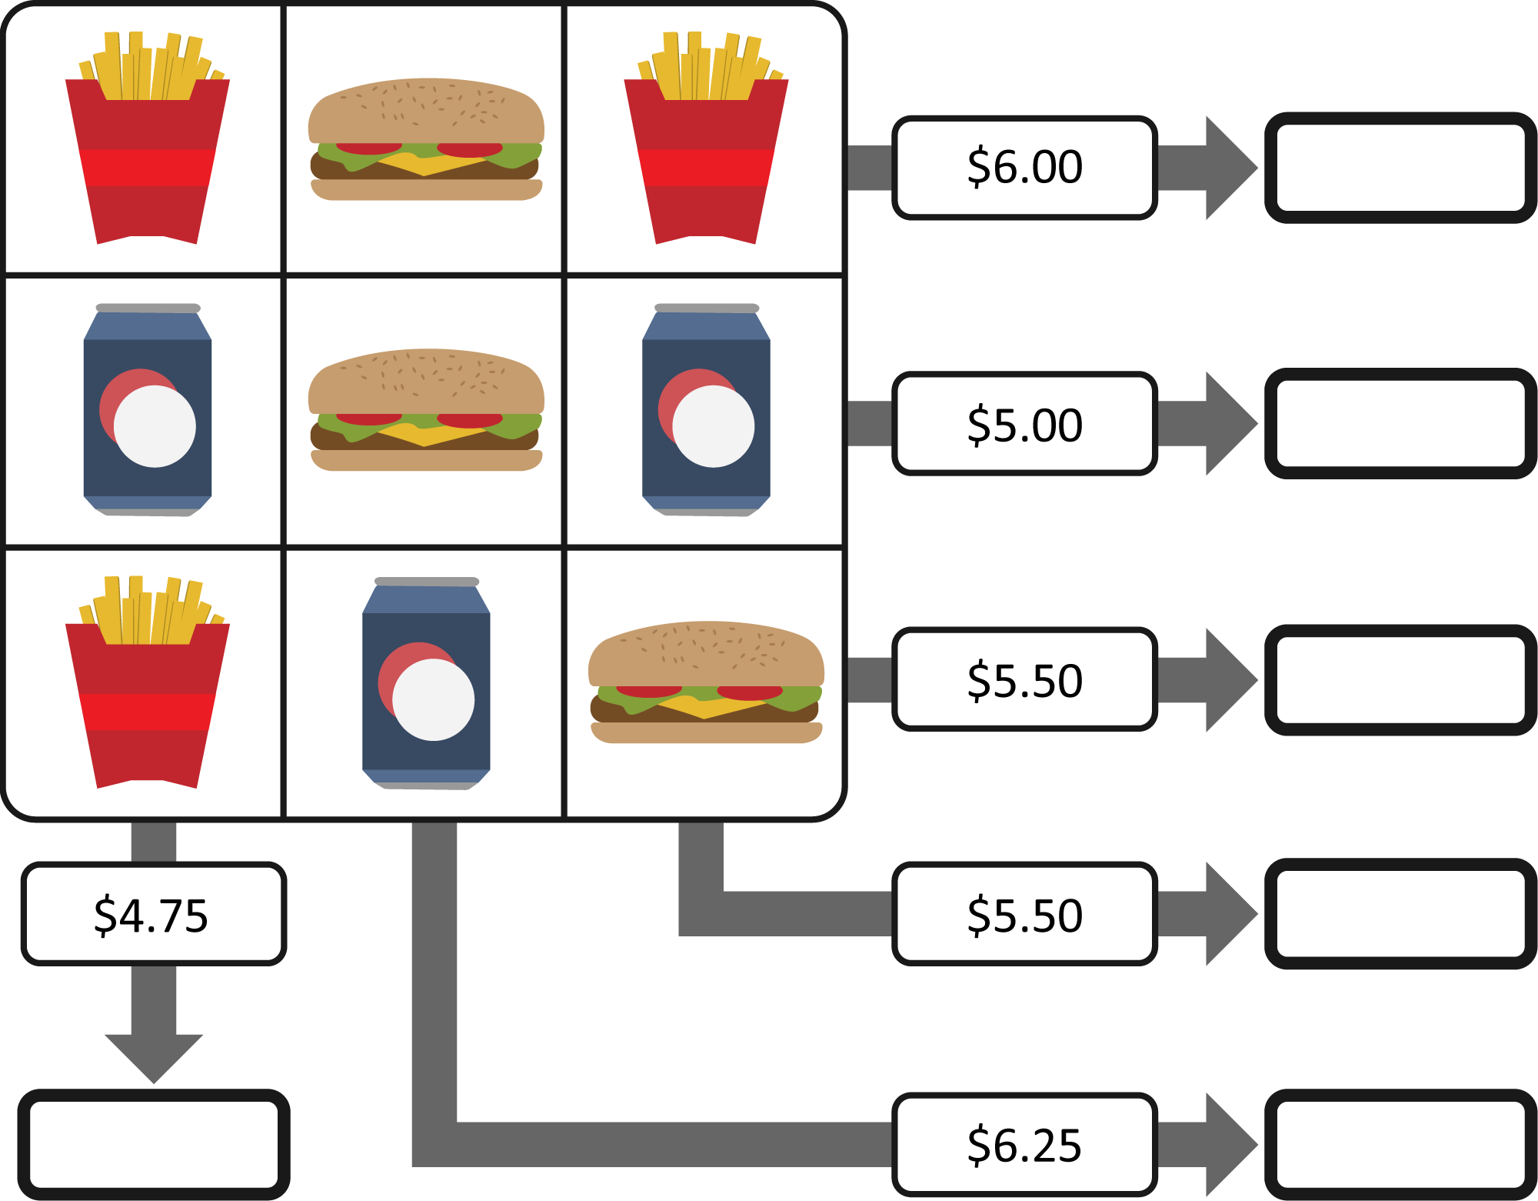Create and solve a system of equations to determine the cost of each item.

|  |  |  |  |  |  |
| --- | --- | --- | --- | --- | --- |
| image1.png | Cost: | image3.png | Cost: | image4.png | Cost: |