Calibration Dial

Each answer will be in the form of . The inner circle   
 represents the real portion of your answer, and the   
 outer circle represents the imaginary portion.   
 Line up the real and imaginary parts with the   
 arrow on the right, then look at the letter   
 that displays under the word *Code*.

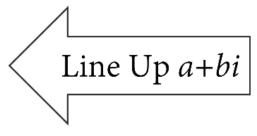

Bottom

Layer

Calibration Dial

Each answer will be in the form of . The inner circle   
 represents the real portion of your answer, and the   
 outer circle represents the imaginary portion.   
 Line up the real and imaginary parts with the   
 arrow on the right, then look at the letter   
 that displays under the word *Code*.

Bottom

Layer

Calibration Dial Layers

1. Cut out one of each type of disk below.
2. Cut out the gray tabs on each of your two disks.
3. Line up the centers of your two disks with the bottom-layer disk from the first page and secure with a paper fastener.

Middle

Layer

Middle

Layer