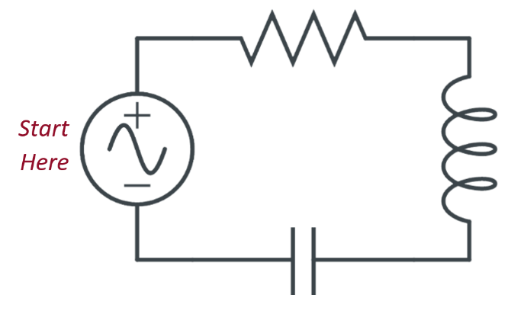
Go With the Flow

Story
One of your crew points out that some
of the symbols are drawn on the battery
pack. You compare the image with the
captain’s journal and discover…
Captain’s Passcode
First Letter | Second Letter | Third Letter

Directions
You will have to rely on these clues
to determine the passcode. Write
the code in the table on the right.

Go with the Flow

Story
One of your crew points out that some
of the symbols are drawn on the battery
pack. You compare the image with the
captain’s journal and discover…
Captain’s Passcode
First Letter | Second Letter | Third Letter

Directions
You will have to rely on these clues
to determine the passcode. Write
the code in the table on the right.

