USER MANUAL—CALCULATIONS (SAMPLE RESPONSES)

Calculating Total Impedance
Use the circuit diagrams below to calculate the total impedance for each circuit. Write your final answer in standard form: a +bi .
Question 1 | Question 2
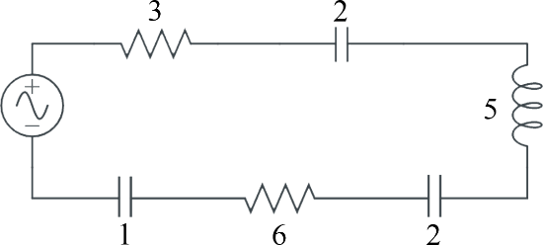  Total Impedance  = − + − + −3 2 5 2 6i i i i  =9 | 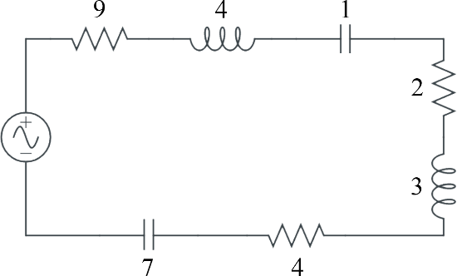  Total Impedance  = + − + + + −9 4i i 2 3 4 7i i  = −15 i
Total Impedance = 9ohms | Total Impedance =(15−i oh) ms

Calculating Voltage
Voltage = (Current)(Impedance) is the formula that relates voltage, current, and total impedance. Use this formula in each of the following scenarios to calculate the voltage. Write your final answer in standard form: a +bi .
Question 3 | Question 4
What is the voltage in a circuit with current 7 5+ i and impedance 8 6− i ?  Voltage = +(7 5 8 6i)( − i)  = − + −56 42 40 30i i i²  = − −56 2 30 1i (− )  = − +56 2 30i  = −86 2i | What is the voltage in a circuit with current 5 8+ i and impedance 5 8− i?  Voltage = +(5 8 5 8i)( − i)  = − + −25 40 40 64i i i²  = −25 64 1(− )  = +25 64  =89
Voltage =(86 2− i volts) | Voltage = 89 volts
MY IMAGINARY FRIEND
,
PART 2

Calculating Current
Use the formula Voltage = (Current)(Impedance) in each of the following scenarios to calculate the current. Write your final answer in standard form: a +bi .
Question 5
What is the current in a circuit with voltage 2i and impedance 1+i ?
Voltage 2i (2i) (1−i) 2 2i − i² 2 2 1i − (− ) 2 2i +
Current = = ⇒ ⋅ = ₂ = =
Impedance 1+i (1+i) (1−i) 1− + −i i i 1− −( 1) 1 1+
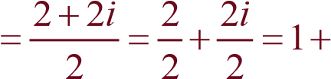i

Current =(1+i am) ps

Definition
•

The
complex conjugate
of
a
bi
+
is
a
bi
−
.
o

For example,
94
i
+
is the complex conjugate of
94
i
−
.

Use the complex conjugate and the voltage formula (from above) to calculate the current.
Write your final answer in standard form: a +bi .
Question 6
What is the current in a circuit with voltage 2 5+ i and impedance 5 2+ i?
2 5+ i (2 5+ i) (5 2− i) 10 4 25 10− i + i − i² 10 21 10 1+ i − (− ) 10 21 10+ i +
Current = ⇒ ⋅ = ₂ = =
5 2+ i (5 2+ i) (5 2− i) 25 10 10 4− i + i − i 25 4 1− (− ) 25 4+
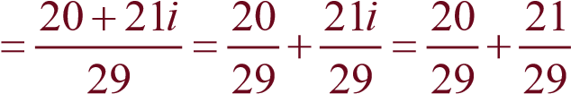i

Current = 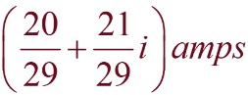

MY IMAGINARY FRIEND
,
PART 2

