PAINTING A PICTURE DOCUMENT PACKET—MISTAKEN FOR THE ENEMY
Image 1 - A resident of Hollywood, California, makes clear her sentiments to any Japanese looking for housing in her neighborhood, around 1923.
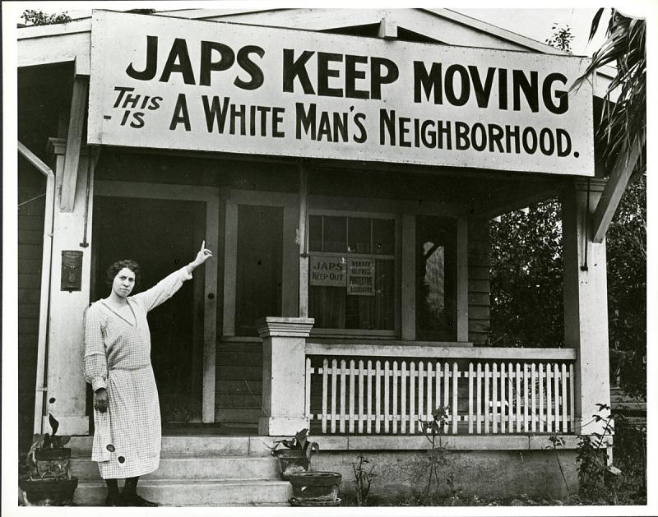
Source: National Japanese American Historical Society. (c. 1923). A resident of Hollywood, California, makes clear her sentiments to any Japanese looking for housing in her neighborhood, around 1923. Smithsonian Institution. https://americanhistory.si.edu/righting-wrong-japanese-americans-and-world-war-ii/racism

Image 2 - A large sign reading "I am an American" placed in the window of a store, at 13th and Franklin streets, on December 8, the day after Pearl Harbor. The store was closed following orders to persons of Japanese descent to evacuate from certain West Coast areas. The owner, a University of California graduate, will be housed with hundreds of evacuees in War Relocation Authority centers for the duration of the war. Oakland, California
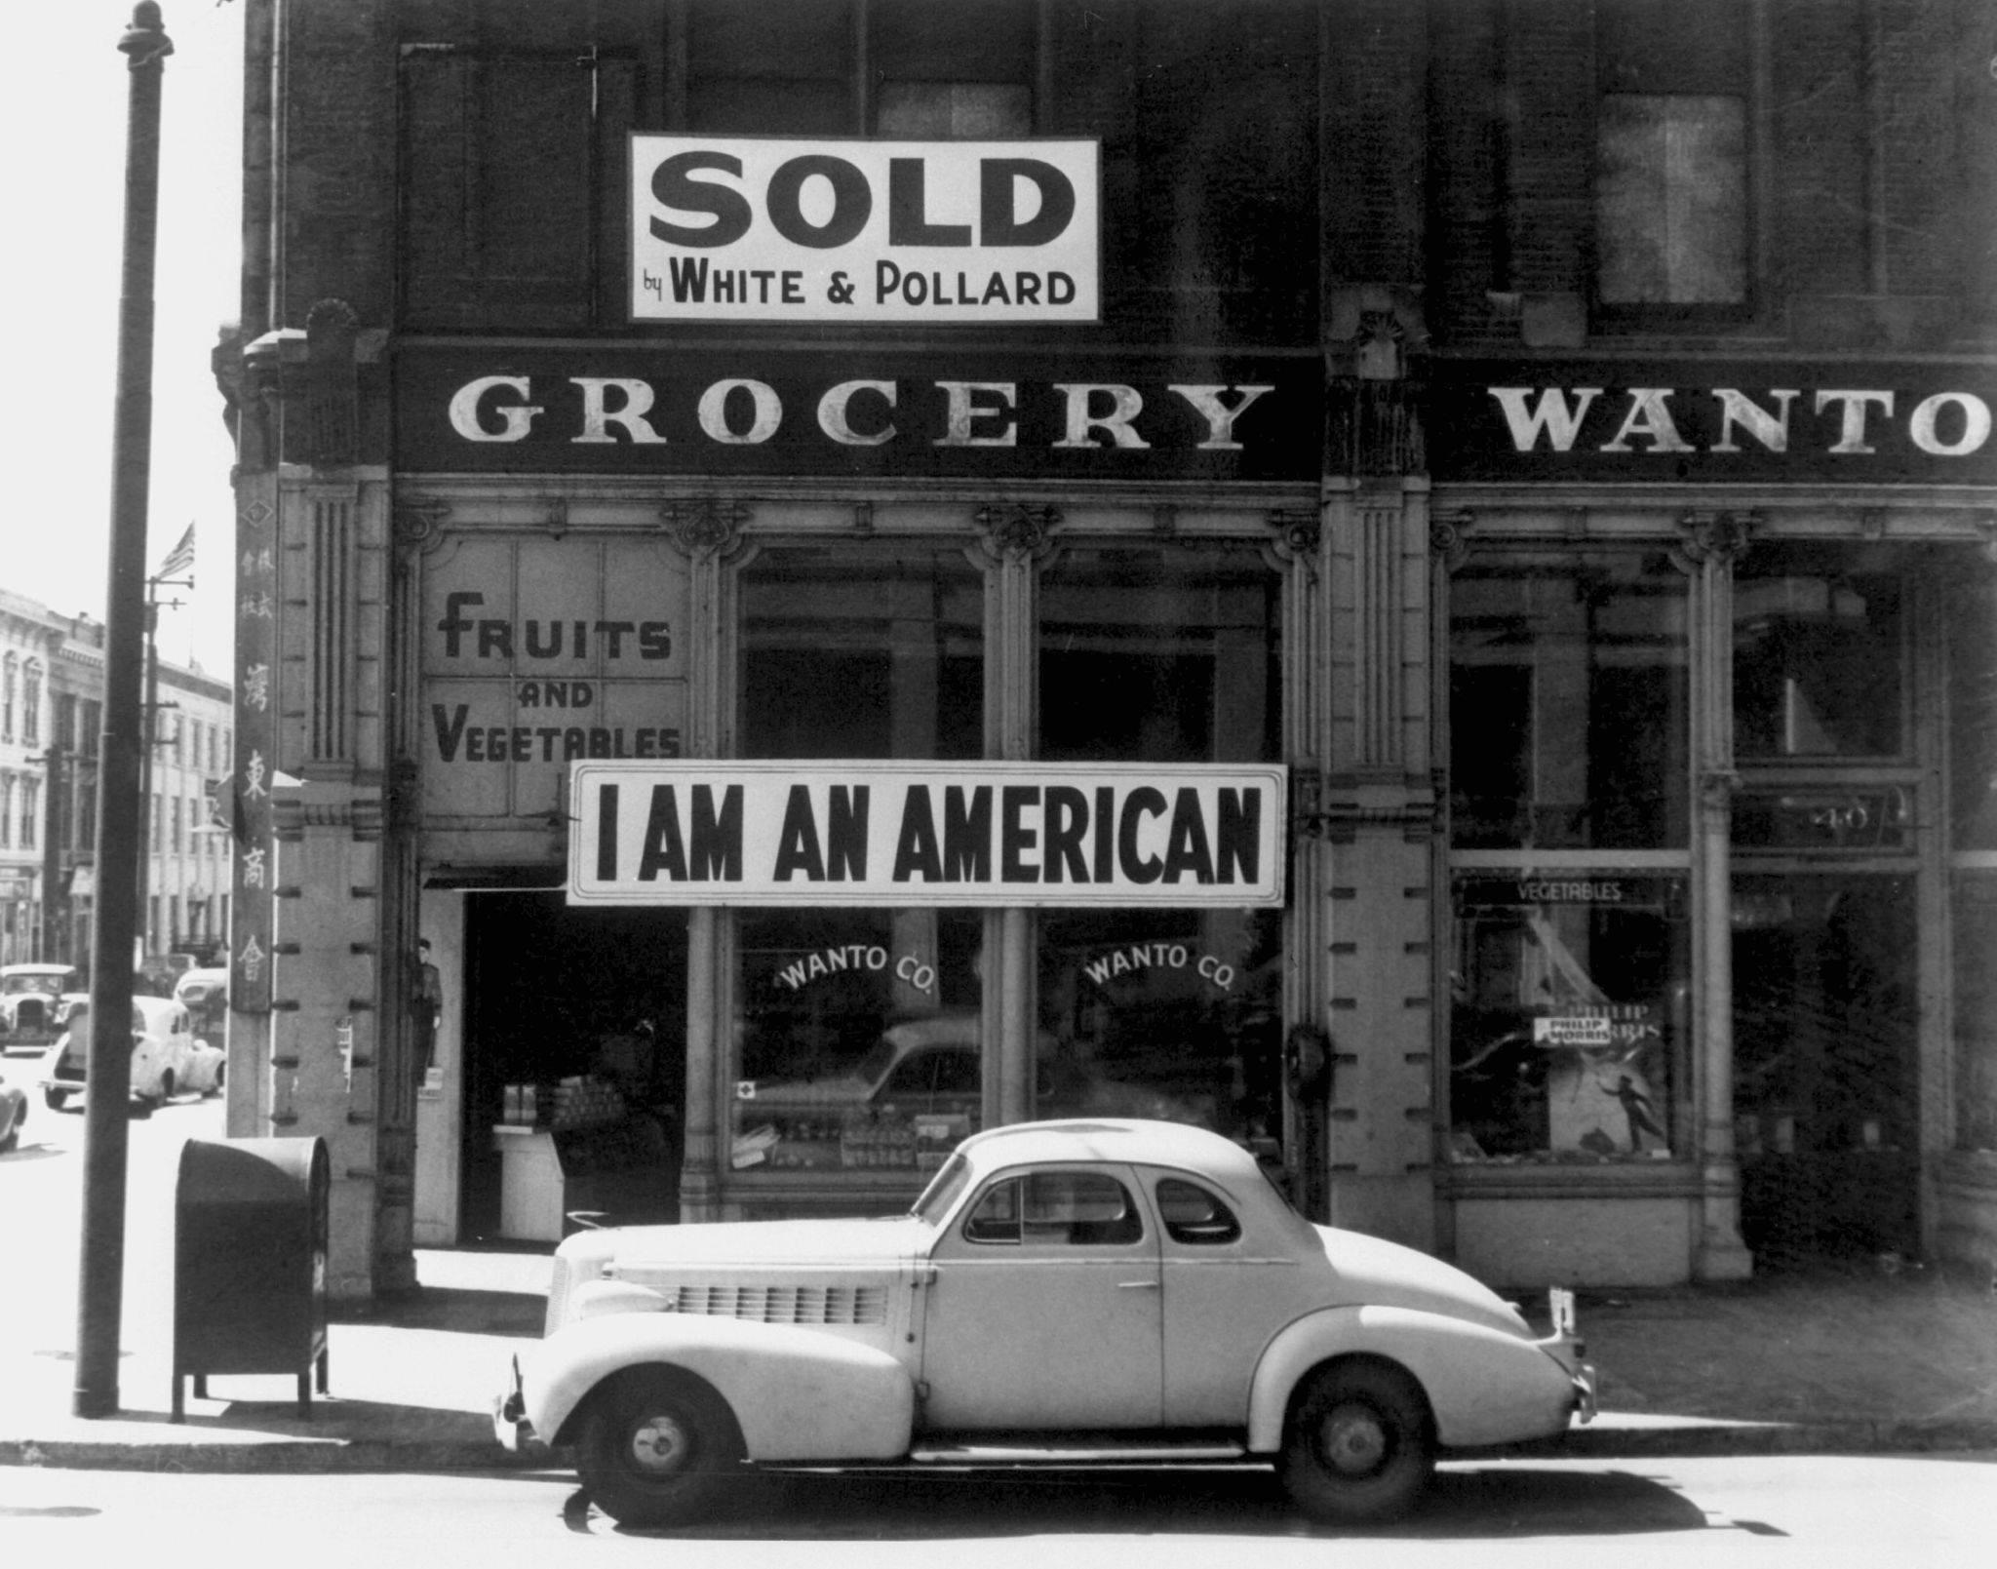
Source: Lange, D. (1942, March 1). A large sign reading “I am an American”. Library of Congress Prints and Photographs Division. https://en.wikipedia.org/wiki/Internment_of_Japanese_Americans#/media/File:JapaneseAmericanGrocer1942.jpg

Image 3 - A child is “Tagged for Evacuation,” Salinas, California, May 1942
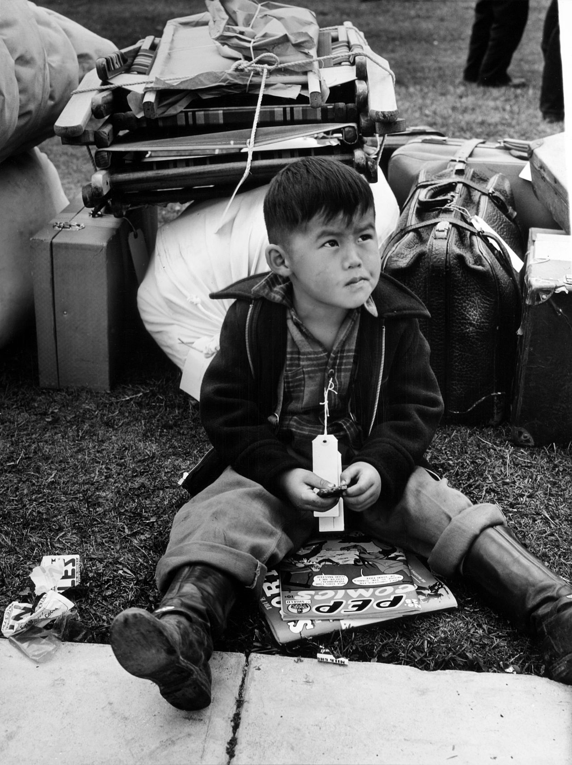
Source: Lee, R. (1942, May 1). A child is “Tagged for evacuation,” Salinas, California, May 1942. Library of Congress Prints and Photographs Division. https://en.wikipedia.org/wiki/Internment_of_Japanese_Americans#/media/File:Russell_Lee,_Tagged_for_evacuation,_Salinas,_California,_May_1942.jpg
Image 4 - Persons of Japanese ancestry arrive at the Santa Anita Assembly Center from San Pedro. Evacuees lived at this center at the former Santa Anita race track before being moved inland to relocation centers.
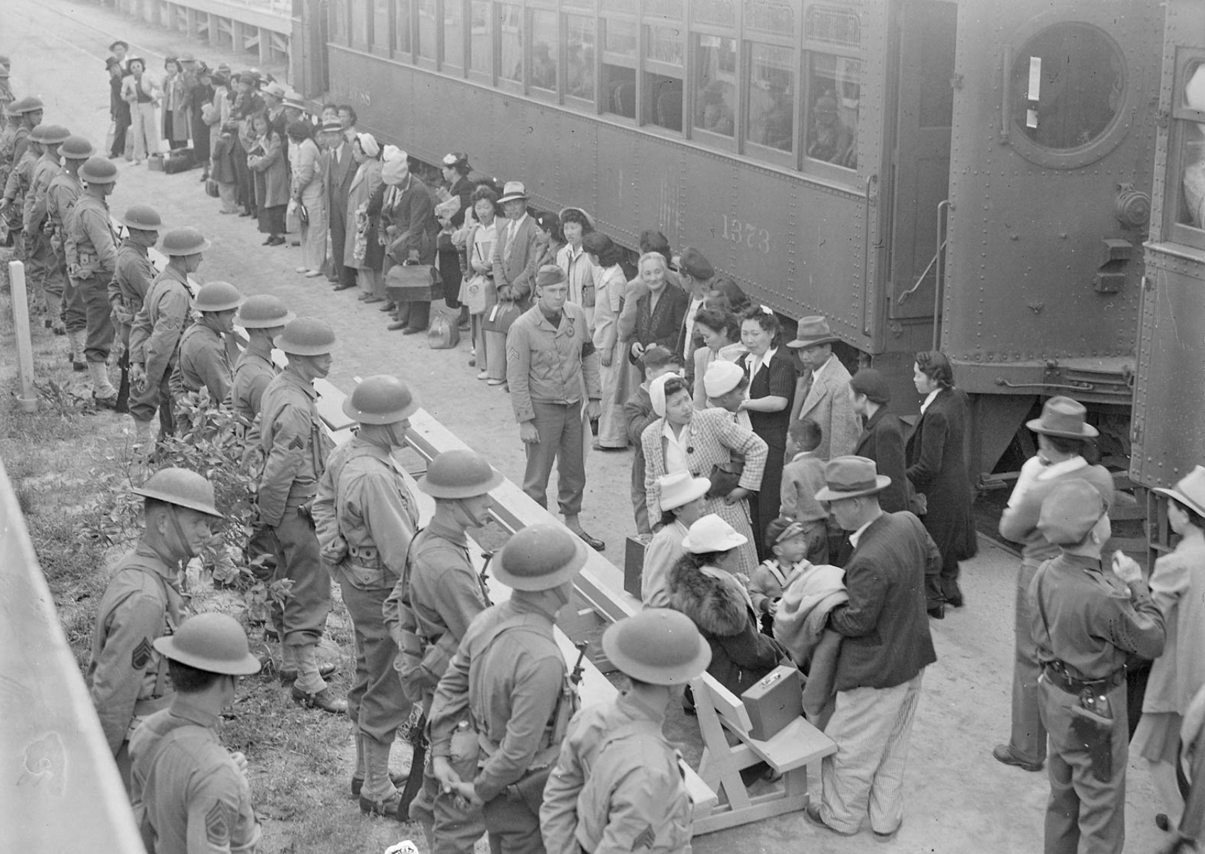
Source: Albers, C. (1942, April 5). Persons of Japanese ancestry arrive at the Santa Anita Assembly Center from San Pedro. Evacuees lived at this center at the former Santa Anita race track before being moved inland to relocation centers. U.S. National Archives and Records Administration. https://www.archives.gov/research/japanese-americans/wra

Image 5 - Crowd behind barbed wire fence waving to departing friends on train
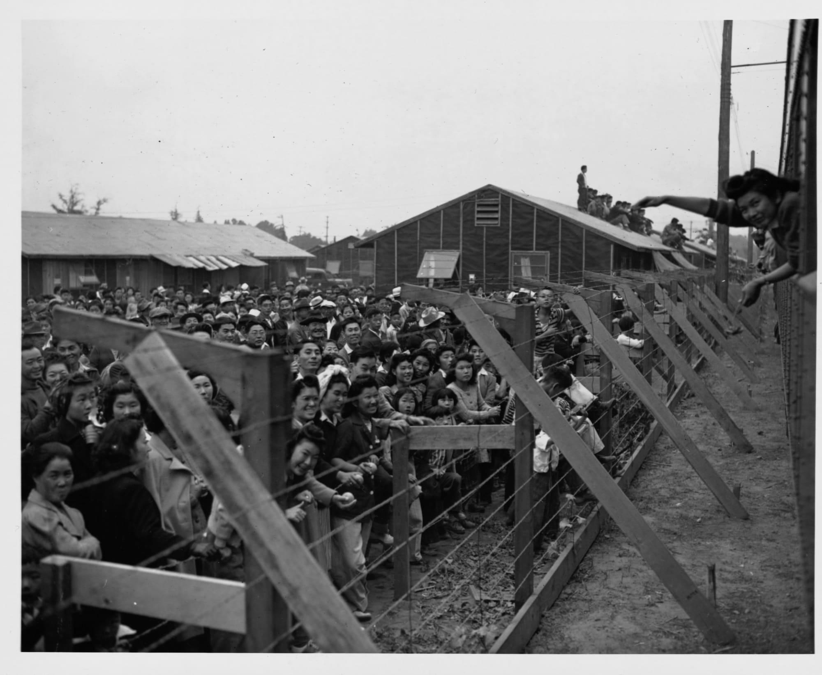
Source: Fowlkes, J.F. (c. 1942). Crowd behind barbed wire fence waving to departing friends on train. Library of Congress Prints and Photographs Division. https://www.loc.gov/item/2004679931/

Image 6 - Dust storm at the Manzanar War Relocation Center
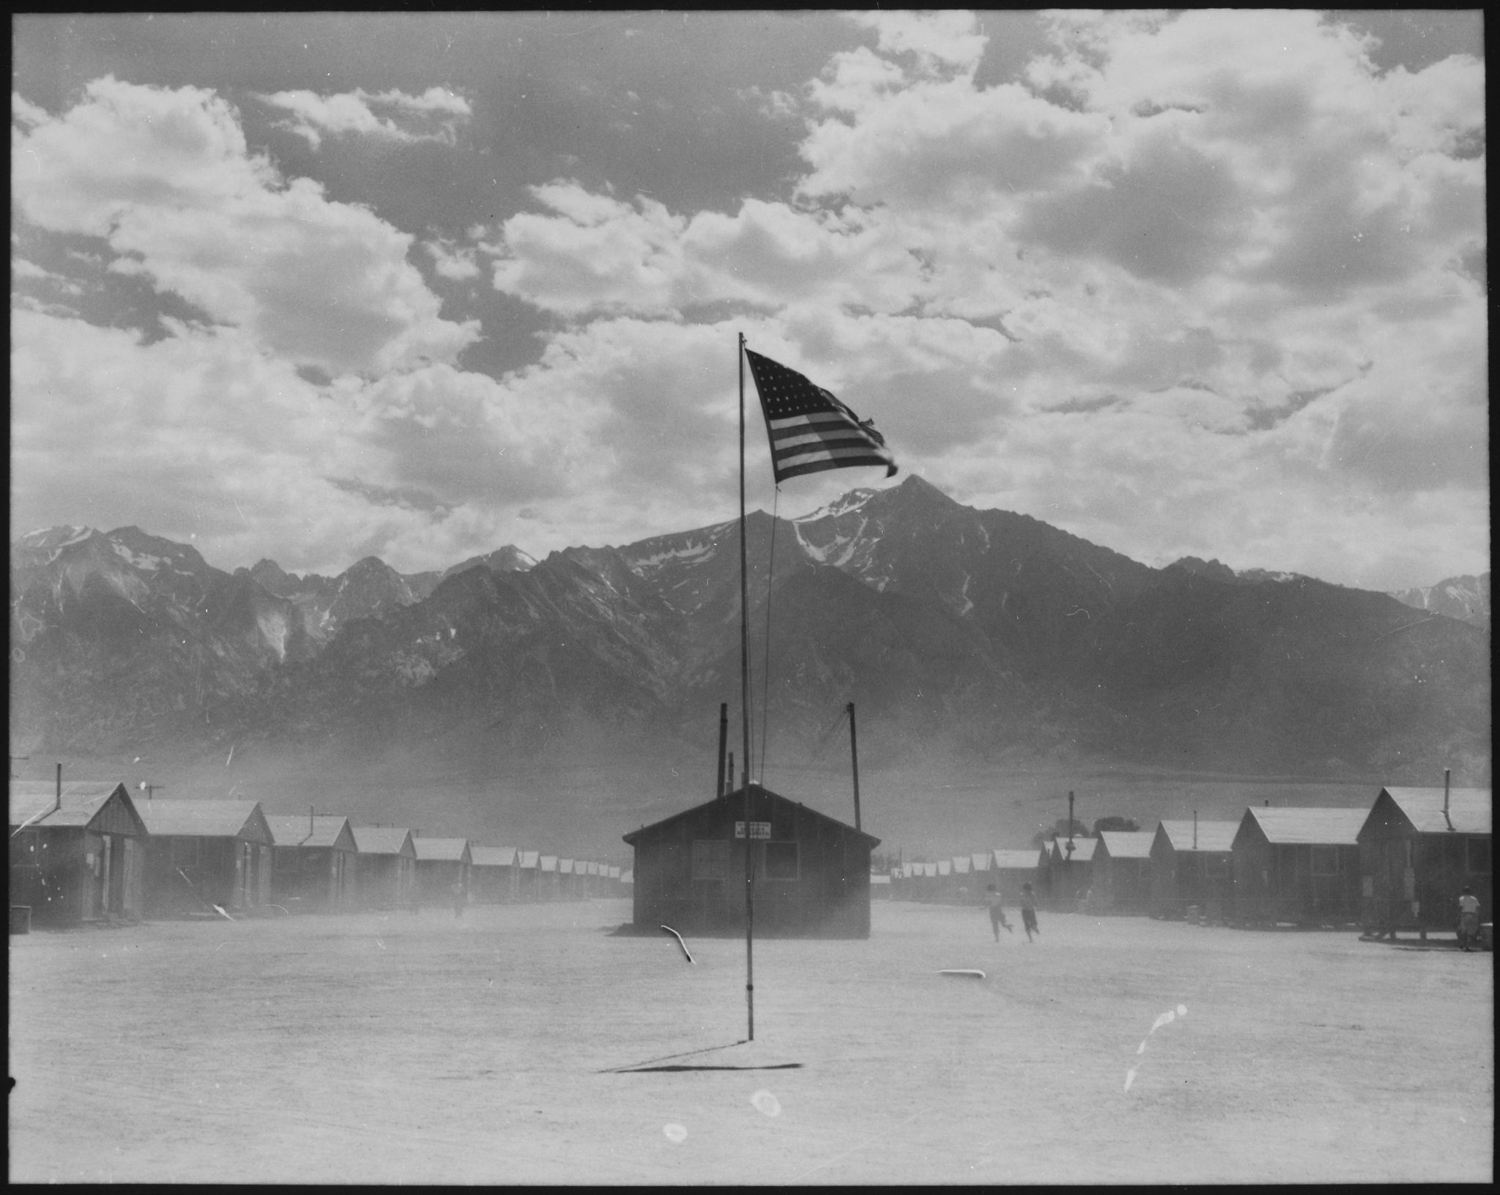
Source: Unknown author. (1942, April 5). Dust storm at the Manzanar War Relocation Center. U.S. National Archives and Records Administration. https://en.wikipedia.org/wiki/Internment_of_Japanese_Americans#/media/File:%22Persons_of_Japanese_ancestry_arrive_at_the_Santa_Anita_Assembly_Center_from_San_Pedro._Evacuees_lived_at_this_center_at_-_NARA_-_539960.jpg

