Graphs
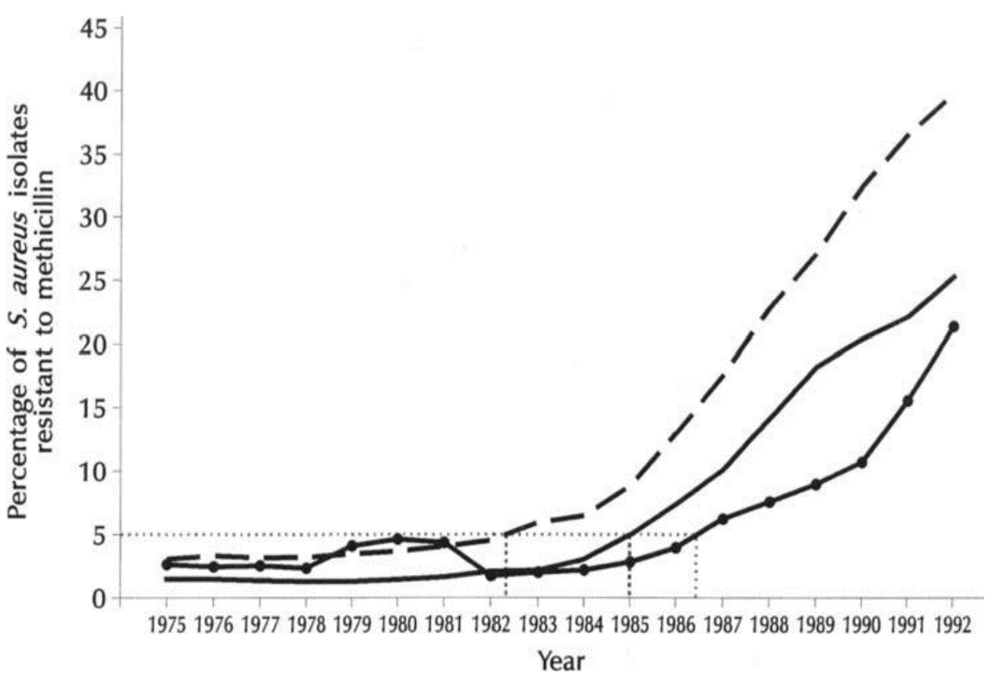
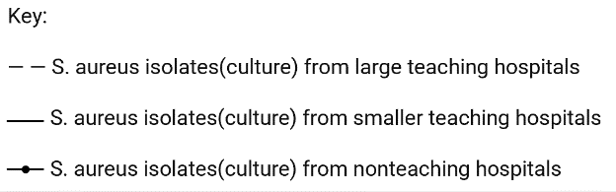

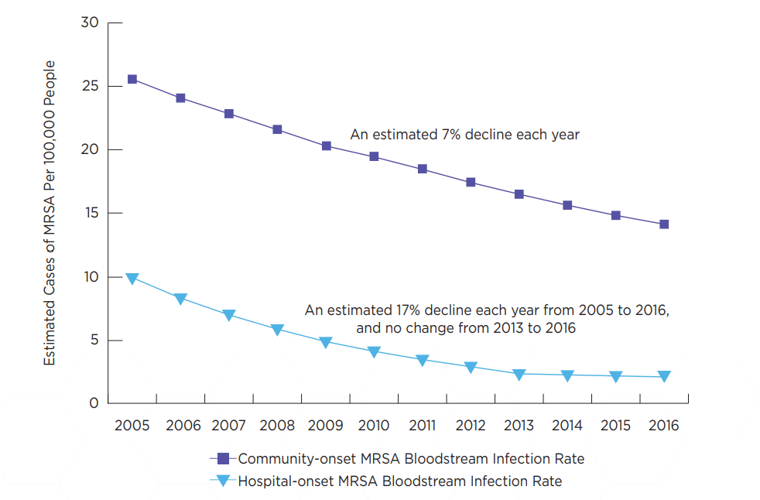
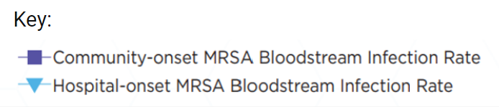
-------------------------------------------------------------------------------------------------------------------------------
Year

