Trenton Register-News

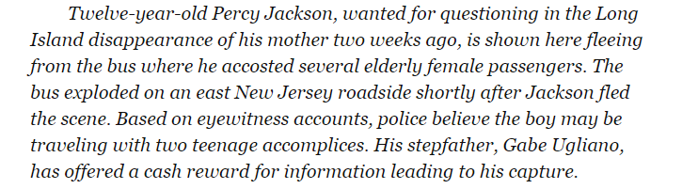

Trenton Register-News

