Common Affixes and Roots
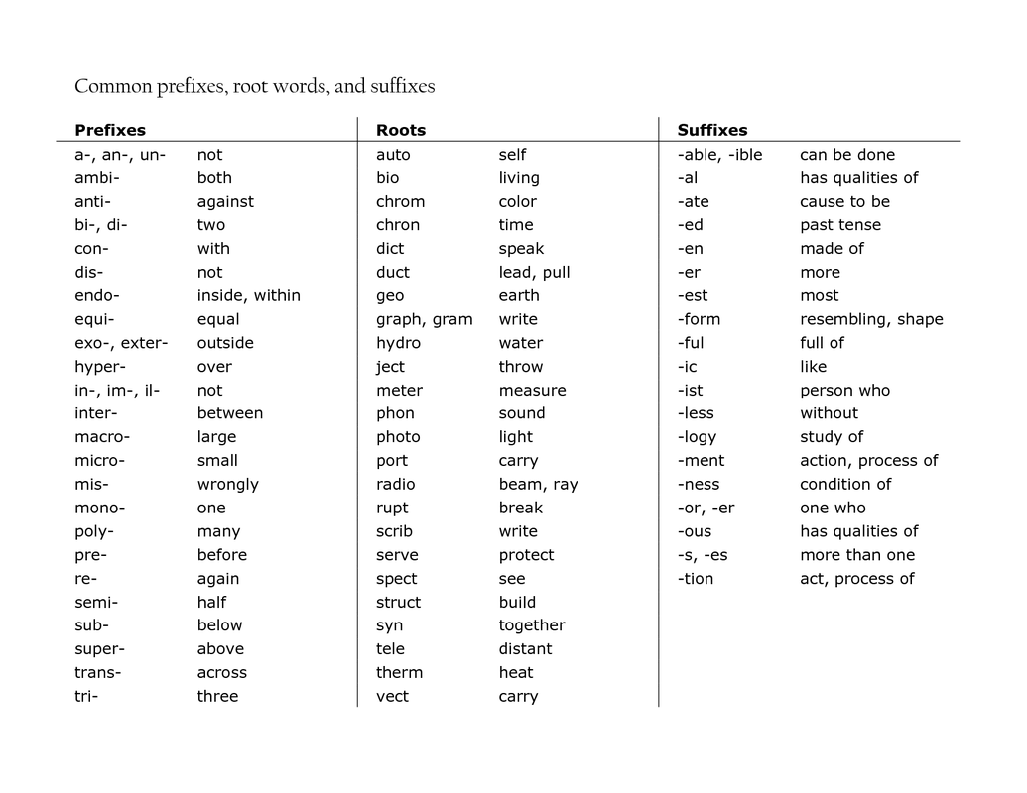
Chart retrieved from: http://ed570.weebly.com/the-importance-of-understanding-word-parts.html

