Infograms
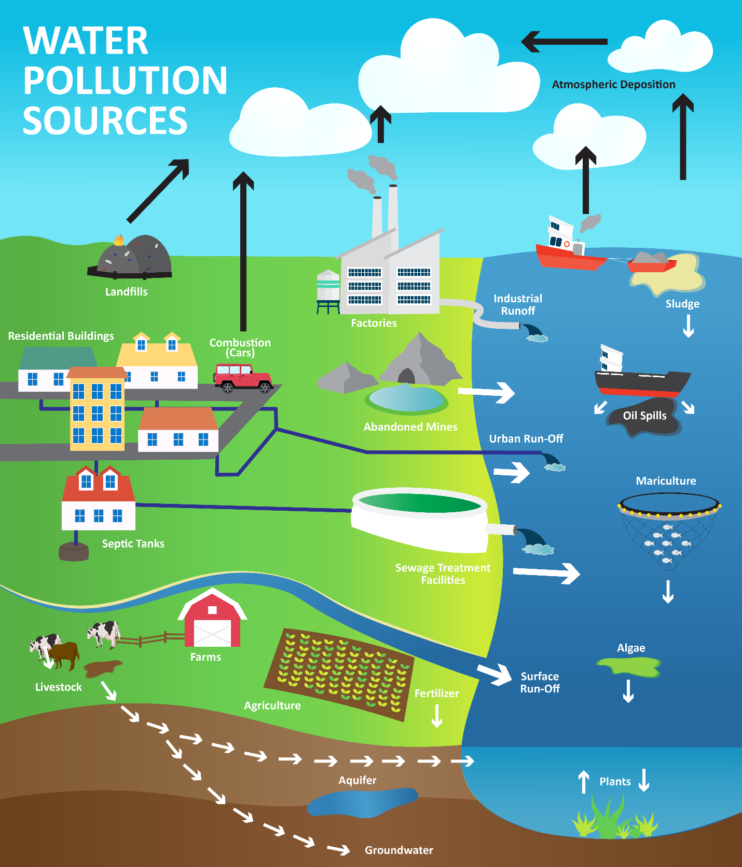
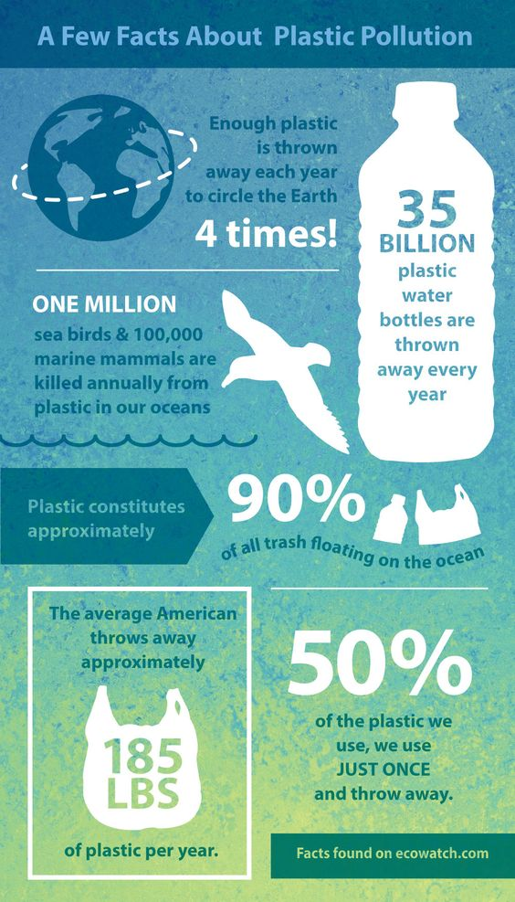
PngImg. (n.d.). Plastic Pollution [Infographic]. https://i.pinimg.com/564x/a5/0a/4e/a50a4e54e34dfffe1e23ebf207b15f1e.jpg

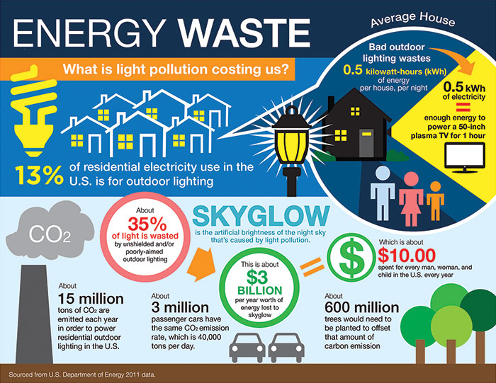

International Dark-Sky Association. (n.d.). Energy Waste Facts [Infographic] https://www.darksky.org/our-work/grassroots-advocacy/resources/public-outreach-materials CC BY-NC-ND

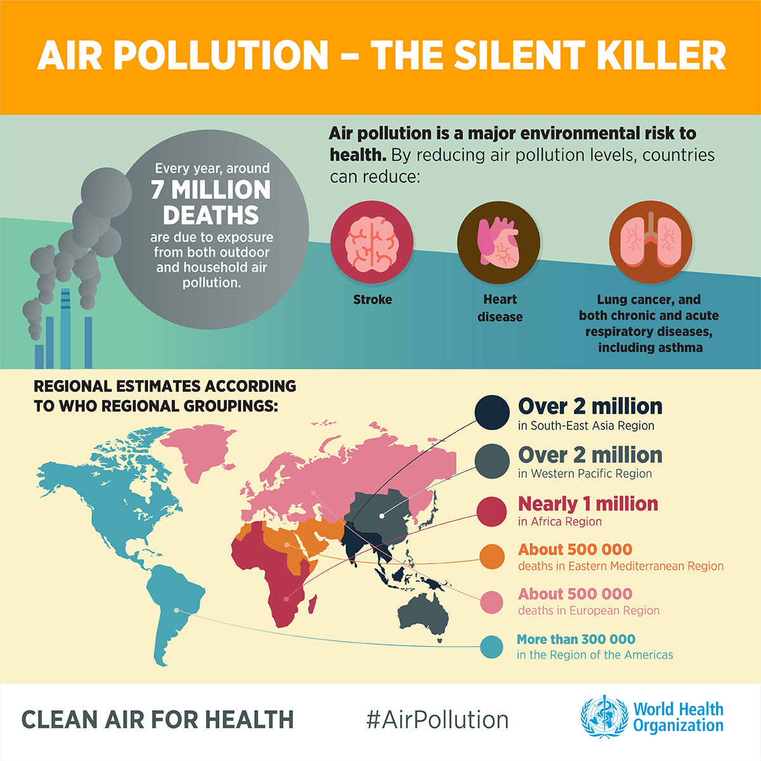
GroundUp. (May 8, 2020). Pollution Facts [Infographic]. https://www.groundup.org.za/media/uploads/images/Graphics/lockdown-pollution-20200508/Air-pollution-WHO%20INFOGRAPHICS-English-1.1200px.jpg

