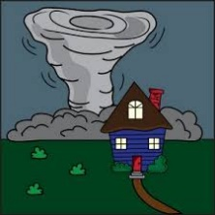
Tornado Safe- Gallery Walk Recording Sheet

Team 1-
- Describe the type of structure did this team built?
____________________________________________________________________________________________________________________________________________________________
- At what fan speeds did the structure continue standing? Circle one.

- 2 3 All 3 speeds

- What was something you liked about their structure?
____________________________________________________________________________________________________________________________________________________________
- How could you improve their structure?
____________________________________________________________________________________________________________________________________________________________

Team 2-
- Describe the type of structure did this team built?
____________________________________________________________________________________________________________________________________________________________
- At what fan speeds did the structure continue standing? Circle one.

- 2 3 All 3 speeds

- What was something you liked about their structure?
____________________________________________________________________________________________________________________________________________________________
- How could you improve their structure?
____________________________________________________________________________________________________________________________________________________________

Team 3-
- Describe the type of structure did this team built?
____________________________________________________________________________________________________________________________________________________________
- At what fan speeds did the structure continue standing? Circle one.

- 2 3 All 3 speeds

- What was something you liked about their structure?
____________________________________________________________________________________________________________________________________________________________
- How could you improve their structure?
____________________________________________________________________________________________________________________________________________________________

Team 4-
- Describe the type of structure did this team built?
____________________________________________________________________________________________________________________________________________________________
- At what fan speeds did the structure continue standing? Circle one.

- 2 3 All 3 speeds

- What was something you liked about their structure?
____________________________________________________________________________________________________________________________________________________________
- How could you improve their structure?
____________________________________________________________________________________________________________________________________________________________

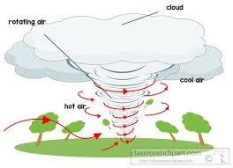
Tornado Safe – Structure Planning Sheet
- Draw a picture of what your structure will look like when it is completed.

- What materials will you use to build your structure?
__________________________________________________________________________________________________________________________________________________________________________
- What steps will you take to build your structure?
____________________________________________________________________________________________________________________________________________________________________________________________________________________________________________________________________________________________________________________________________________________
- Make a prediction. Will your structure work? Why or why not?
______________ because__________________________________________________________________________
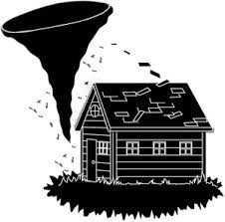
Tornado Safe – Structure Reflection/Revision Sheet
- What worked on your structure?
______________________________________________________________________________
- What did not work on your structure?
__________________________________________________________________________________________________________________________________________________________________________
- Why do you think it didn’t work?
____________________________________________________________________________________________________________________________________________________________________________________________________________________________________________________________________________________________________________________________________________________
- How could you make your structure better?
__________________________________________________________________________________________________________________________________________________________________________
- What is your plan to improve your structure?
__________________________________________________________________________________________________________________________________________________________________________
- Draw a picture of your improved structure.

