Sea Otter  Diet: sea urchins, clams, crabs, fish, octopus, squid  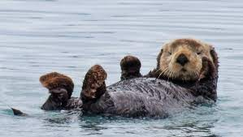 | Sea Urchin  Diet: algae, plankton, kelp  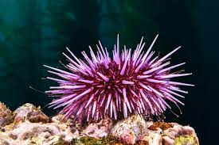
Clam  Diet: plankton, algae  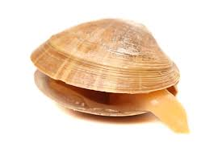 | Crab  Diet: plankton, algae, clams, detritus  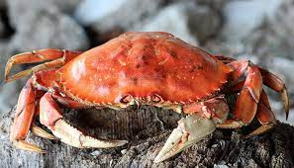
Octopus  Diet: clams, crabs, shrimp, fish, other octopus  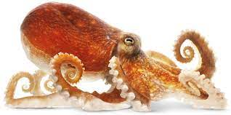 | Squid  Diet: fish, shrimp, other squid  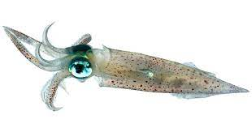
Orca  Diet: fish, squid, seals, sea lions, penguins, beluga whales  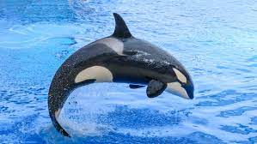 | Beluga Whale  Diet: octopus, squid, shrimp, crab, clams, fish  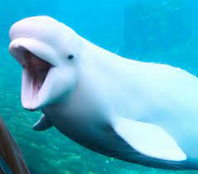
Sting Ray  Diet: fish, clams, crab, squid, shrimp  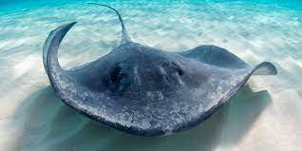 | Dolphin  Diet: fish, squid, shrimp, jellyfish, octopus  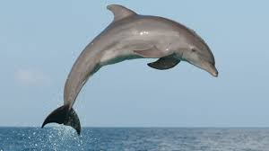
Blue Whale  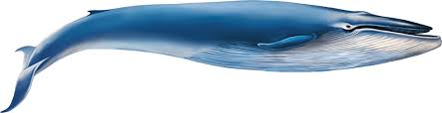  Diet: krill | Shark  Diet: fish, dolphins, seals,  sea turtles, other sharks  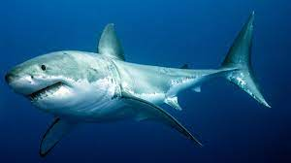
Sea Turtle  Diet: algae, sea grass, seaweed  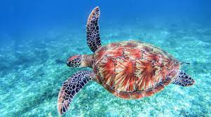 | Seal  Diet: fish, penguins, octopus, squid  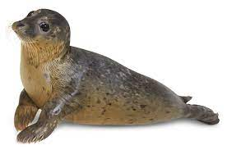
Sea Lion  Diet: fish, squid, clams  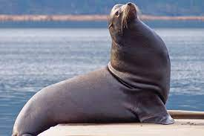 | Jellyfish  Diet: plankton, fish & fish eggs, other jellyfish  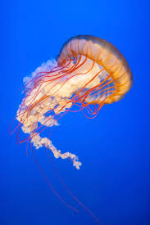
Sea Star  Diet: clams, sea urchins, plankton, detritus  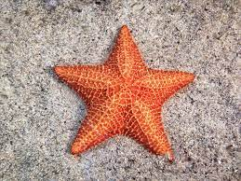 | Shrimp  Diet: algae, plankton, detritus  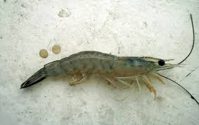
Penguin  Diet: krill, squid, fish  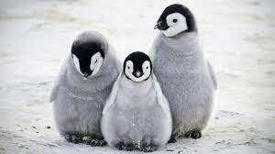 | Krill  Diet: plankton  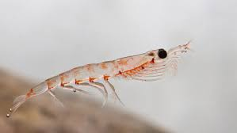
Manatee  Diet: sea grass, seaweed, algae  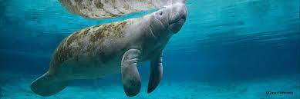 | Fish  Diet: plankton, algae, seaweed, other fish  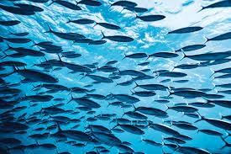
Detritus  Dead plant and animal material  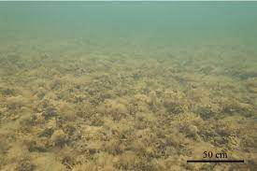 | Plankton  Microscopic marine  plants and animals  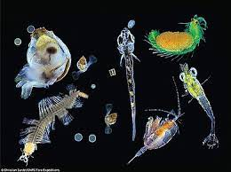
Seaweed  (plant)  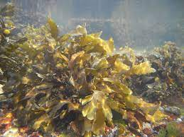 | Algae  (plant)  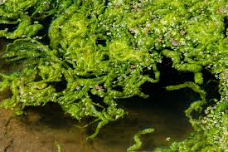
Kelp  (plant)  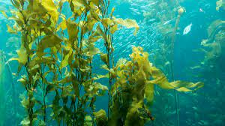 | Sea Grass  (plant)  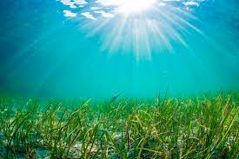

Image address for card sort pictures:
Sea-Otterhttps://www.gannett-cdn.com/-mm-/7cfa0cdce1b602172c2e2961197d42679ab2b3cc/c=0-278-2520-1702/local/-/media/2017/01/28/USATODAY/USATODAY/636211875995222622-GettyImages-462548187.jpg
Sea Urchin https://oceana.org/marine-life/corals-and-other-invertebrates/pacific-purple-sea-urchin
Clam:https://www.collinsdictionary.com/images/full/clam_383609269.jpg
Crab:https://pngimg.com/uploads/crab/crab_PNG15.png
Octopus: https://www.flickr.com/photos/mentalblock/6968924997
Squid:https://www.dkfindout.com/uk/animals-and-nature/squid-snails-and-shellfish/squid/
Orca:https://assets.rebelmouse.
Beluga Whale:https://www.google.com/imgres?imgurl=https%3A%2F%2Fs.hdnux.com%2Fphotos
:Sting Ray:https://www.visitsealife.com/michigan/media/1kijexqx/stingray-1200x600.jpg
Dolphin:https://bit.ly/3lXZzYN
Blue Whale:https://fh-sites.imgix.net/sites/1580/2019/11/09073846/blue-whale-illustration.png
Shark:https://static01.nyt.com/images/2020/08/12/multimedia/00xp-shark/merlin_102239914_6de5d563-4aaa-44d7-bdb0-2a263e515181-superJumbo.jpg
Sea Turtle:https://pxhere.com/en/photo/1614282?utm_content=shareClip&utm_medium=referral&utm_source=pxhere
Seal:https://pxhere.com/en/photo/1341115?utm_content=shareClip&utm_medium=referral&utm_source=pxhere
Sea Lion:https://1kc6192wfbuqzt2py3il3781-wpengine.netdna-ssl.com/wp-content/uploads/2019/02/15572271_web1_Cull2-Sealion-20feb19-1024x683.jpg
Jellyfish:https://images.unsplash.com/photo-1543007168-
Sea star:https://www.thoughtco.com/facts-about-sea-stars-2291865
Shrimp:https://commons.wikimedia.org/wiki/File:Shrimp_body.jpg
Penguin:https://media.istockphoto.com/photos/three-penguin-chicks-picture-id619633758?
Krill:https://media.istockphoto.com/photos/antarctic-krill-floating-in-the-water-picture-id494038045?s=612x612
Manatee:https://www.savethemanatee.org/manatees/facts/
School of Fish:https://commons.wikimedia.org/wiki/File:School_of_fish_02708.jpg
Detritus:https://www.researchgate.net/profile/Karl-Attard-2/publication/328305826/figure/fig9/AS:682259623452676@1539674778300/Large-underwater-fields-of-unattached-macroalgal-detritus-composed-primarily-of-F.png
Plankton:https://en.wikipedia.org/wiki/Plankton
Algae and Seaweed:https://ioc.unesco.org/news/unprecedented-analysis-global-harmful-algal-blooms-launched-ioc
Sea grass and Kelp:https://mediad.publicbroadcasting.net/p/wvtf/files/styles/large/public/202011/Seagrass.jpg

