GROUP 1 VINTAGE AD PACKET
1920s Ad 1: Sayre Headlight, February 19, 1920, p. 4

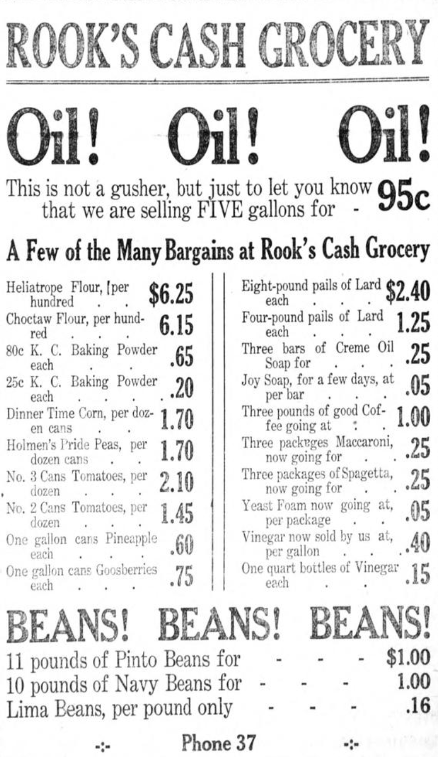

Find the cost of coffee, divide it by 3, and enter it in your chart.

1920s Ad 2: Sapulpa Herald, May 7, 1920, p. 5

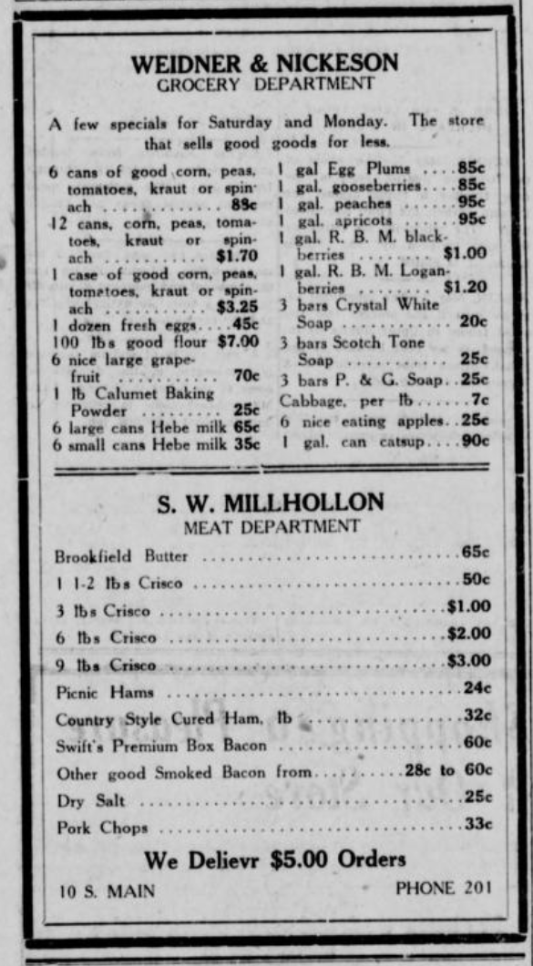

Find the lowest listed prices of milk and bacon, and enter the values in your chart. Also, since 5-lb. flour sacks were usually advertised in later years, take the value of flour listed here, divide it by 20, and enter it in your chart.

1920s Ad 3: Dewey Globe, February 27, 1920, p. 5

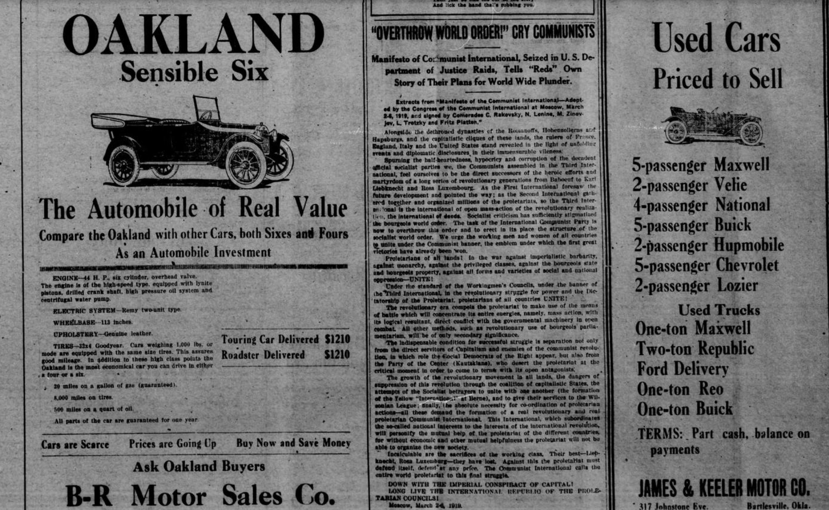

Find the cost of the Oakland and enter it in your chart.

1920s Ad 4: Texhoma Times, October 15, 1920, p. 4
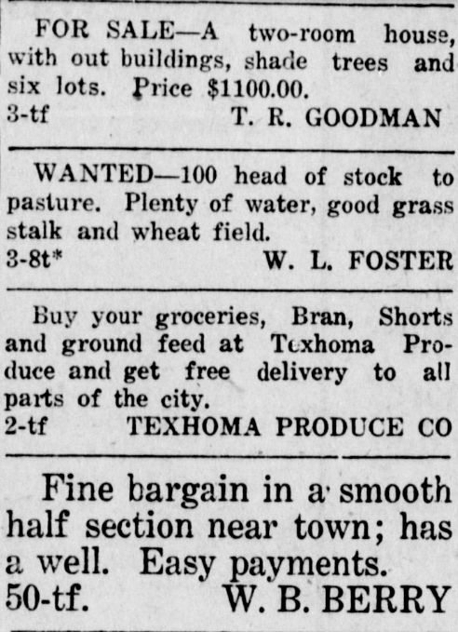

Find the price of the two-room house, and enter it in your chart.

1970s Ad 1: Sapulpa Herald, December 16, 1970, p. 4

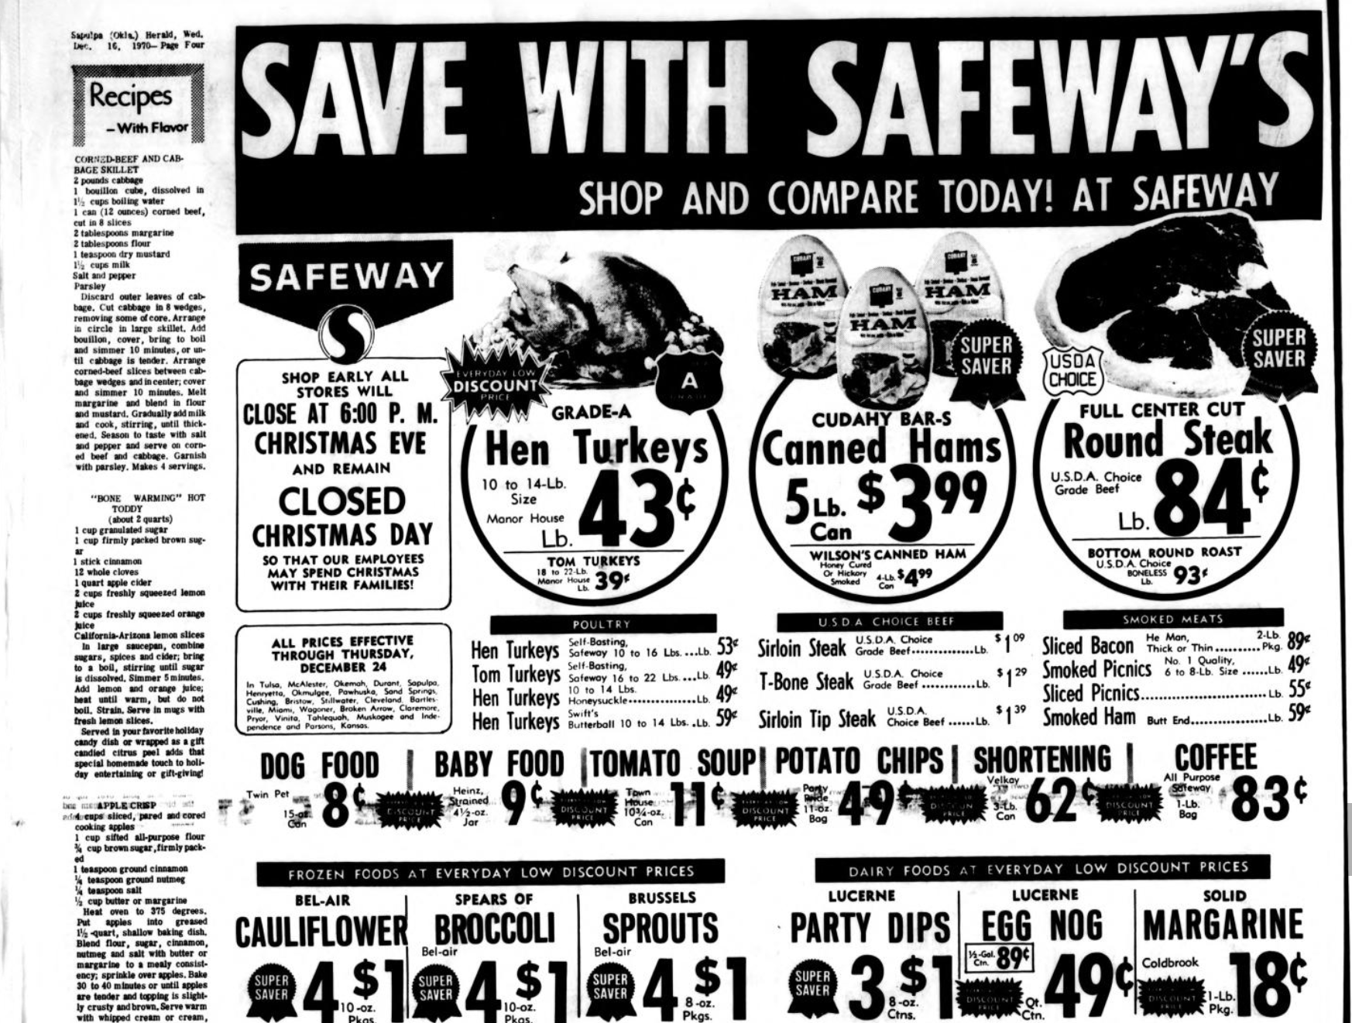

Find the price of coffee, and divide the price of bacon in half. Enter both prices into your chart.

1970s Ad 2: Sapulpa Herald, December 16, 1970, p. 5

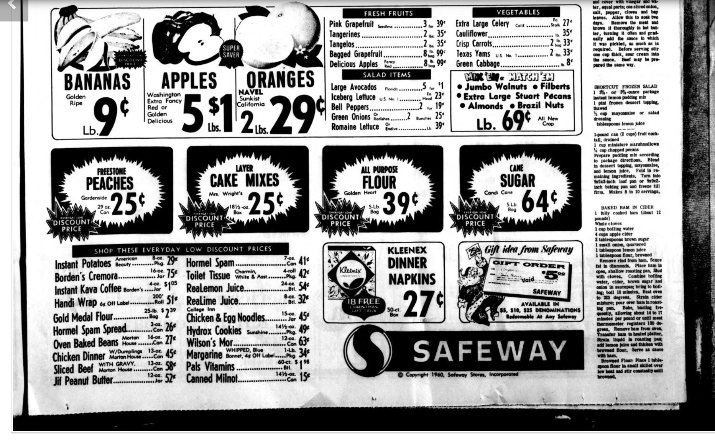
Find the cost of a 5-lb. bag of flour, and enter it in your chart.

1970s Ad 3: Sapulpa Herald, August 18, 1970, p. 6

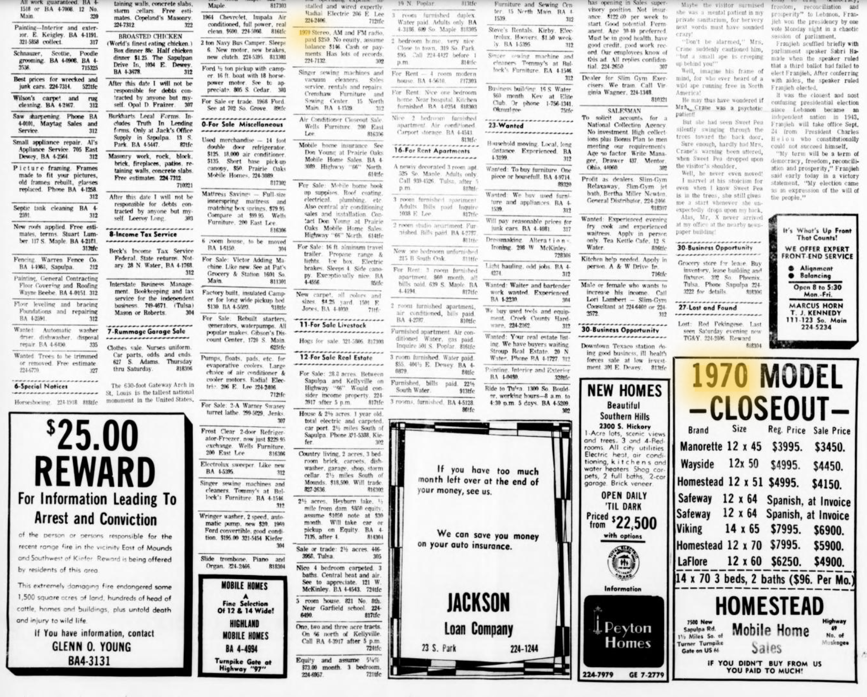

Enter the minimum cost (“Priced from”) of the new homes in your chart.

1970s Ad 4: Sapulpa Herald, June 29, 1970, p. 13

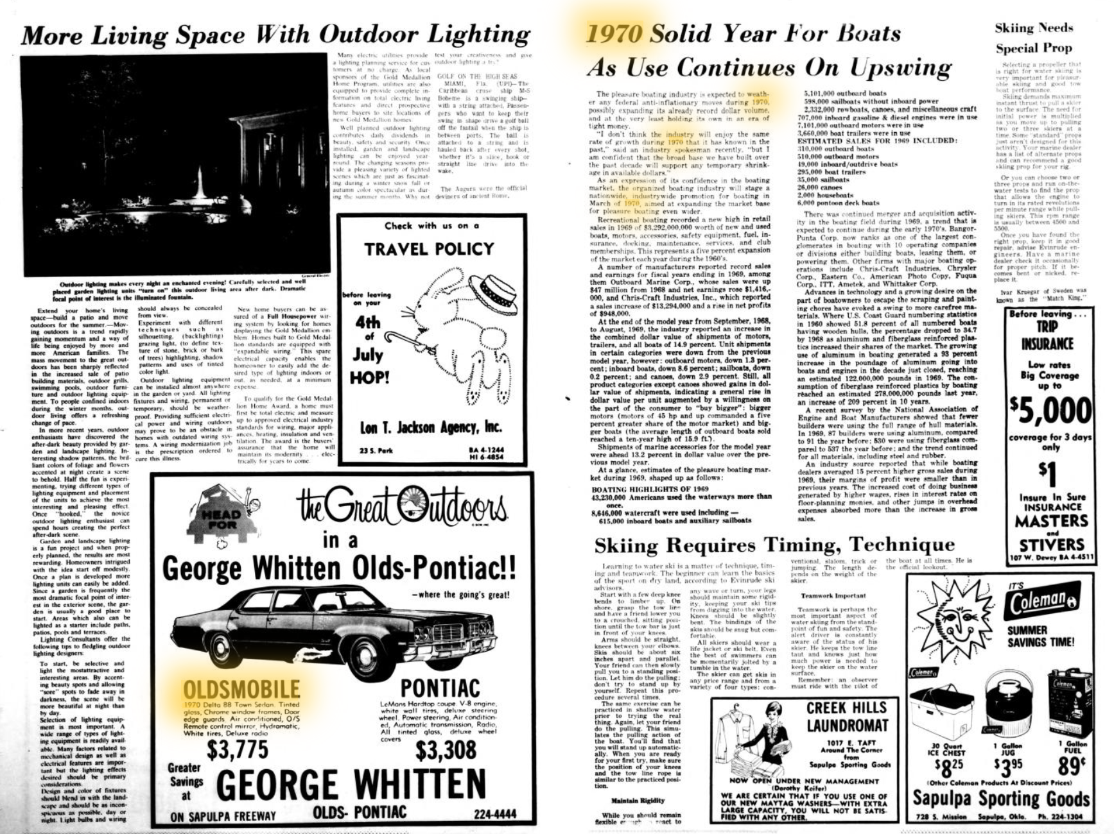

Enter the costs of the Oldsmobile and Pontiac in your chart.

1970s Ad 5: Oklahoma Eagle, June 11, 1970, p. 18

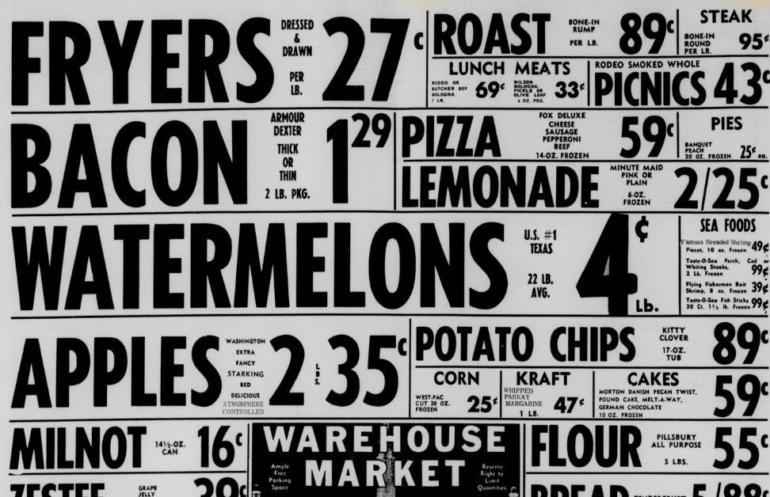

Enter the price of the Milnot evaporated milk in your chart.

