GROUP 2 VINTAGE AD PACKET
1930s Ad 1: Sapulpa Herald, January 11, 1930, p. 4

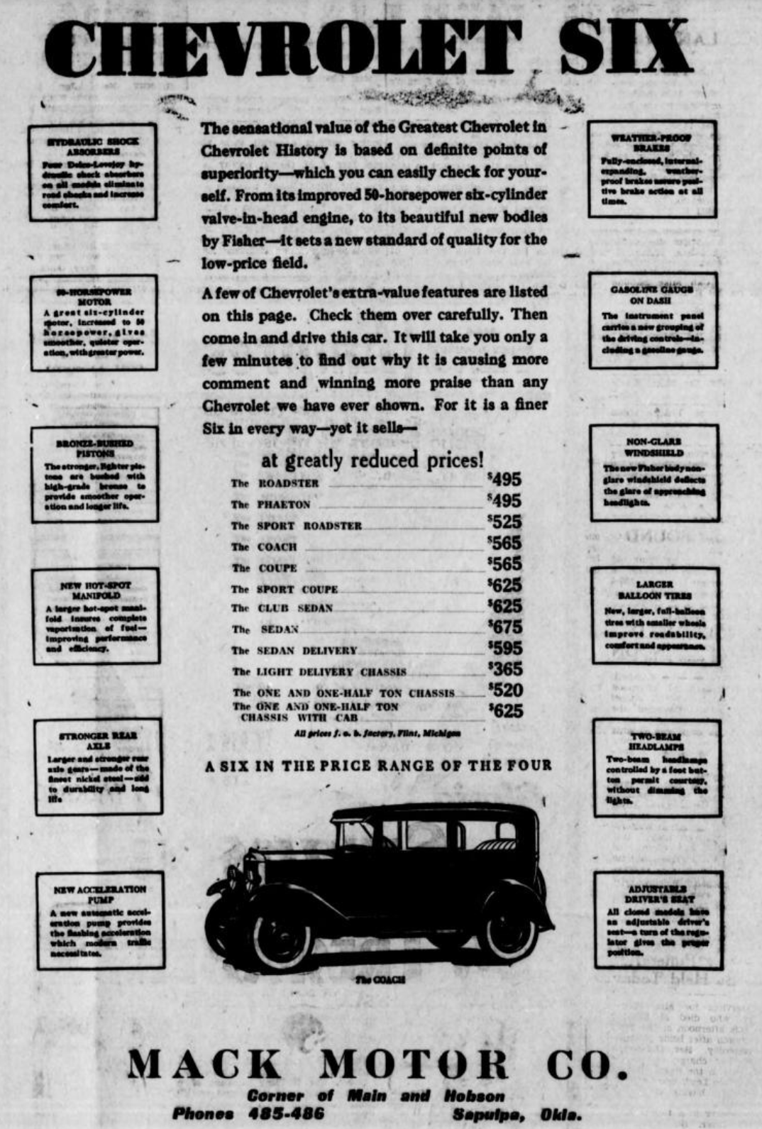

Enter the range of prices for different Chevrolet models in your chart.
1930s Ad 2: Sapulpa Herald, December 26, 1930, p. 4

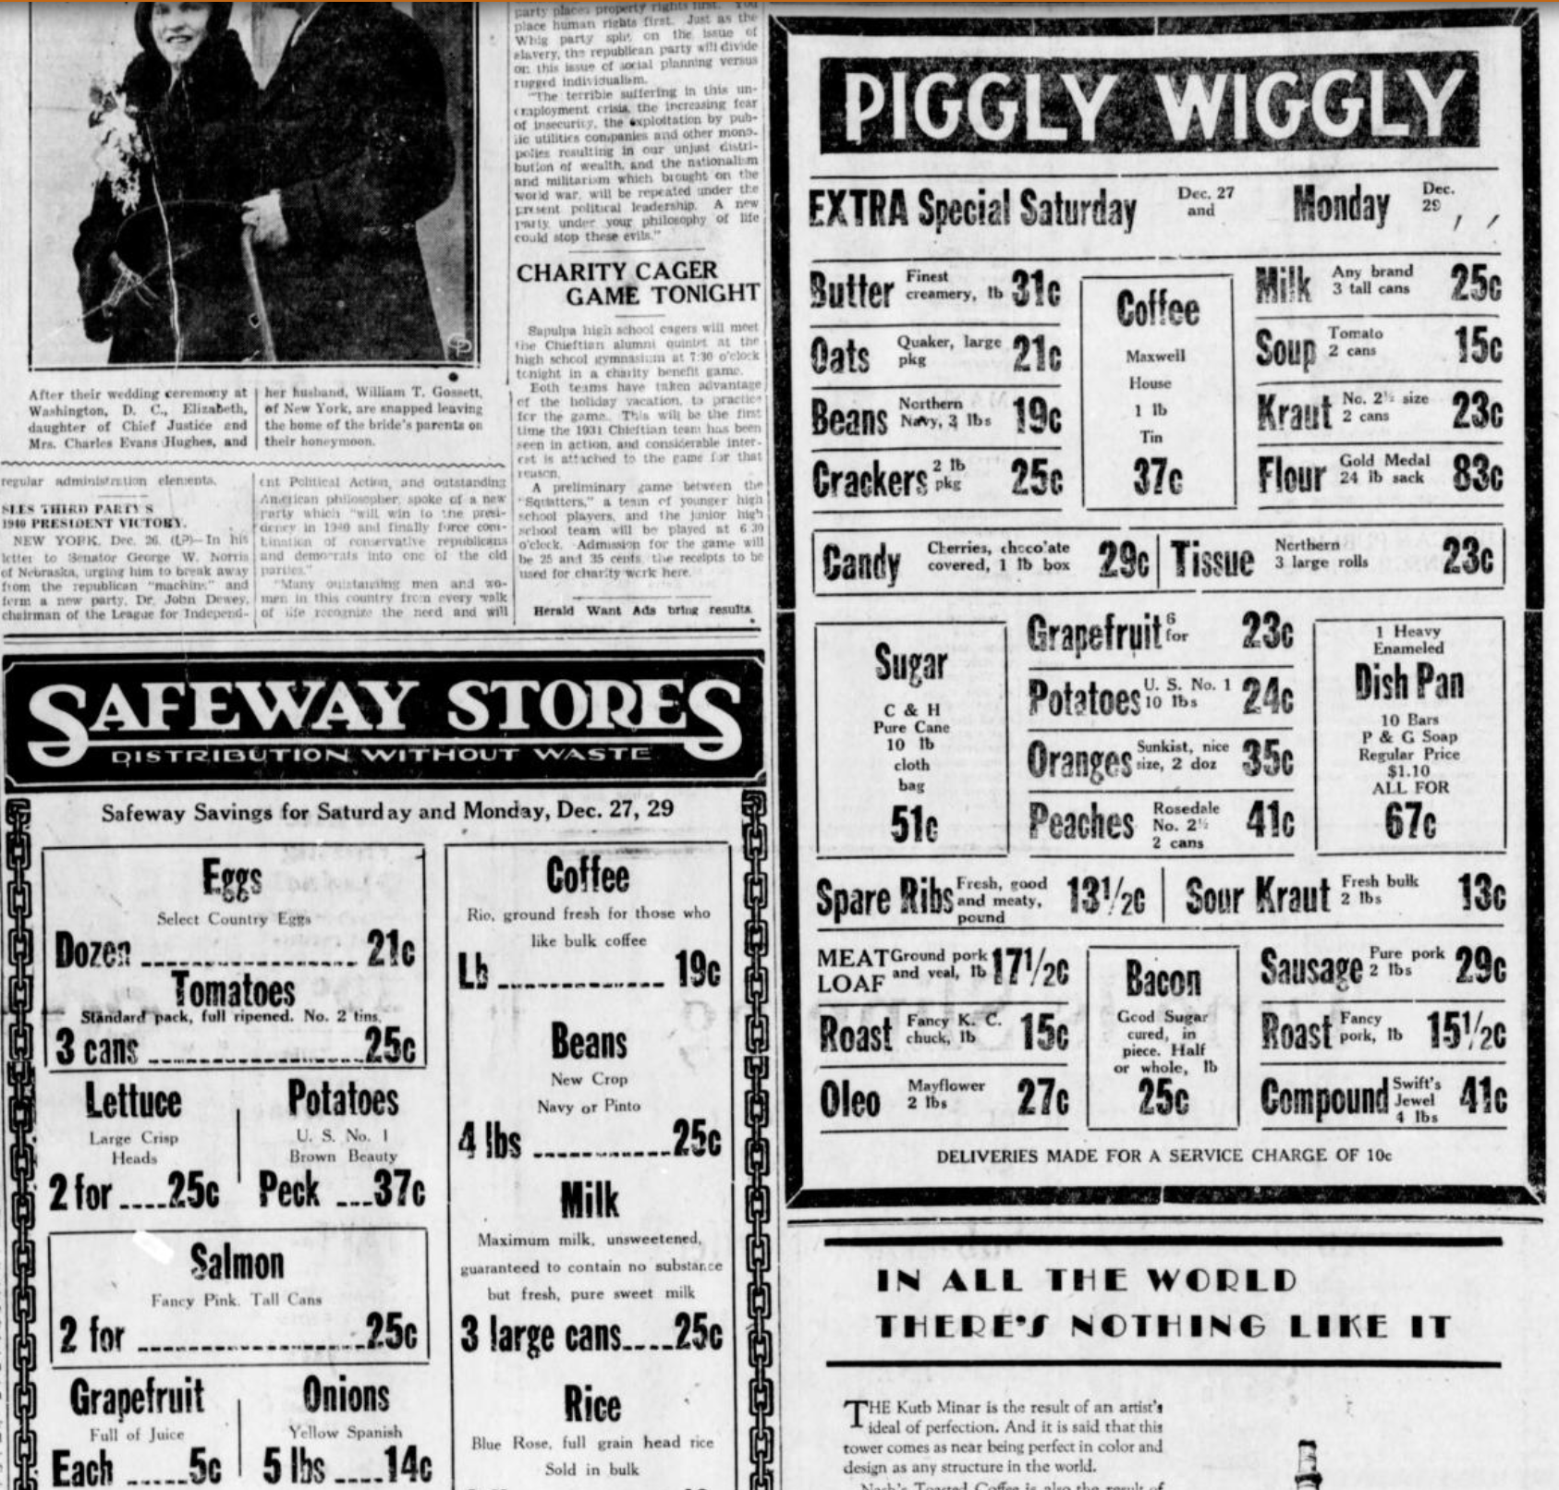

Find the prices of milk, coffee, and bacon, and enter them in your chart. Also, since 5-lb. flour bags were usually advertised in later years, divide the value of flour by 5 so you’ll see how it roughly compares to prices later on, and enter that number in your chart.

1930s Ad 3: Sapulpa Herald, February 24, 1930, p. 5

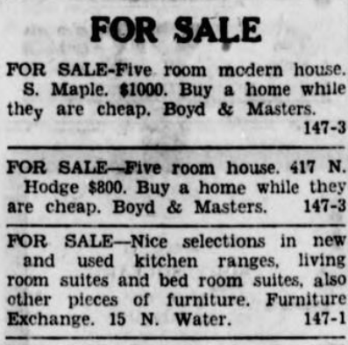

Enter both of the home prices in your chart.

1980s Ad 1: Sapulpa Herald, April 27, 1980, p. 18

Find the price of the 2-bedroom home in Sapulpa, and enter it in your chart.

1980s Ad 2: Sapulpa Herald, April 27, 1980, p. 32

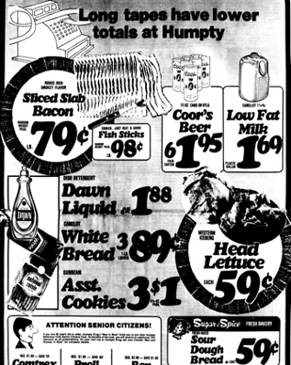

Find the prices of milk and bacon, and enter them in your chart.

1980s Ad 3: Sapulpa Herald, June 23, 1980, p. 6

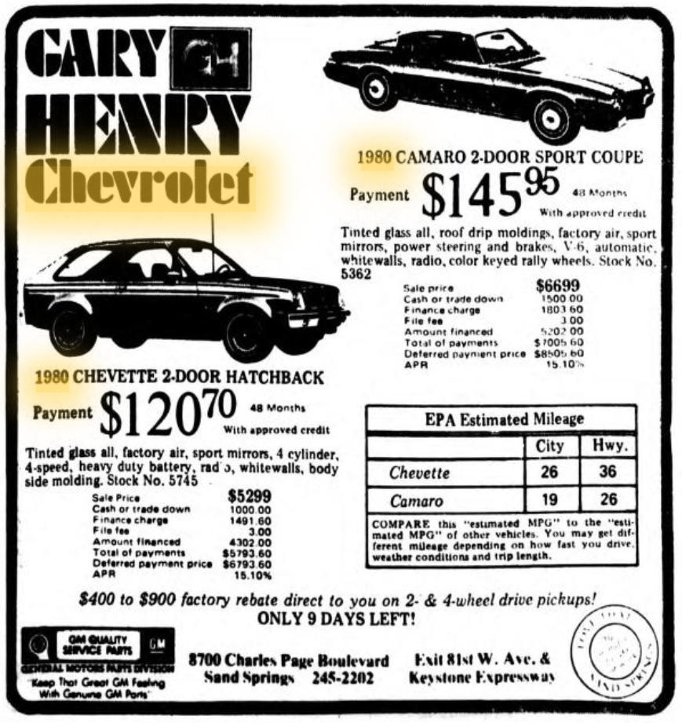

Find the total sale prices of both Chevrolets, and enter them in your chart.

1980s Ad 4: Oklahoma Eagle, February 14, 1980, p. 13

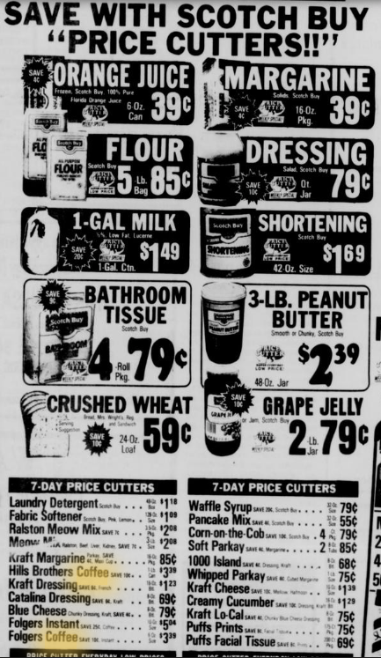

Enter the price of Hills Brothers coffee in your chart.

