group 3 vintage ad packet
1940s Ad 1: Sapulpa Herald, April 12, 1940, p. 8

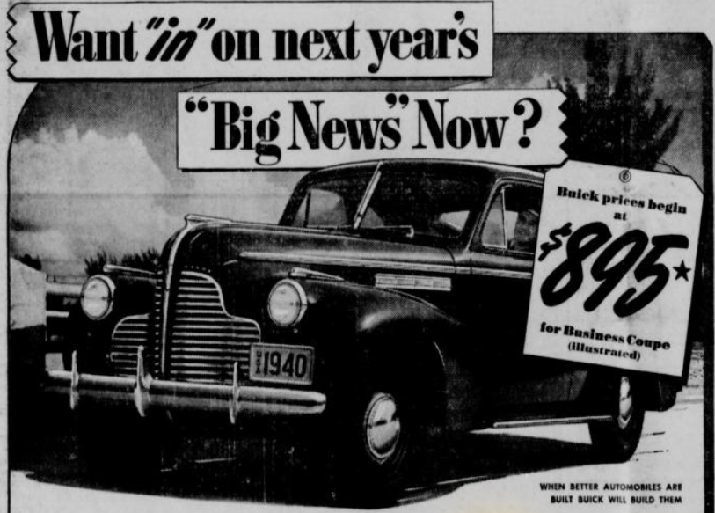

Find the price of the Buick, and enter it in your chart.

1940s Ad 2: Sapulpa Herald, April 12, 1940, p. 2

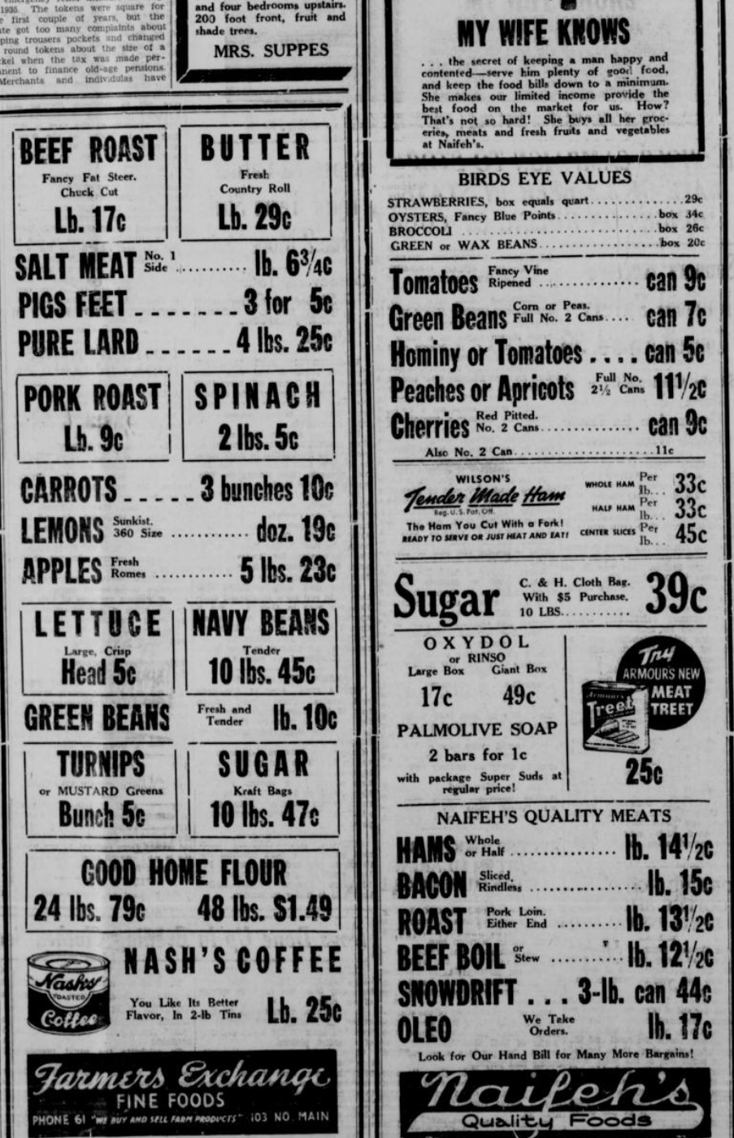

Find the values of bacon and coffee, and enter them in your chart. Also, since 5-lb. flour bags were usually advertised in later years, divide the value of flour by 5 so you’ll see how it roughly compares to prices later on, and enter that number in your chart.
1940s Ad 3: Sapulpa Herald, April 12, 1940, p. 6

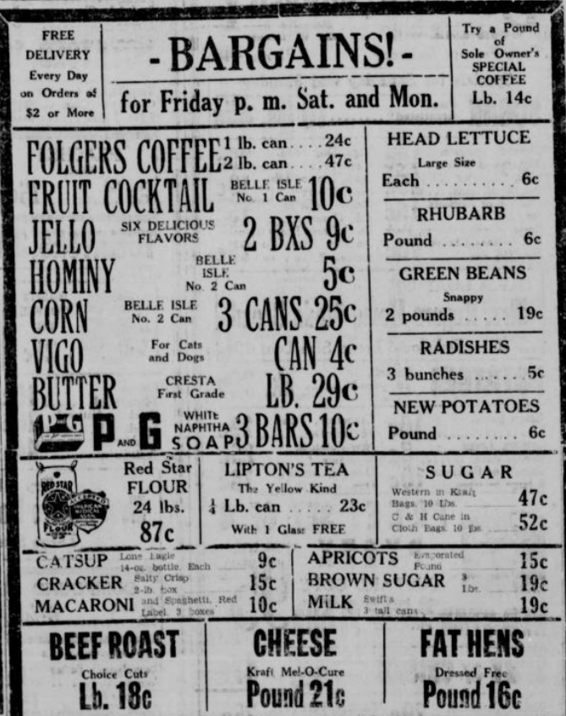

Find the cost of milk, and enter it in your chart.

1940s Ad 4: Sapulpa Herald, March 1, 1940, p. 7

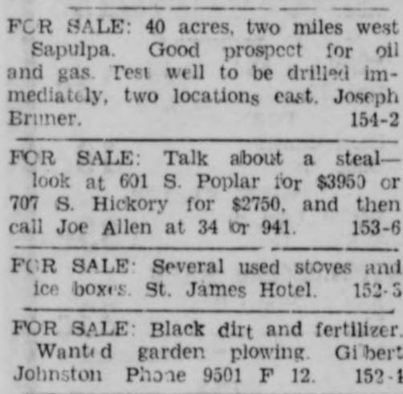

Enter the prices of both homes in your chart.

1990s Ad 1: Sapulpa Herald, July 1, 1990, p. 5

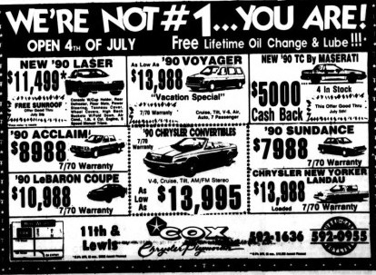

Determine the range of prices for the listed cars, and enter them in your chart.

1990s Ad 2: Sapulpa Herald, February 14, 1990, p. 5

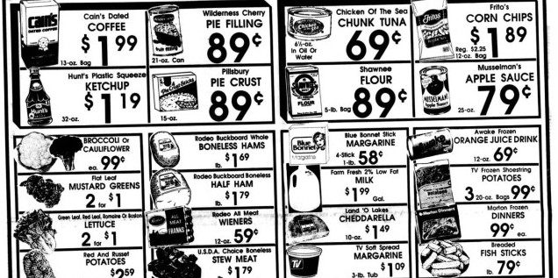

Find the prices of coffee, milk, and flour, and enter them in your chart.

1990s Ad 3: Sapulpa Herald, February 14, 1990, p. 9



Enter the price of the home in your chart.

1990s Ad 4: Sapulpa Herald, January 7, 1990, p. 14

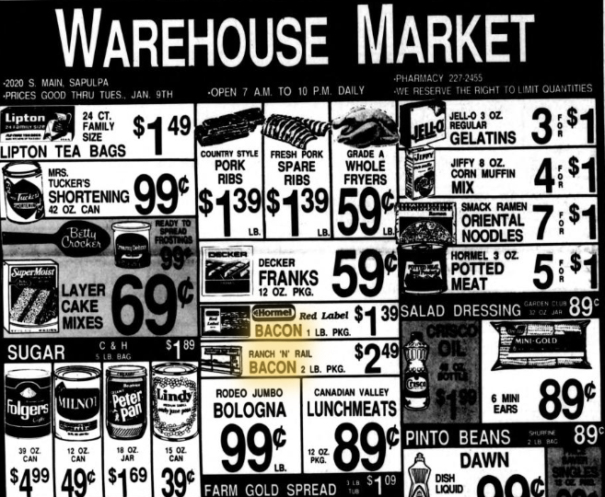

Enter the price of Hormel bacon in your chart.

