group 4 vintage ad packet
1950s Ad 1: Democrat News, December 21, 1950, p. 6
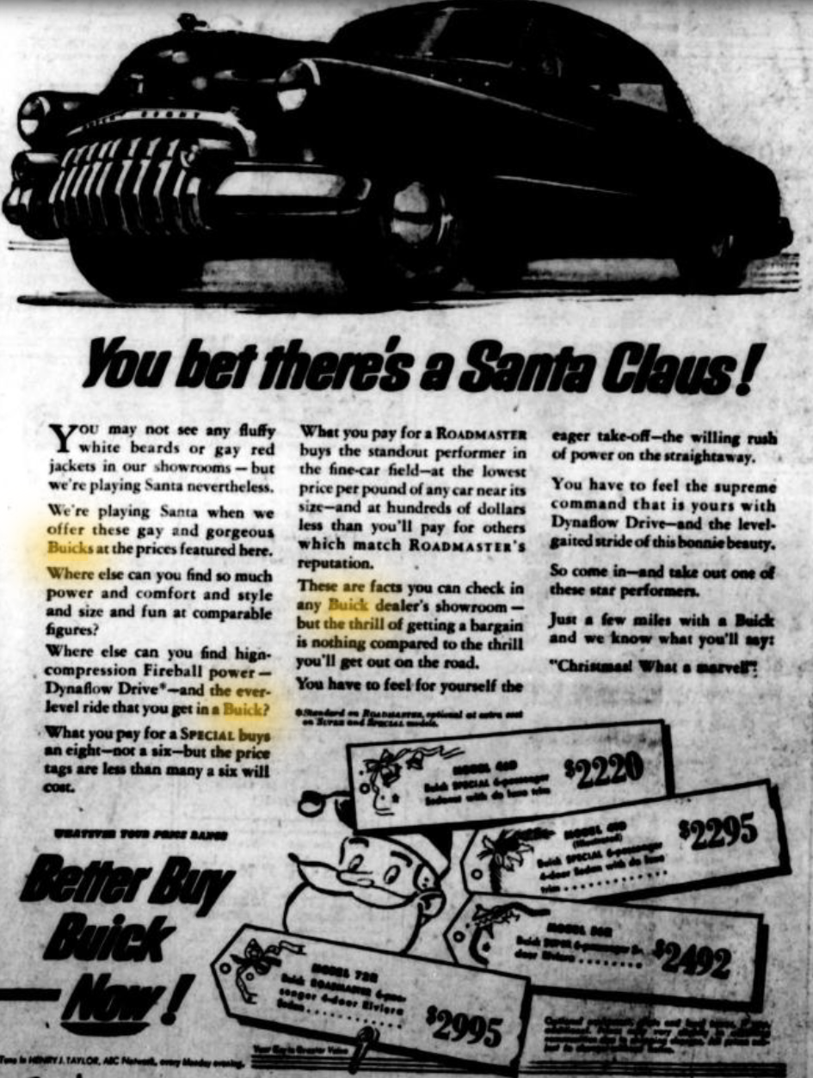
Find the price range of the Buicks, and enter it in your chart.

1950s Ad 2: Sapulpa Herald, November 2, 1950, p. 12

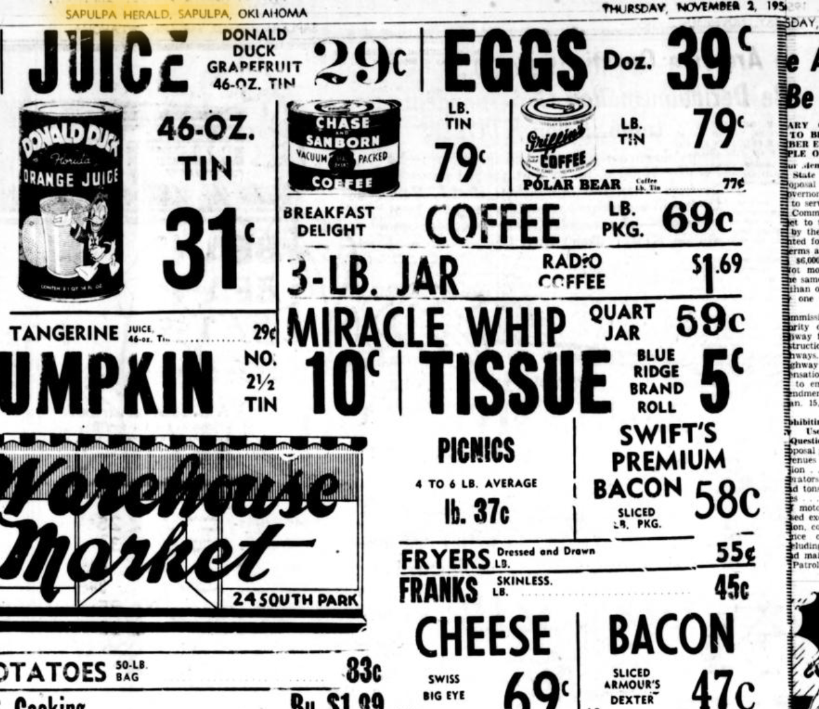

In your chart, enter the range of prices listed for a pound of coffee and a pound of bacon.

1950s Ad 3: Sapulpa Herald, November 2, 1950, p. 6

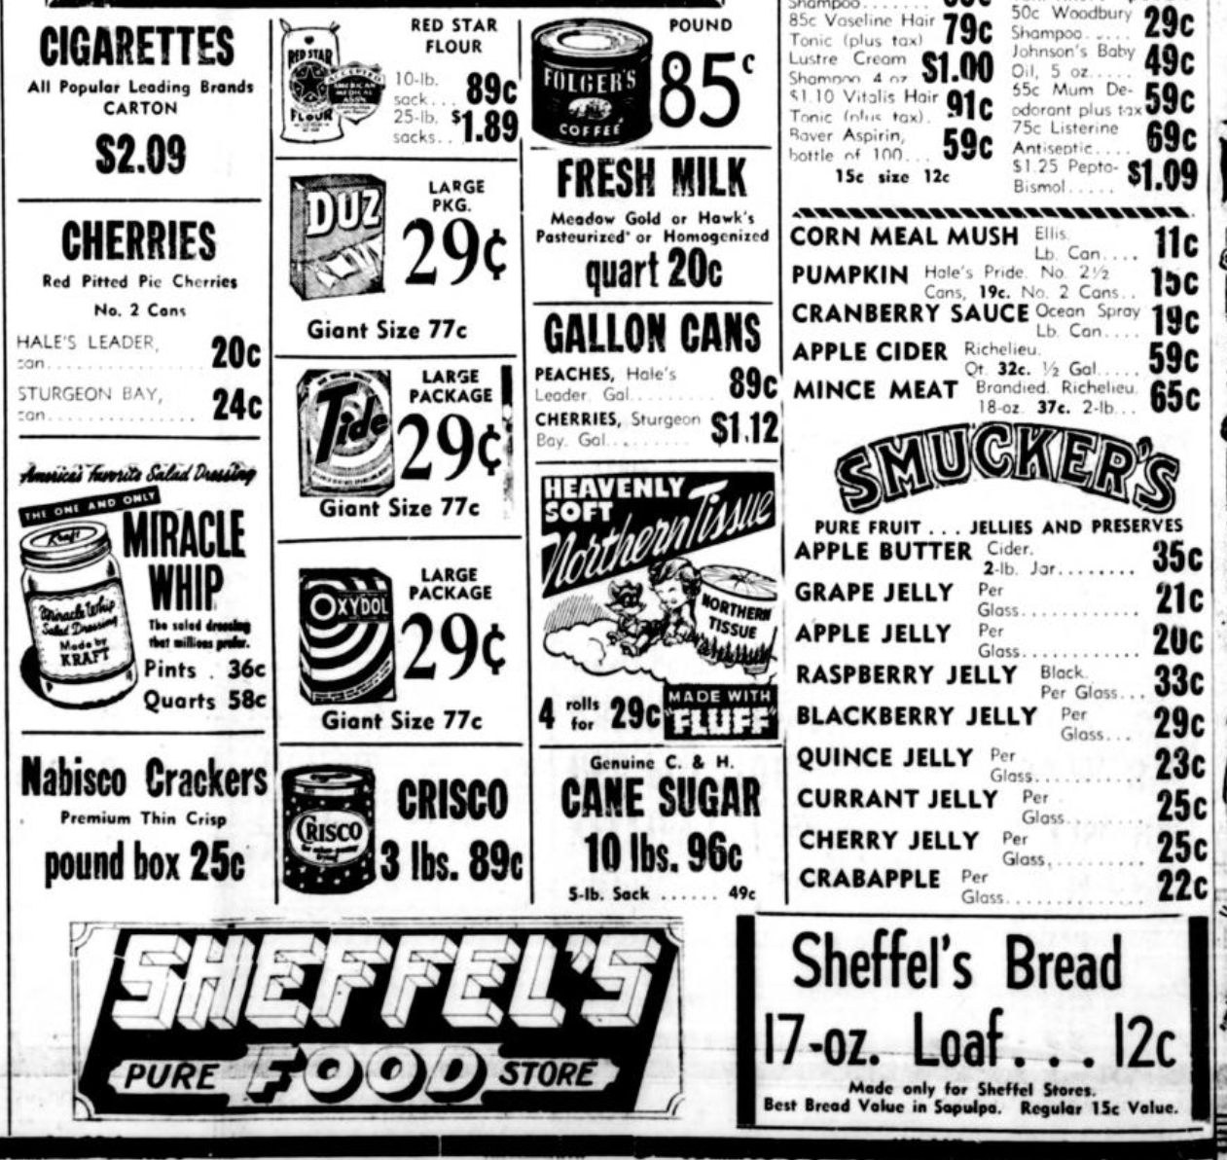

Find the cost of milk, and enter it in your chart. Also, since 5-lb. flour sacks were usually advertised in later years, divide the value of the 10-lb. sack of flour in half so you’ll see how it roughly compares to prices later on, and enter that number in your chart.

1950s Ad 4: Oklahoma Eagle, March 9, 1950, p. 2

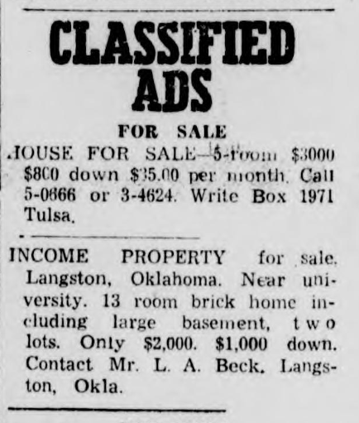

Enter the prices of both homes in your chart. (Leave out the down payments and per-month value.)

2000s Ad 1: Sapulpa Herald, February 6, 2000, p. 5

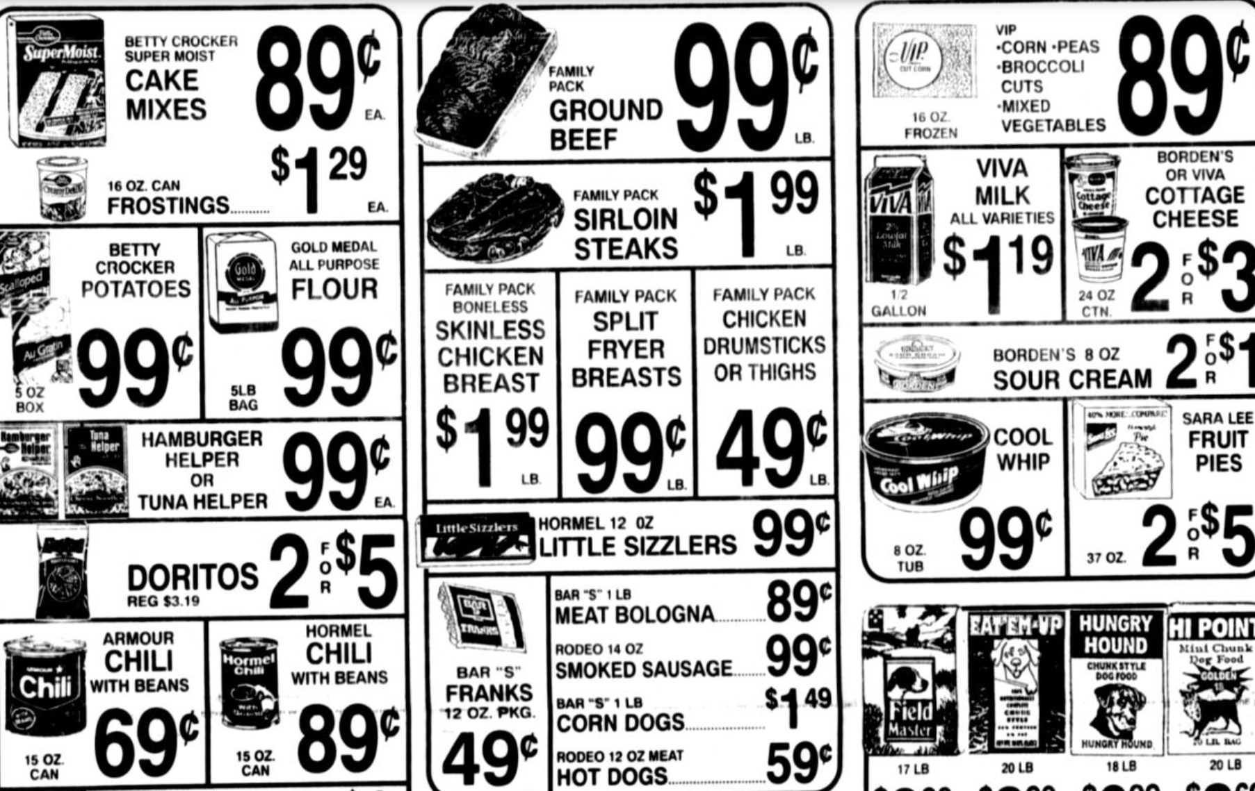

Find the prices of milk and flour, and enter them in your chart.

2000s Ad 2: Sapulpa Herald, February 6, 2000, p. 15



Find the cost of the house, and enter it in your chart.

2000s Ad 3: Sapulpa Herald, May 19, 2000, p. 14

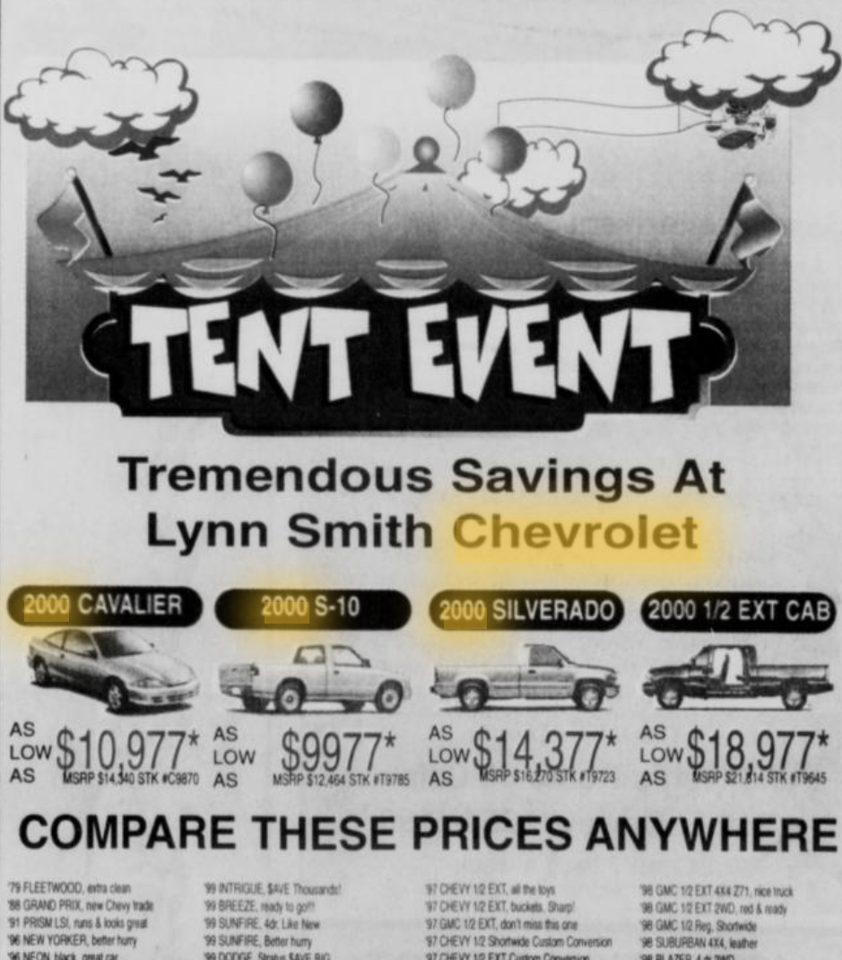

Enter the range of prices for the Chevrolets in your chart.
2000s Ad 4: Sapulpa Herald, January 9, 2000, p. 5

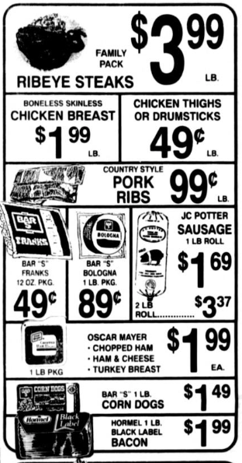

Enter the price of Hormel bacon in your chart.

2000s Ad 5: Sapulpa Herald, January 16, 2000, p. 5

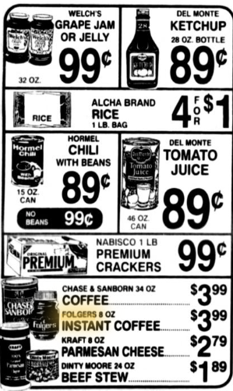

Divide the price of Chase & Sanborn coffee in half to see approximately how much a pound of coffee would cost. Enter that value in your chart.

