group 5 vintage ad packet
1960s Ad 1: Sapulpa Herald, August 11, 1960, p. 5

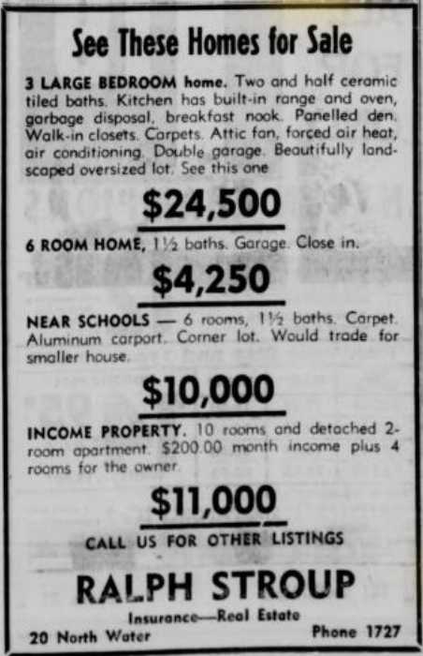

Determine the price range of the homes, and enter it in your chart.

1960s Ad 2: Sapulpa Herald, August 11, 1960, p. 10

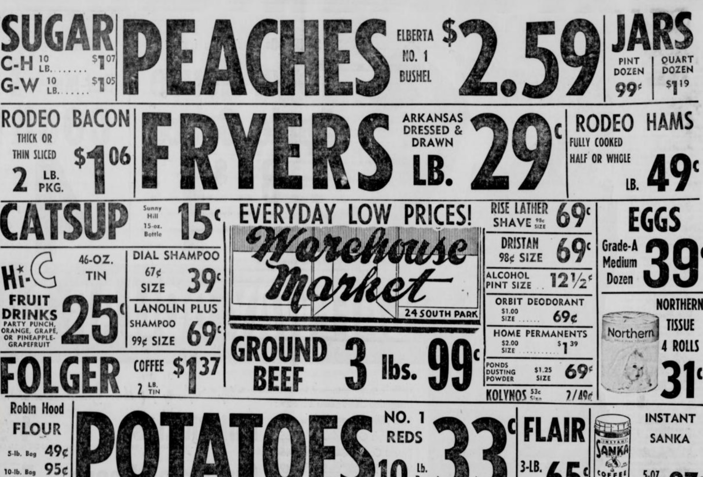

Divide the price of coffee in half, and enter the value in your chart. Find the price of a 5-lb. bag of flour, and enter it in your chart.

1960s Ad 3: Oklahoma Eagle, April 7, 1960, p. 7

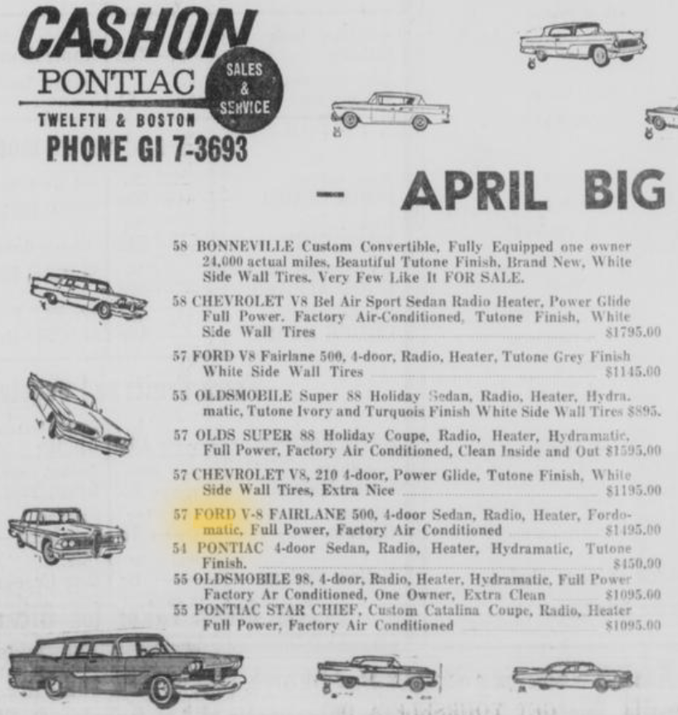

Enter the cost of the ’58 Chevy in your chart.

1960s Ad 4: Oklahoma Eagle, November 3, 1960, p. 11

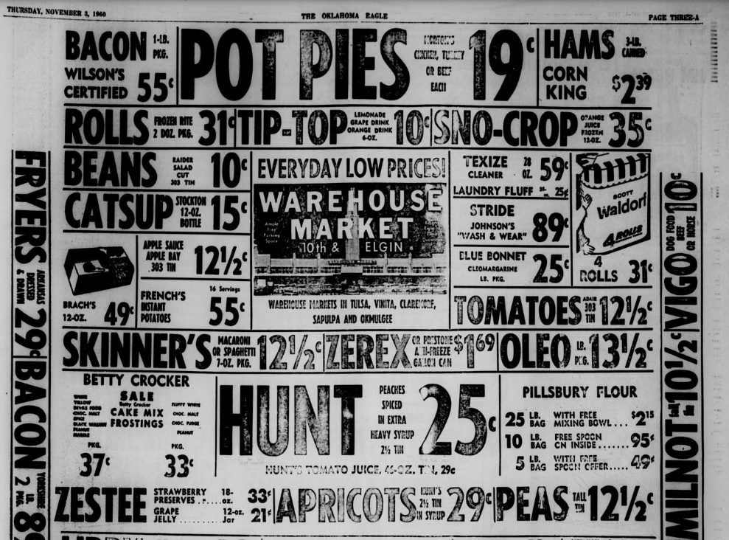

Enter the price of Wilson’s Certified bacon in your chart.

1960s Ad 5: Sapulpa Herald, April 14, 1960, p. 10

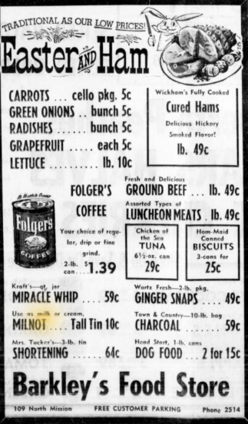

Enter the price of the Milnot evaporated milk in your chart.

2010s Ad 1: Sapulpa Herald, March 14, 2010, p. 16

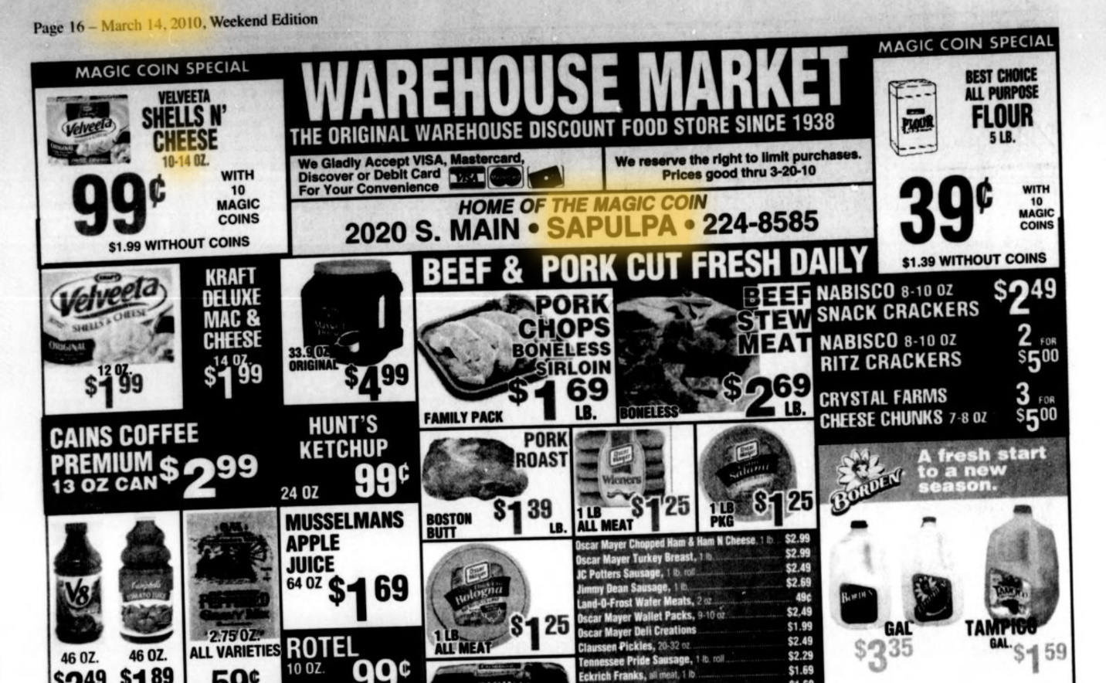

Find the prices of coffee, milk, and flour (without coins), and enter them in your chart.

2010s Ad 2: Sapulpa Herald, September 23, 2010, p. 12

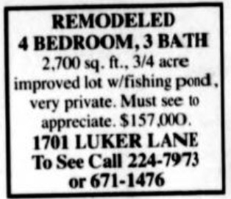

Find the cost of the house, and enter it in your chart.

2010s Ad 3: Sapulpa Herald, November 25, 2010, p. 16

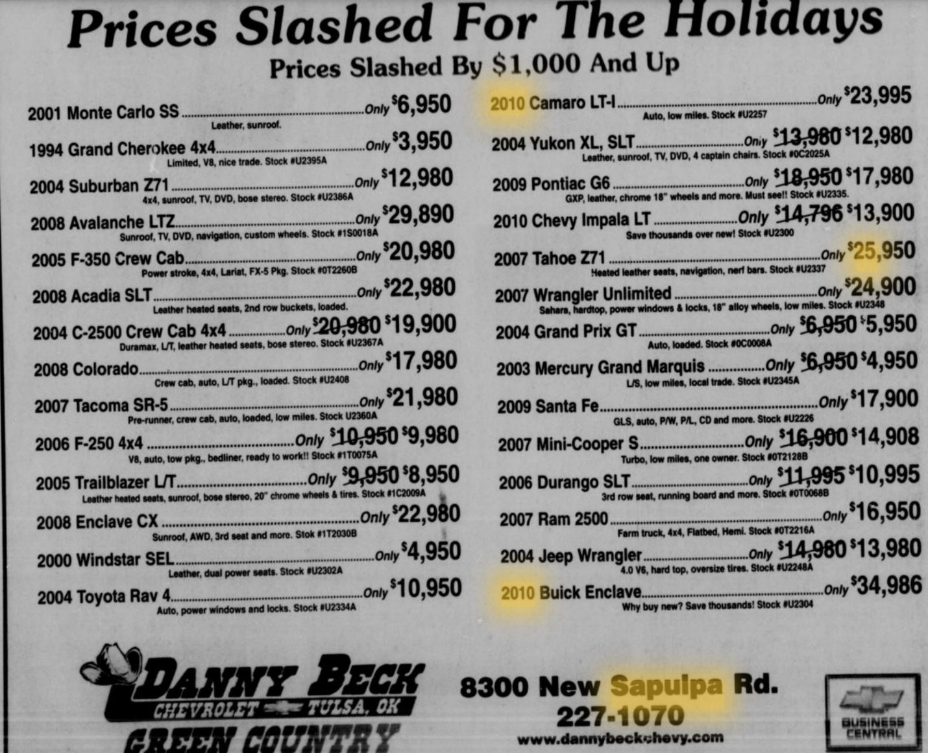

Find the range of prices for the 2010 cars, and enter it in your chart.

2010s Ad 4: Sapulpa Herald, January 3, 2010, p. 14

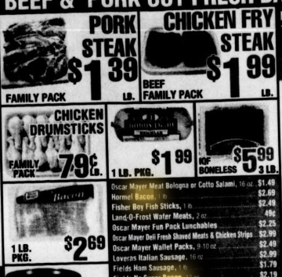

Enter the price of Hormel bacon in your chart.

