Wave Vocabulary Teacher guide
Term | Definition | Examples
Oscillation | Consistently repeating vibration or motion
Medium | A physical substance that carries the wave; The wave medium always returns to its original position after the wave passes through it. | Almost any kind of matter, air, water, or solids, such as steel or rock.
Transverse waves | Bouncy waves; The medium vibrates up and down. | 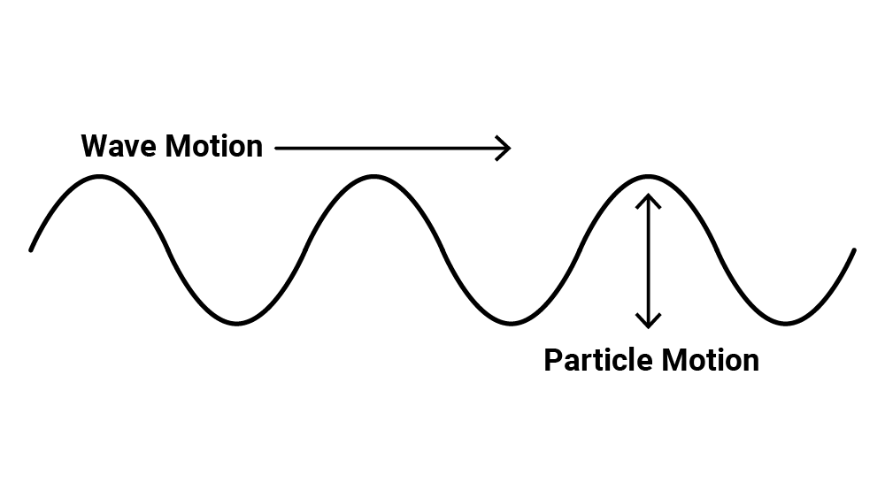
Longitudinal waves | Stretchy waves; The medium expands (stretches) and compresses (squeezes). | 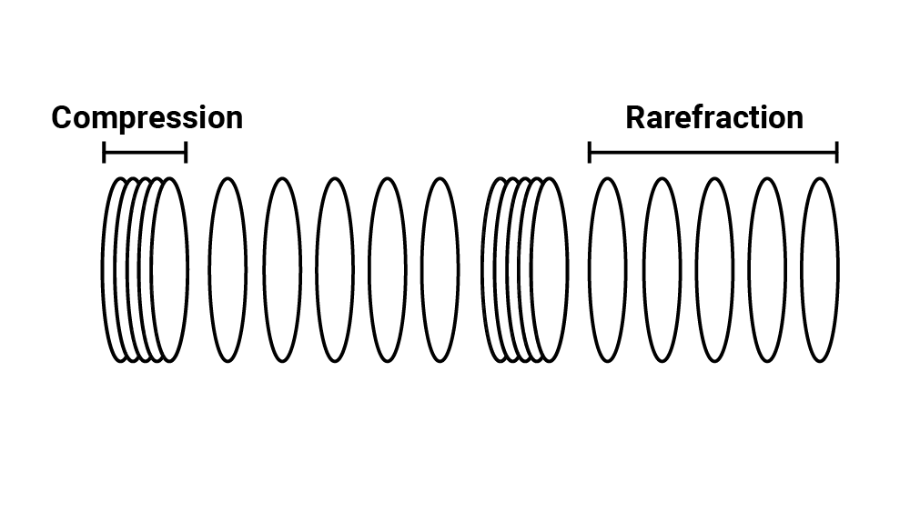
Wave pulse | A short duration vibration that creates a single displacement traveling through the medium | 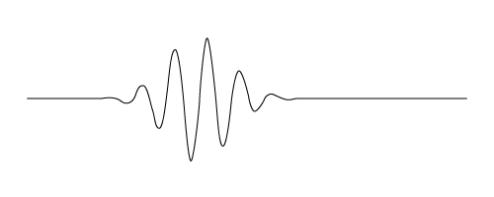
Driven wave | A constant oscillation that creates a continuous displacement or vibration of the medium | 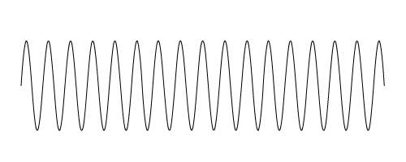
Velocity | The speed that something travels  If we know the speed something is traveling and the total time the object was moving, we can determine the distance it traveled. | Velocity = distance/time  Distance = velocity · time
Wavelength: λ “lambda” | The horizontal distance between start and end points of one full wave cycle | 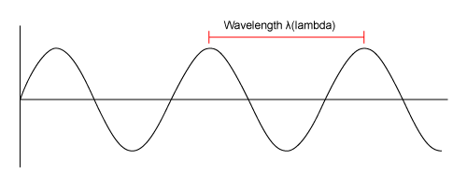
Amplitude: A | The vertical height of a wave, measured from the center line to the top of a peak or the bottom of a trough | 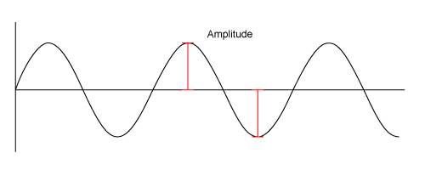
Frequency: f | The number of wavelengths that passes a fixed point in one second | 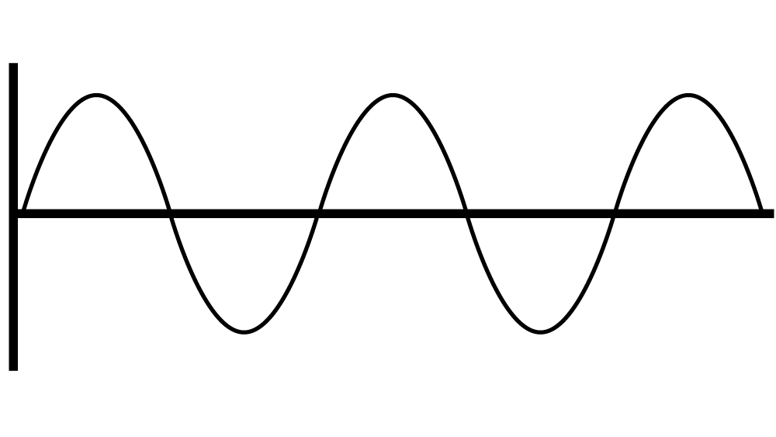
The wave equation | Velocity = Frequency · Wavelength  - Velocity is represented by a V  - Frequency is represented by f  - Wavelength is represented by λ, which is the Greek letter “lambda” | v = f λ
Triangle of Power | Visual representation of equations to calculate velocity, frequency, and distance of wavelengths | 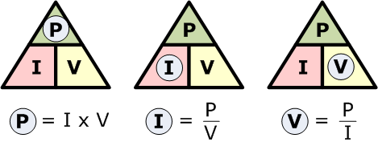
Inverse relationship | For two interconnected quantities, as one gets bigger, the other gets proportionally smaller, and vice-versa. | f → λ λ→f
Interference | When two or more waves combine additively
Constructive interference | Waves combine peak + peak or trough + trough to produce a wave of larger amplitude. | 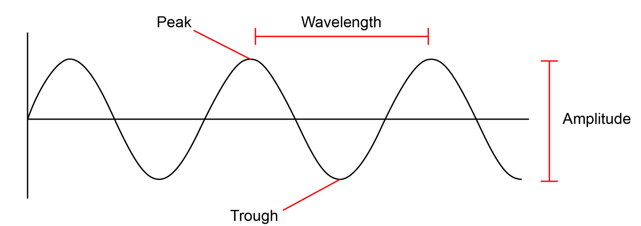
Destructive interference | Waves combine peak + trough so that amplitudes cancel one another.
Interference patterns | When two or more freely traveling waves interfere and merge via constructive and destructive interference
Reflection | When a wave bounces off a barrier and changes direction of travel; A wave that encounters a hard barrier is flipped on itself.
Phase | The position of one wave in relation to another
In phase | Peaks and troughs directly line up.
Out of phase | Peaks and troughs do not line up.
180° out of phase | Peaks and troughs are exactly opposite.
Resonance | When a system vibrates at a single frequency we call this a standing wave; only wavelengths that fit within an object will resonate.
Refraction | The fact or phenomenon of light, radio waves, etc. being deflected in passing obliquely through the interface between one medium and another through a medium of varying density
Absorption | The process or action by which one thing soaks up or blots out another
Emission | Something that has been emitted, released, or discharged

