WAVE UNIT VOCABULARY (Teacher’s Guide)
Word | Definition | Examples
Oscillation | Consistently repeating vibration or motion.
Medium | A physical substance that carries the wave. The wave medium always returns to its original position after the wave passes through it. | Almost any kind of matter: air, water or other liquids, or solids, such as steel or rock.
Transverse Waves | Bouncy waves; the medium vibrates up and down. | 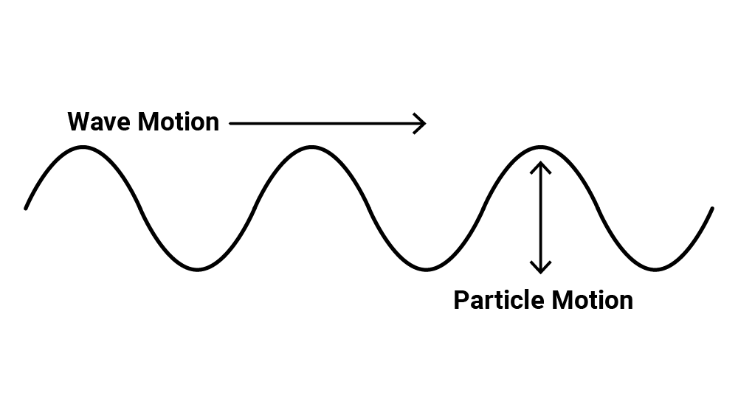
Longitudinal Waves | Stretchy waves; the medium compresses (squeezes) and expands (stretches). | 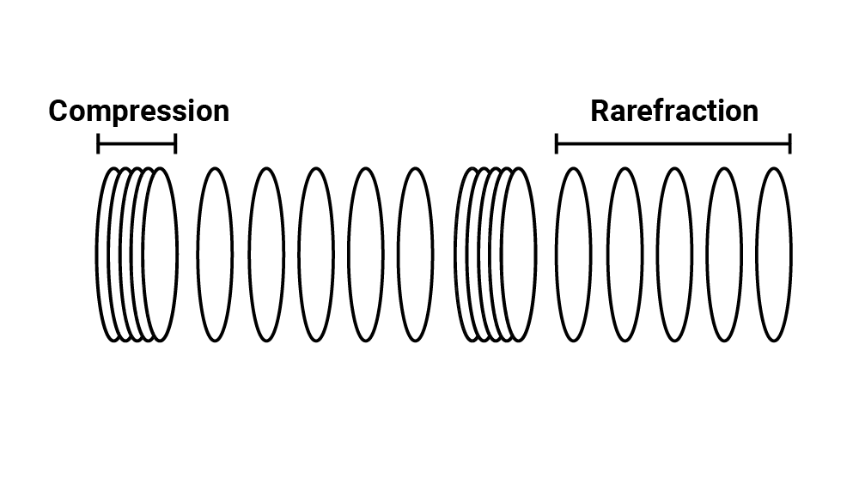
Wave Pulse | A short-duration vibration creates a single displacement, which then travels through the medium as a wave. | 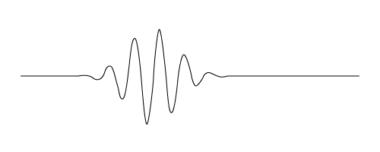
Driven Wave | A constant oscillation that creates a continuous displacement or vibration of the medium. | 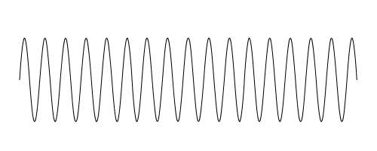
Velocity | The speed at which something travels.  If we know the speed at which something was traveling and the total time the object was moving, we can determine the distance it traveled. | Velocity = distance/time  Distance = velocity · time
Wavelength  λ  “lambda” | The horizontal distance between start and endpoints of one full wave cycle. | 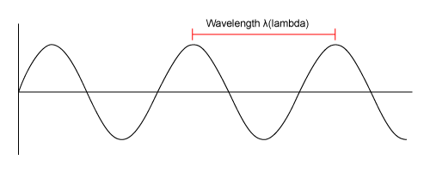
Amplitude  A | The vertical height of a wave, measured from the center line to the top of a peak or the bottom of a trough. | 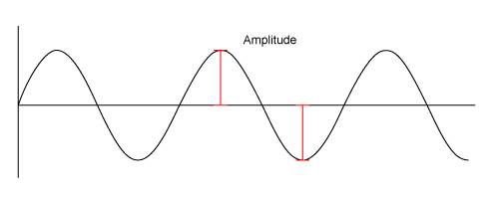
Frequency  f | The number of wavelengths that passes a fixed point in one second. | 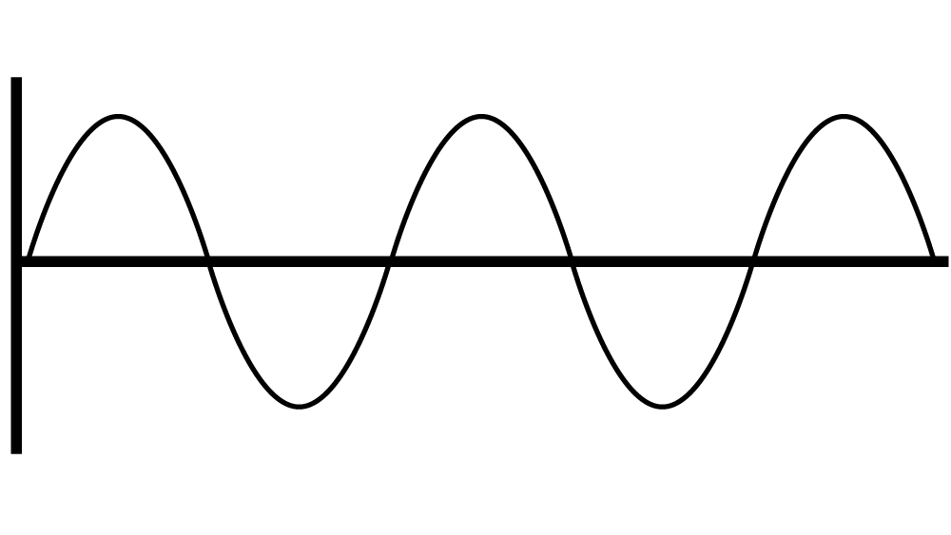
The Wave Equation | Velocity = Frequency · Wavelength  - Velocity is represented by a V.  - Frequency is represented by f.  - Wavelength is represented by λ, which is the Greek letter “lambda.” | v = f λ
Triangle of Power | Visual representation of equations to calculate velocity, frequency, and distance of wavelengths. | 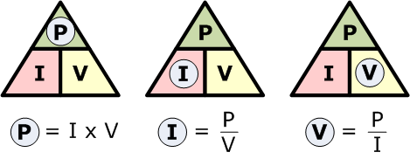
Inverse Relationship | For two interconnected quantities, as one gets bigger, the other gets proportionally smaller, and vice versa. | f → λ λ→f
Interference | When two or more waves combine additively.
Constructive Interference | Waves combine peak + peak or trough + trough to produce a wave of larger amplitude. | 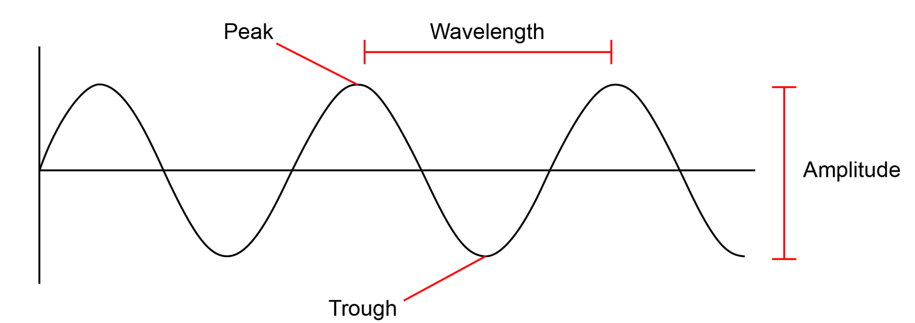
Destructive Interference | Waves combine peak + trough so that amplitudes cancel one another.
Interference Patterns | When two or more freely traveling waves interfere and merge via constructive and destructive interference.
Reflection | When a wave bounces off a barrier and changes direction of travel; a wave that encounters a hard barrier is flipped on itself.
Phase | The position of one wave in relation to another.
In Phase | Peaks and troughs directly line up.
Out of Phase | Peaks and troughs do not line up.
180° Out of Phase | Peaks and troughs are exactly opposite.
Resonance | When a system vibrates at a single frequency, we call this a standing wave.  Only wavelengths that fit within an object will resonate.
Refraction | The fact or phenomenon of light, radio waves, etc. being deflected in passing obliquely through the interface between one medium and another through a medium of varying density.
Absorption | The process or action by which one thing soaks up or blots out another.
Emission | Something that has been emitted, released, or discharged.

