long spring activity
Group Members: _______________________________________________________________
Objective: Multiple waves can occupy the same space. How do they do it? In this activity, you will observe the changes in the amplitude of two waves that meet in the middle of a long spring.
Materials: Long spring, meter stick, masking tape, marker, activity sheet, pencil/pen

Part I: Making Waves

Set-up:
- Place a 1-meter-long piece of masking tape on the floor.
- Mark the center of this piece of tape and label it “0”.
- Starting from 0 and moving perpendicularly from the first piece of tape, measure 3 meters and place an identical 1-meter-long piece of tape on the floor parallel and centered to the first piece.
- Mark the center of this piece of tape and label it “3.”
- Repeat the process, this time starting from 3, and place an identical 1-meter-long piece of tape on the floor parallel and centered to the first two pieces.
- Mark the center of this piece of tape and label it “6.”
- When you are finished, the tape should look like the example below.
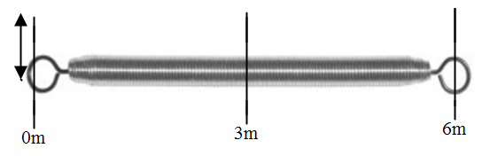

Positioning:
Student A: Hold one end of the long spring at the center of the “0” tape marker.
Student B: Hold the other end of the spring and stretch it to the center of the “6” tape marker.
Student C: Sit at the “3” marker and observe the displacement of the spring from the center mark during the activity.

Experimenting:
- Student C: Record your observations of the displacement along the 3m tape mark during the experiment.
- Student A: Continue to hold the spring tightly.
- Student B: Use a quick snapping movement to move the end of the spring from the center of the tape mark to one end of the tape mark and back to the center.
  - This snap should create a wave that travels down to Student A and back to you.
- What type of wave is this? ___________________________
- Practice making more of these waves with the spring until you can make consistent waves and allow Student A and Student B to switch roles.
- How does the displacement at the “3” tape marker compare to the displacement at the “0” tape marker?

- Draw 3 pictures of the wave as it travels down the spring.

- What happens to the peak of the wave when it is reflected?

Part II: Wave Interaction
- Student C: Record your observations of the displacement along the “3” tape marker.
- Student A and Student B: Snap the spring from the center of your tape marker to the end and back to the center at the same time and in the same direction.
- Practice your timing so that the two waves meet in the middle of the spring.
- How does the displacement compare to the displacement at the 0 m tape marker?

- Draw a picture of the waves before, during and after they meet in the middle.
- What do you think has happened to the two waves when they combine?

- Student A and Student B: Snap the spring from the center of your tape marking to the end and back to the center at the same time but in opposite directions.
- Practice your timing so that the two waves meet in the middle of the spring.
- How does the displacement compare to the displacement at the 0 m tape marker?

- Draw a picture of the waves before, during and after they meet in the middle.
- Does your hypothesis about what happened when the waves combined still make sense? Explain your reasoning.

