Teacher Guide: Wave interference activity
Group Members: _______________________________________________________________
Objective: Working in a group, you will explore different visual models that illustrate how two waves combine so that both can occupy the same space.

Model One
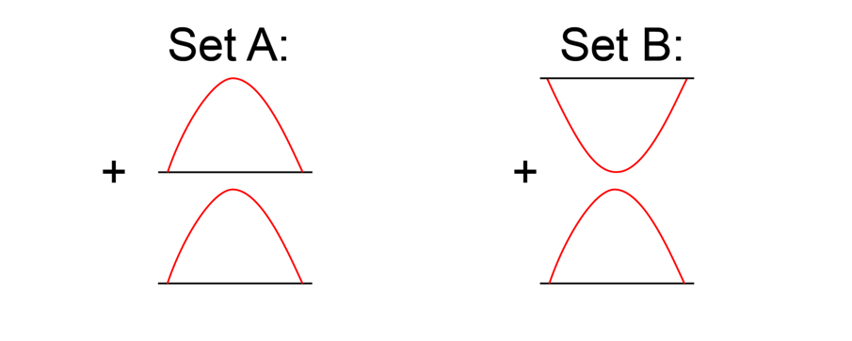
Two different ways that waves can interfere with each other.
Concept Questions
- Predict how the waves in Set A combine and sketch the result.

The waves will combine to form a wave with twice the magnitude.

- Predict how the waves in Set B combine and sketch the result.

The waves will combine and cancel out.

- Set A represents constructive wave interference. Define this term in your own words.

Constructive interference describes when waves combine that have amplitude in the same direction so that the result is a wave with a larger amplitude than the original waves.

- Set B represents destructive wave interference. Define this term in your own words.

Destructive interference describes when waves combine that have amplitudes opposite directions so that the result is a wave with a smaller amplitude than the original waves.
For the following, assume the two waves have the same frequency and velocity but are traveling in opposite directions.

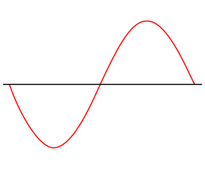
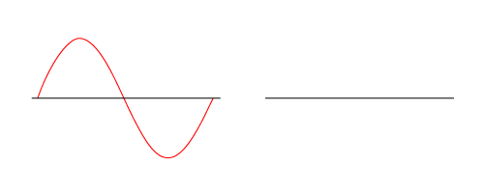
- Sketch a wave that will destructively interfere with the wave on the left.
- Sketch two waves that are different from the previous drawings that will destructively interfere when they meet.

Drawings will vary, but amplitudes of the waves should be inverted about the zero line so that they cancel.

- Sketch two waves that will only partially experience destructive interference.

Drawings will vary, but amplitudes of the waves should be inverted about the zero line so that they cancel.

- Sketch a wave that will constructively interfere with the following wave. 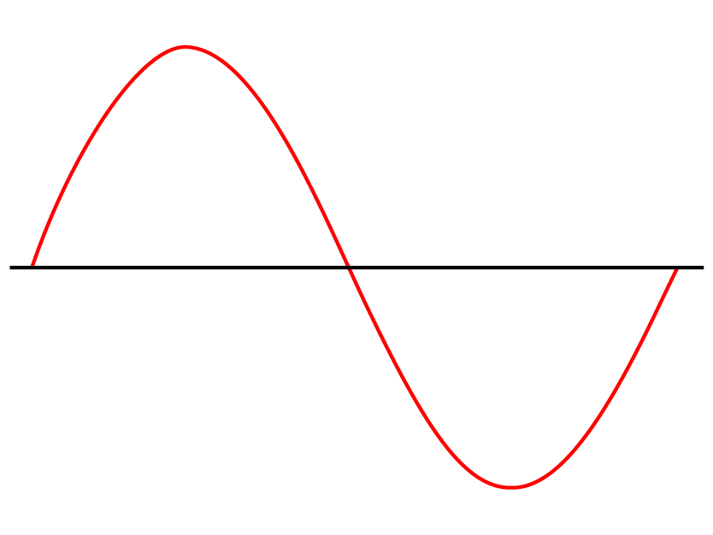

Model 2
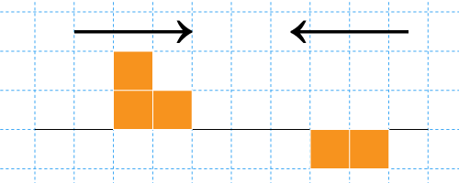
Wave interference using a different way to draw the area under peaks and troughs.

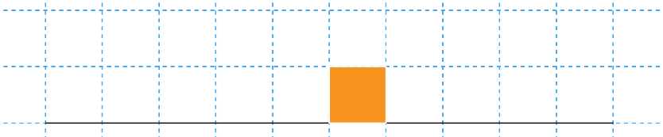
- Two pulse waves are sent through a spring in opposite directions as shown above. On the graph below, sketch the result of the pulse waves at the instant they combine. Is this constructive or destructive interference?

This is destructive interference. The 2 squares directly above the zero line cancel the two squares directly below it.
- Two pulse waves are sent through a spring in opposite directions as shown below. On the graph below, sketch the result of the pulse waves at the instant they combine. Is this constructive or destructive interference?
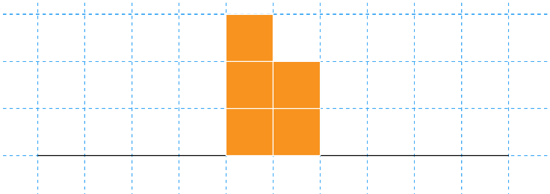
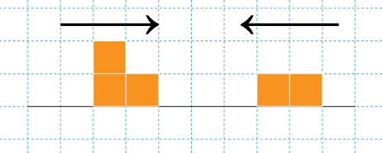
This is constructive interference. Since both wave amplitudes are above the zero line, they combine to produce a new amplitude that is the positive sum of both amplitudes.

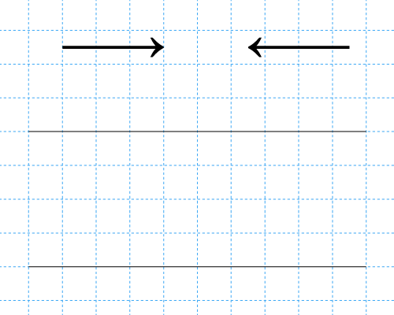
- Sketch an original pulse wave pattern using blocks to represent peak and trough area and show the result of the combined pulse waves.

Drawings will vary. Check that amplitudes above (positive) and below (negative) the zero line add correctly.

