Composite Figures
Find the area and perimeter of each of the following. Be sure to show your thinking.
1
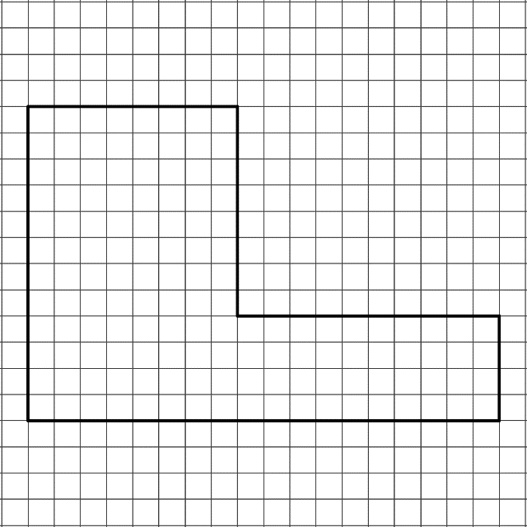  Area: __________  Perimeter: __________ | 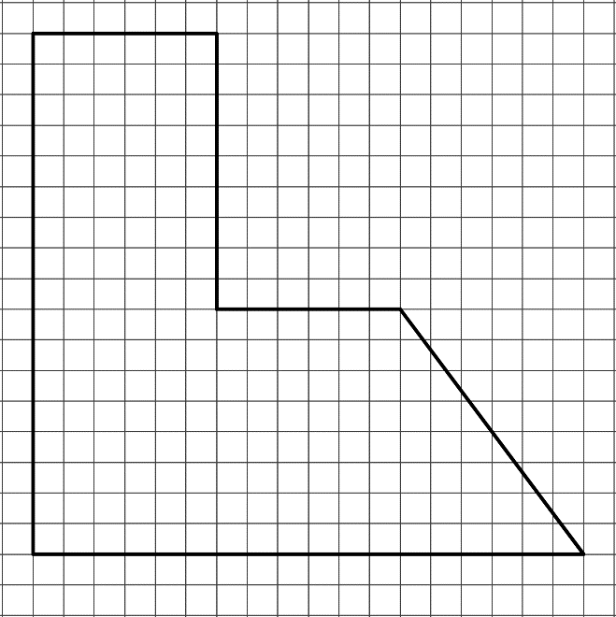  2  Area: __________  Perimeter: __________
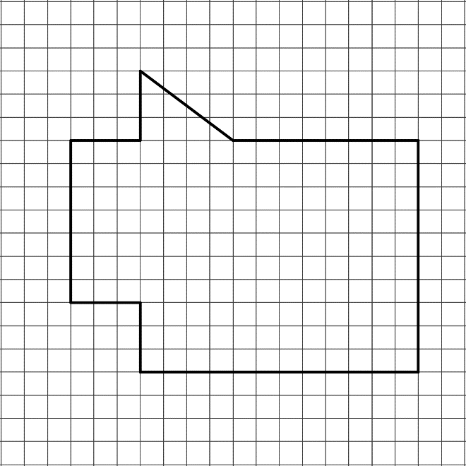  4  3  Area: __________  Perimeter: __________ | 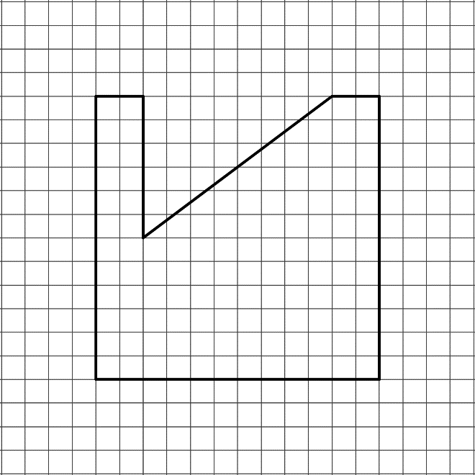  Area: __________  Perimeter: __________

