DIY Mirror
You are starting up your own DIY TikTok account and are on a tight budget. You want to show the world how to make their own mirror to liven up their living space. You found a regular octagonal mirror at a flea market, but the frame is broken. You have measured 11 inches as the side length, and the apothem is 26.5 inches. You need to order trim to build a frame and paint to make it pop. Your budget does not give any wiggle room for wasted materials. The trim you found is 3 inches wide, and you want the side lengths of the frame to each be 24.5 inches. How much trim do you need to order? How much paint will you need?

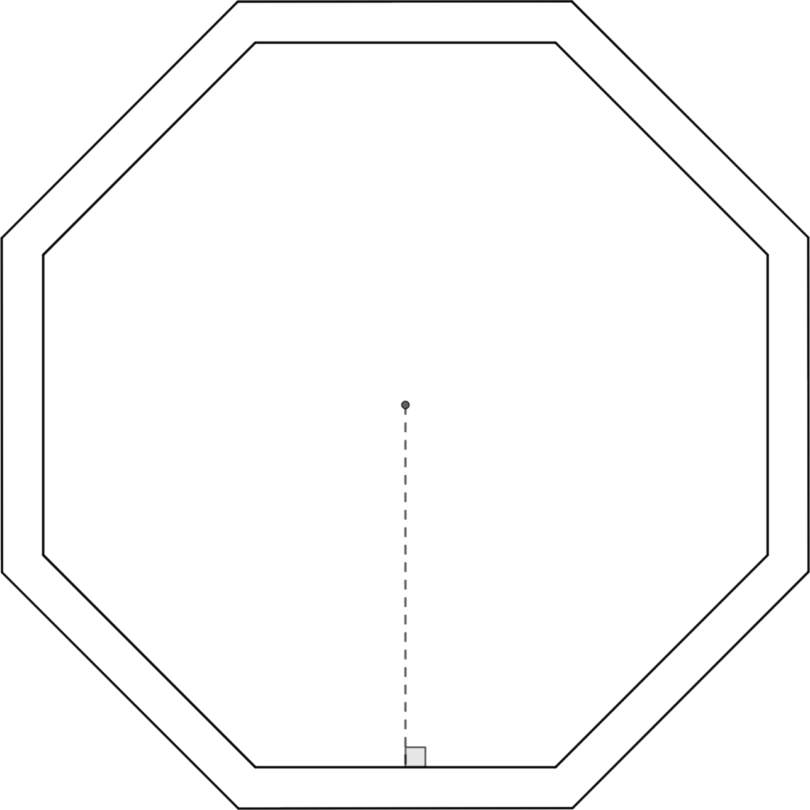

Length of Trim: __________
Enough Paint to Cover: __________

