Regular Polygons – Area & Perimeter: Guided Notes

Use what you know about triangles to find the area of the following regular polygon.

# A picture containing text, black, dark Description automatically generated1)





**apothem**: the perpendicular distance from the center of the polygon to any side of the polygon

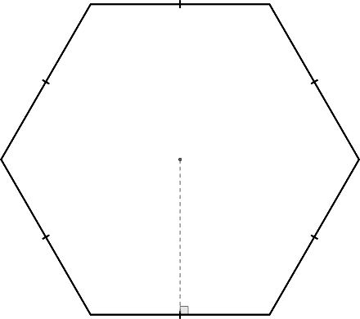

side length

apothem

 = apothem

 = side length

 = number of sides

**Area of a Regular Polygon**: 

**Perimeter of a Regular Polygon**: 

Find the area of the following regular polygon.

# 2)



