Polygon Pool Party
Your client has asked you to build a geometric pool. You design a beautifully symmetric pool, and from above, it looks like a half of a regular hexagon on each end of a rectangle. It is deep enough in the center of the pool to dive and shallow enough on the ends to stand. Your client loves the design and needs a quote for the cost of tiling the pool. You need to order tile based on the square footage of the pool. Find the area of each surface to determine the quantity of tile to order. Record your results on the next page.

Pool (3D)
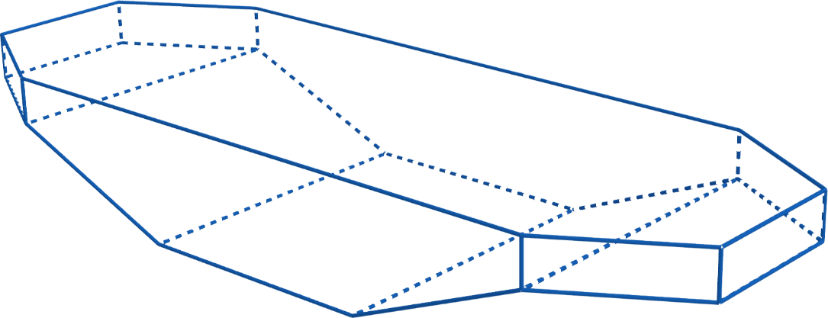

Pool (bottom)
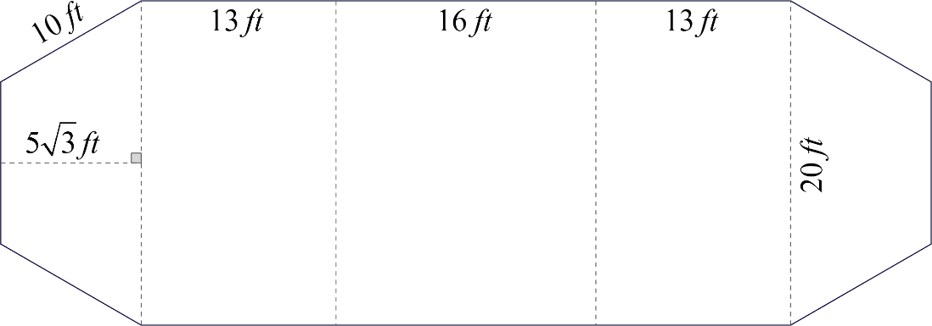

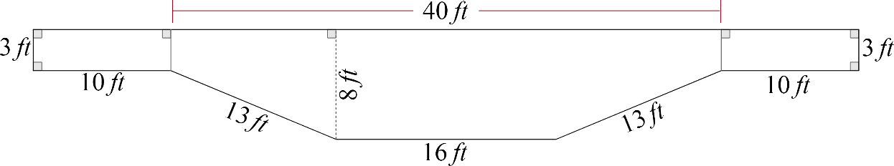
Pool (sides)

Pool (front/back)
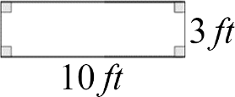

- Tile is $5 per square foot. Determine the cost for your client by multiplying your total area and the cost per square foot of the tile.
Surface | Square Footage (Area)
Bottom
Right Side
Left Side
Front Side
Back Side
Total Area:
x (Cost of Tile) | x $5.00/ft²
Total Cost:

Pool (above)
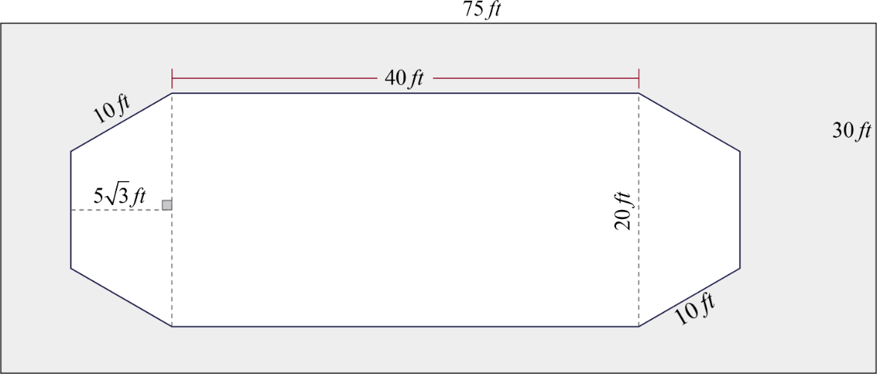
- Your client also wants a concrete patio around the pool. The pool and patio will take up a 30-foot by 75-foot space, as shown in the Pool (above) image. Find the area around the pool to determine how much concrete to order. Be sure to label your answer with the appropriate units.

Total Concrete Area: _________

