Finding Matches

Not Like the Others
Which of the following is not like the others?
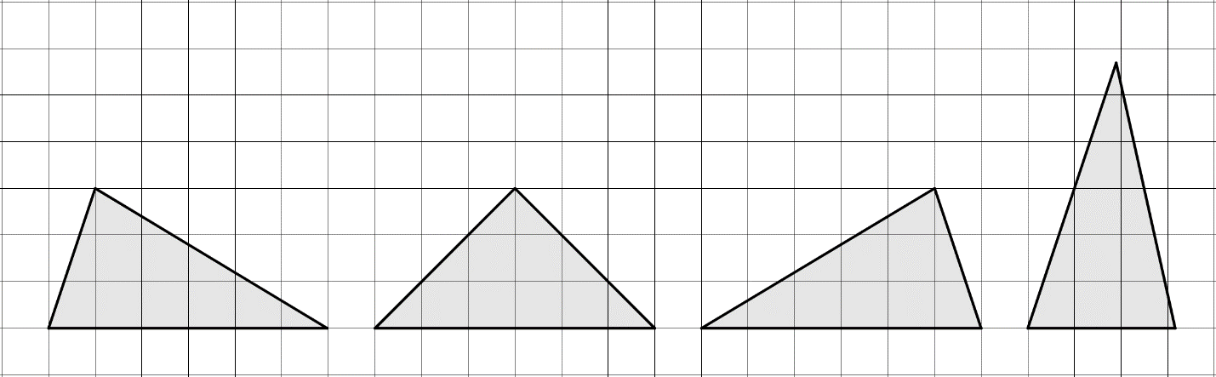
Explain your reasoning.

Equal Halves
Draw 1 line segment, connecting 2 points, to divide each polygon into 2 congruent polygons.
 | 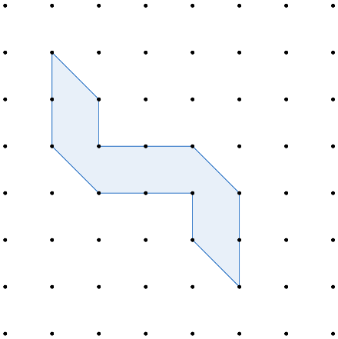 | 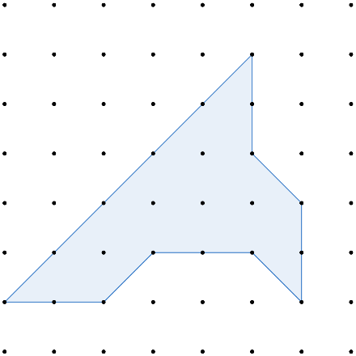

How do you know that the 2 halves are congruent?

