CONGRUENT POLYGONS: GUIDED NOTES
All of the following pentagons are congruent. Label each polygon and identify the corresponding parts. Write a congruence statement for each polygon.
ABCDE Rotated 90° CW
Polygon ABCDE
ABCDE ≅ __________
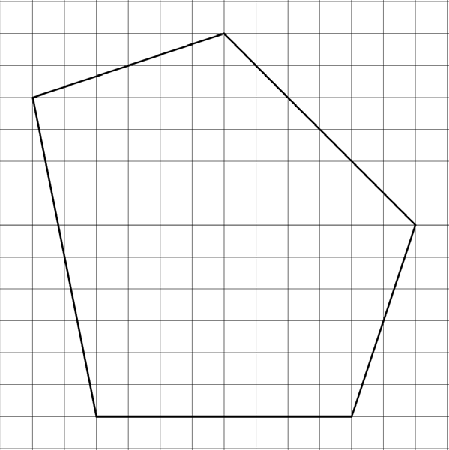
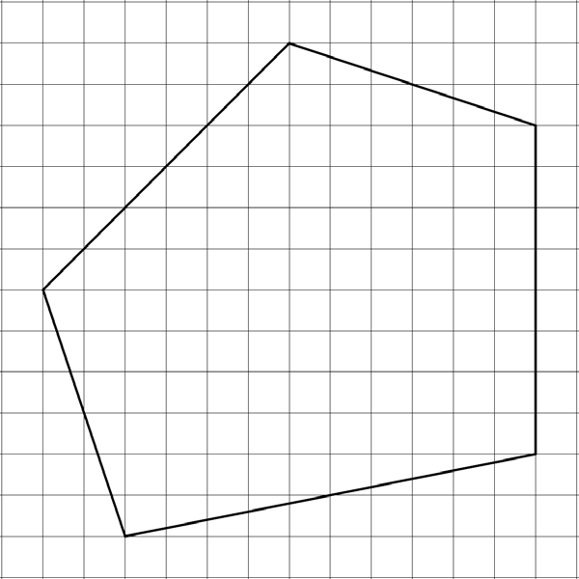
F
G
H
I
J
A
B
C
D
E
97
°
117
°
101
°

ABCDE Rotated 90° CCW  ABCDE ≅ __________ | ABCDE Rotated 180° CW  ABCDE ≅ __________
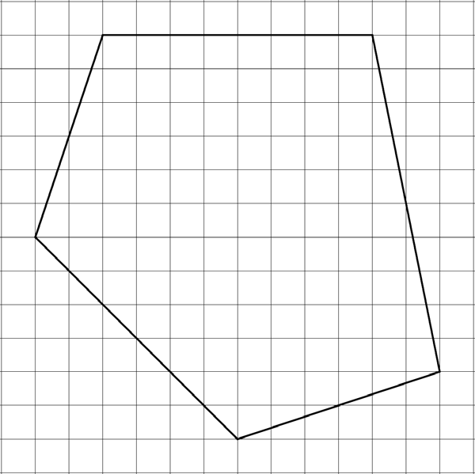

Polygons with the same shape and size are congruent. Congruent polygons have
congruent corresponding angles and sides.
Horizontal Reflection of ABCDE
ABCDE ≅ __________
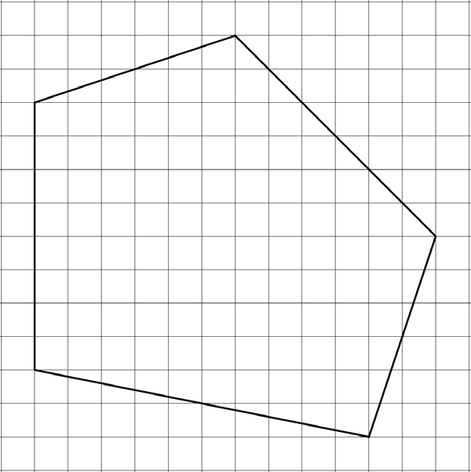
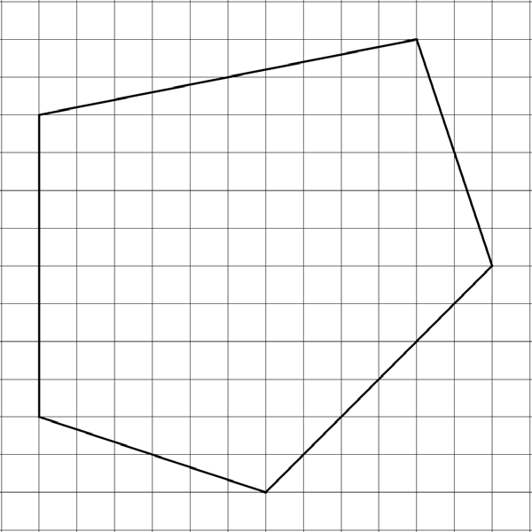
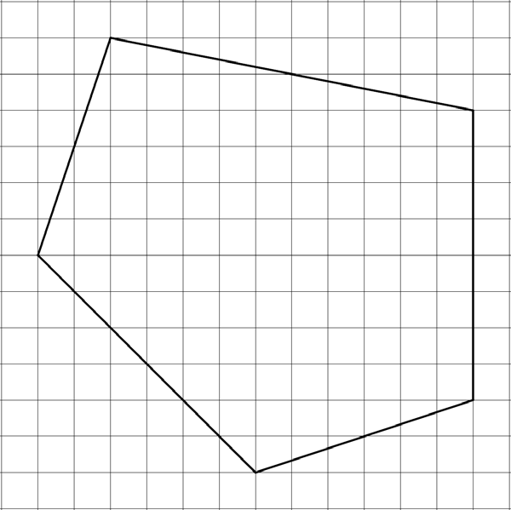
Vertical Reflection of ABCDE ABCDE ≅ __________

A

P
ERFECT
M
ATCH

