Trying Tessellations
Tessellations are the repetition of one or more shapes such that the shapes cover a surface with no gaps or overlap. The following tessellation is made up of 1 pentagon repeated, so all of the pentagons are congruent. Use this information to solve for each unknown.
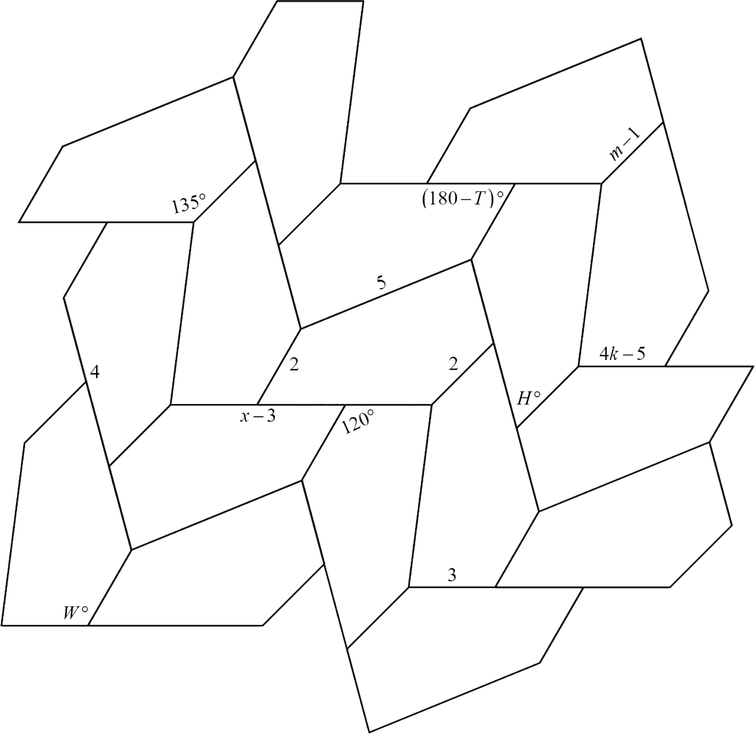

H = __________ | T = __________ | W = __________
k = __________ | m = __________ | x = __________

