Painting a picture chart: ELECTROMAGNETIC WAVE SPECTRUM
Image | Observations | Inferences | Explanation
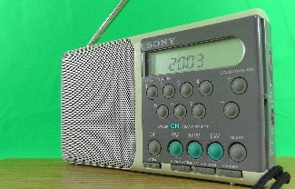
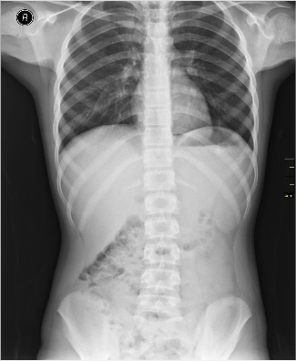
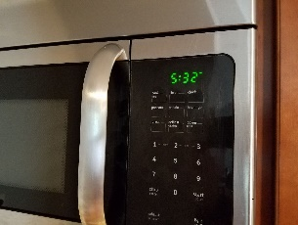
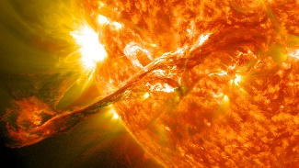
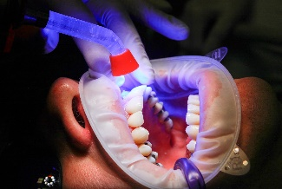

Image Sources
dansamu. (2016). Radio small green background [Image]. Pixabay. https://pixabay.com/photos/radio-small-green-background-1339186/
Dilmen, N. (2011). Medical X-ray [Image]. Wikimedia Commons. https://commons.wikimedia.org/wiki/File:Medical_X-Ray_imaging_TOW07_nevit.jpg
ECTran71. (2020). Frigidaire microwave clock [Image]. Wikimedia Commons. https://commons.wikimedia.org/wiki/File:Frigidaire_microwave_clock_20200418.jpg
NASA Goddard Space Flight Center. (2012). Magnificent cme erupts on the Sun [Image]. Wikimedia Commons. https://commons.wikimedia.org/wiki/File:Magnificent_CME_Erupts_on_the_Sun_-_August_31.jpg
ales_kartal. (2016). UV light curing [Image]. Pixabay. https://pixabay.com/photos/dentist-facet-uv-light-curing-1864921/

