WAVE UNIT CONCEPT CARDS
Driven Wave | Velocity | Wavelength | Lambda
Amplitude | Frequency | Triangle of Power | The Wave Equation
Medium | Transverse Waves | Longitudinal Waves | Wave Pulse  NEW DIRECTION
Inverse Relationship | Interference | Constructive Interference | Destructive Interference
Interference Patterns | Reflection | Phase | In Phase
Out of Phase | 180° Out of Phase | Resonance | Oscillation
Consistently repeating vibration or motion. | A physical substance that carries the wave. The wave medium always returns to its original position after the wave passes through it. | Bouncy waves when the medium vibrates up and down. | A constant oscillation that creates a continuous displacement or vibration of the medium.
Stretchy waves when the medium expands (stretches) and compresses (squeezes). | The speed that something travels at.  If we know the speed something is traveling at and the total time the object was moving, we can determine the distance it traveled. | A short duration vibration that creates a single displacement traveling through the medium. | The horizontal distance between start and end points of one full wave cycle.
The vertical height of a wave, measured from the center line to the top of a peak or the bottom of a trough | The number of wavelengths that passes a fixed point in one second | Velocity = Frequency · Wavelength  - Velocity is represented by a V.  - Frequency is represented by f.  - Wavelength is represented by λ, which is the Greek letter “lambda.” | Visual representation of equations to calculate velocity, frequency, and distance of wavelengths.
For two interconnected quantities, as one gets bigger, the other gets proportionally smaller and vice-versa. | When two or more waves combine additively. | Waves combine peak + peak or trough + trough to produce a wave of larger amplitude. | Waves combine peak + trough so that amplitudes cancel one another.
When two or more freely traveling waves interfere and merge via constructive and destructive interference. | When a wave bounces off a barrier and changes direction of travel. A wave that encounters a hard barrier is flipped on itself. | The position of one wave in relation to another. | Peaks and troughs directly line up.
Peaks and troughs do not line up. | Peaks and troughs are exactly opposite | When a system vibrates at a single frequency, we call this a standing wave. Only wavelengths that fit within an object will resonate. | λ
A | f | Some waves are visible, but not all waves. | Sound waves are not visible.
Waves can be used to determine the behavior of less obvious things like light, TV and radio signals, and cell phone data signals as they travel from one location to another. | There are patterns in waves. | Waves are affected by their environment. | A wave can be thought of as a disturbance that travels through something, accompanied by a transfer of energy.
Sound waves need to travel through a substance or material. | Amplitude and frequency affect the energy of a wave. | The frequency of a note is 277 Hz and the wavelength is 1.2 meters. What is the speed of sound? | Wavelength of trapped wave or pulse must fit within the volume/length of the reflected area in order for resonance to occur.
Freely traveling waves combine using constructive and destructive interference to form a distinct series of larger and smaller peaks and troughs. | Light travels through space in the form of a wave. | In 1801, Thomas Young observed bright and dark bands of light as it passed through two very narrow openings. | First evidence that light travels through space in the form of a wave.
Electromagnetic radiation includes a large variety of electromagnetic waves of different frequencies and energies. | EM waves include all types of electromagnetic radiation, from radio waves, to microwaves, to IR, to visible light, to UV, to x-rays, and gamma rays. | Each category has its own range of frequencies and energies. | EM waves are carried by electric and magnetic fields (which are present everywhere in the universe and act as the wave medium) and travel at "c" through the vacuum of space or close to "c" through matter. c = speed of light = 3 x 10⁸ m/s.
Energized electrons in atoms that make up matter. Different electron energies produce EM waves with different frequencies. | A vibration of electric and magnetic fields that travel at the speed of light. | EM waves with the lowest energy have the longest wavelength and smallest frequency. As the energy of EM waves increases, their wavelength gets shorter and their frequency increases. | Radio waves, microwaves, infrared radiation, visible light, ultraviolet light, x-rays, and gamma rays are all part of the electromagnetic spectrum. We only detect heat (through our skin) and visible light (through our eyes).
The color of visible light is directly related to its frequency, which is directly related to its energy. Red light has lowest energy (even though we feel infrared as “heat”) and violet light has highest energy. | 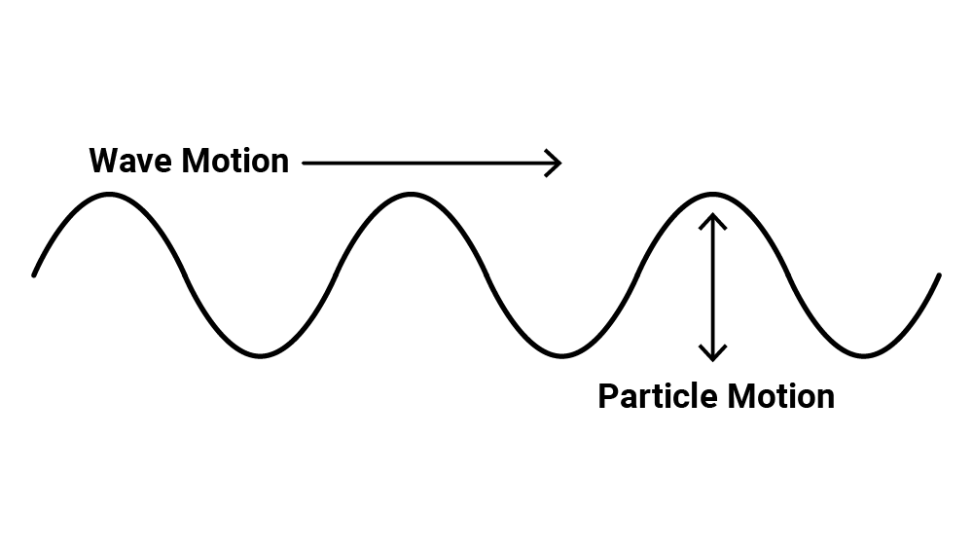 | 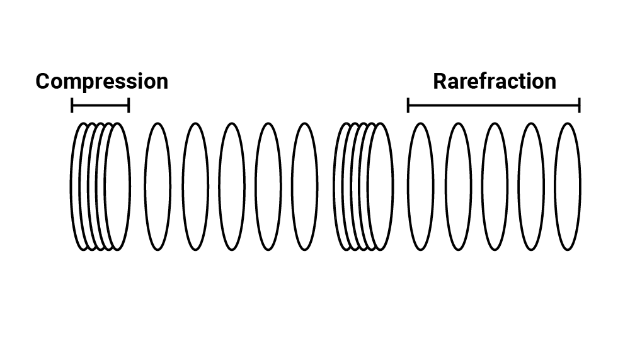 | 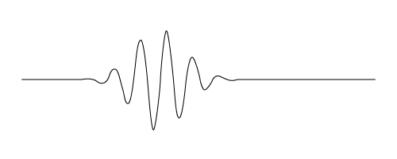
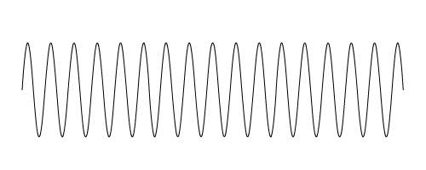 | 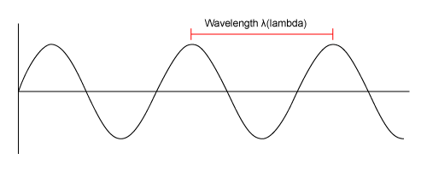 | 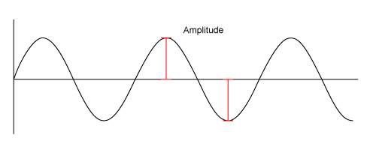 | 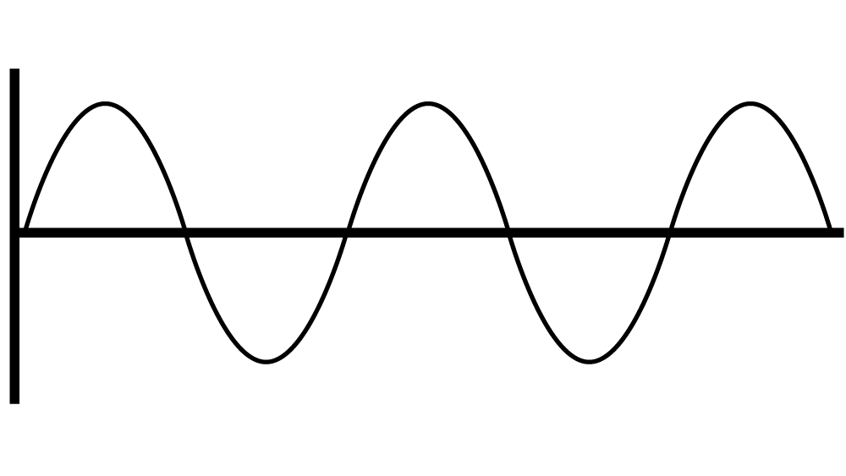
f → λ λ→f | 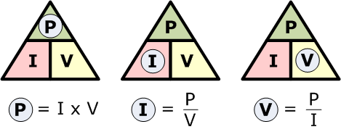 | v = f λ | 