Waves Unit Vocabulary (Teacher’s Guide)
Word | Definition | Examples
Oscillation | Consistently repeating vibration or motion.
Medium | A physical substance that carries the wave. The wave medium always returns to its original position after the wave passes through it. | Almost any kind of matter, air, water, or solids, such as steel or rock.
Transverse Waves | Bouncy waves when the medium vibrates up and down. | 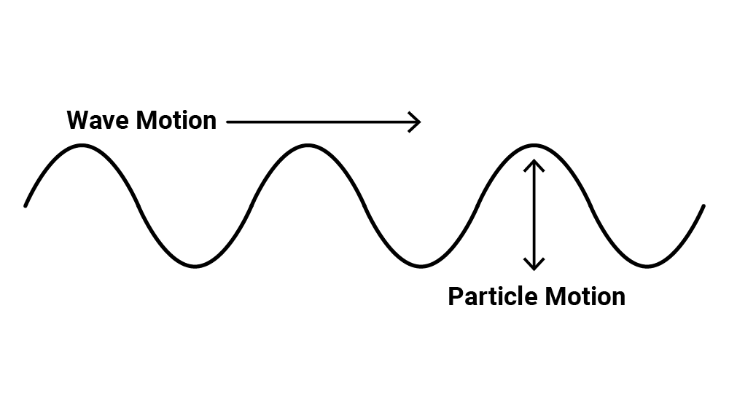
Longitudinal Waves | Stretchy waves when the medium expands (stretches) and compresses (squeezes). | 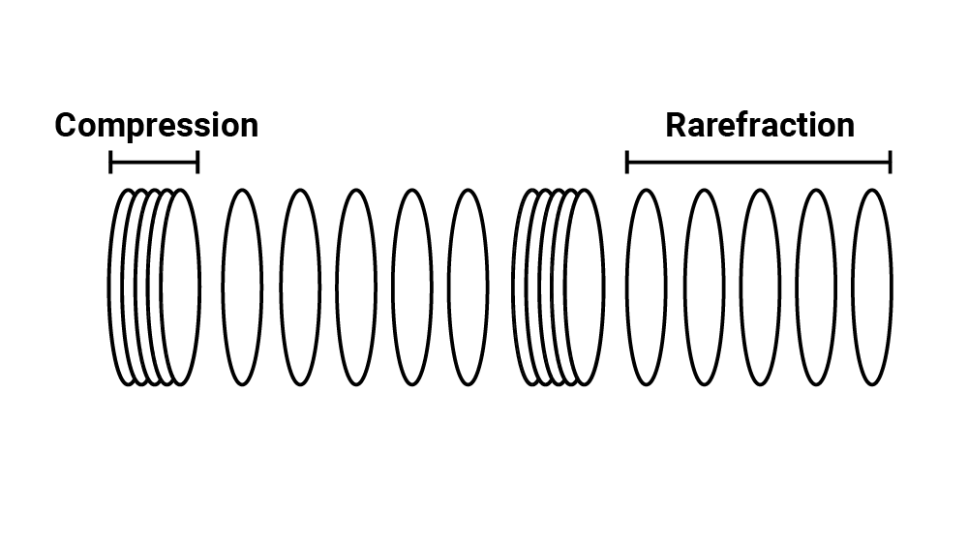
Wave Pulse | A short duration vibration that creates a single displacement traveling through the medium. | 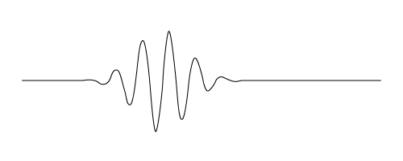
Driven Wave | A constant oscillation that creates a continuous displacement or vibration of the medium.
Velocity | The speed that something travels at. If we know the speed something is traveling at and the total time the object was traveling, we can determine the distance it traveled. | Velocity = distance/time  Distance = velocity · time
Wavelength  λ  “lambda” | The horizontal distance between the start and end points of one full wave cycle. | 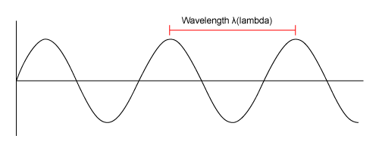
Amplitude  A | The vertical height of a wave, measured from the center line to the top of a peak or the bottom of a trough. | 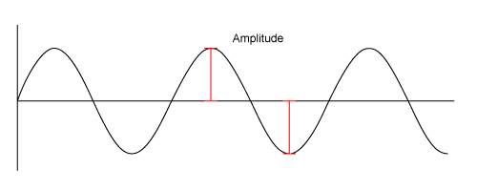
Frequency  f | The number of wavelengths that passes a fixed point in one second. | 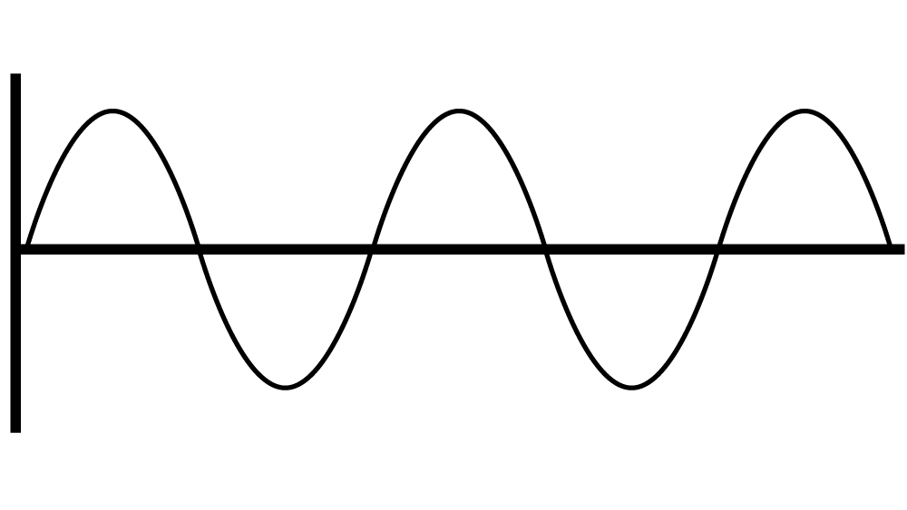
The Wave Equation | Velocity = Frequency · Wavelength  - Velocity is represented by a V  - Frequency is represented by f  - Wavelength is represented by λ, which is the Greek letter “lambda” | v = f λ
Triangle of Power | Visual representation of equations to calculate velocity, frequency, and distance of wavelengths. | 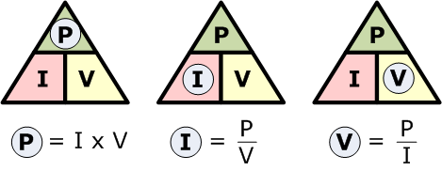
Inverse Relationship | For two interconnected quantities, as one gets bigger, the other gets proportionally smaller, and vice-versa. | f → λ λ→f
Interference | When two or more waves combine additively.

Word | Definition | Examples
Constructive Interference | Waves combine peak + peak or trough + trough to produce a wave of larger amplitude. | 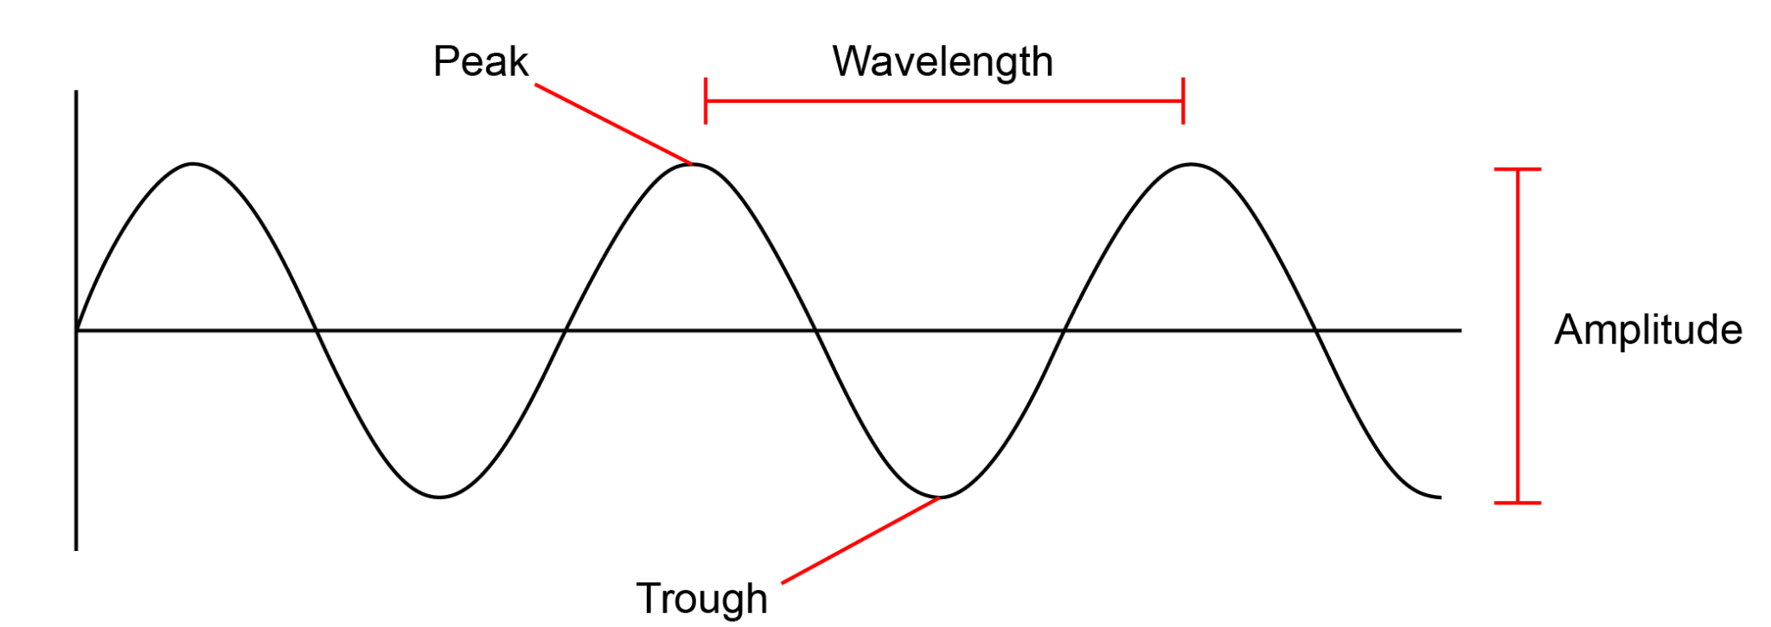
Destructive Interference | Waves combine peak + trough so that amplitudes cancel one another.
Interference Patterns | When two or more freely traveling waves interfere and merge via constructive and destructive interference. | 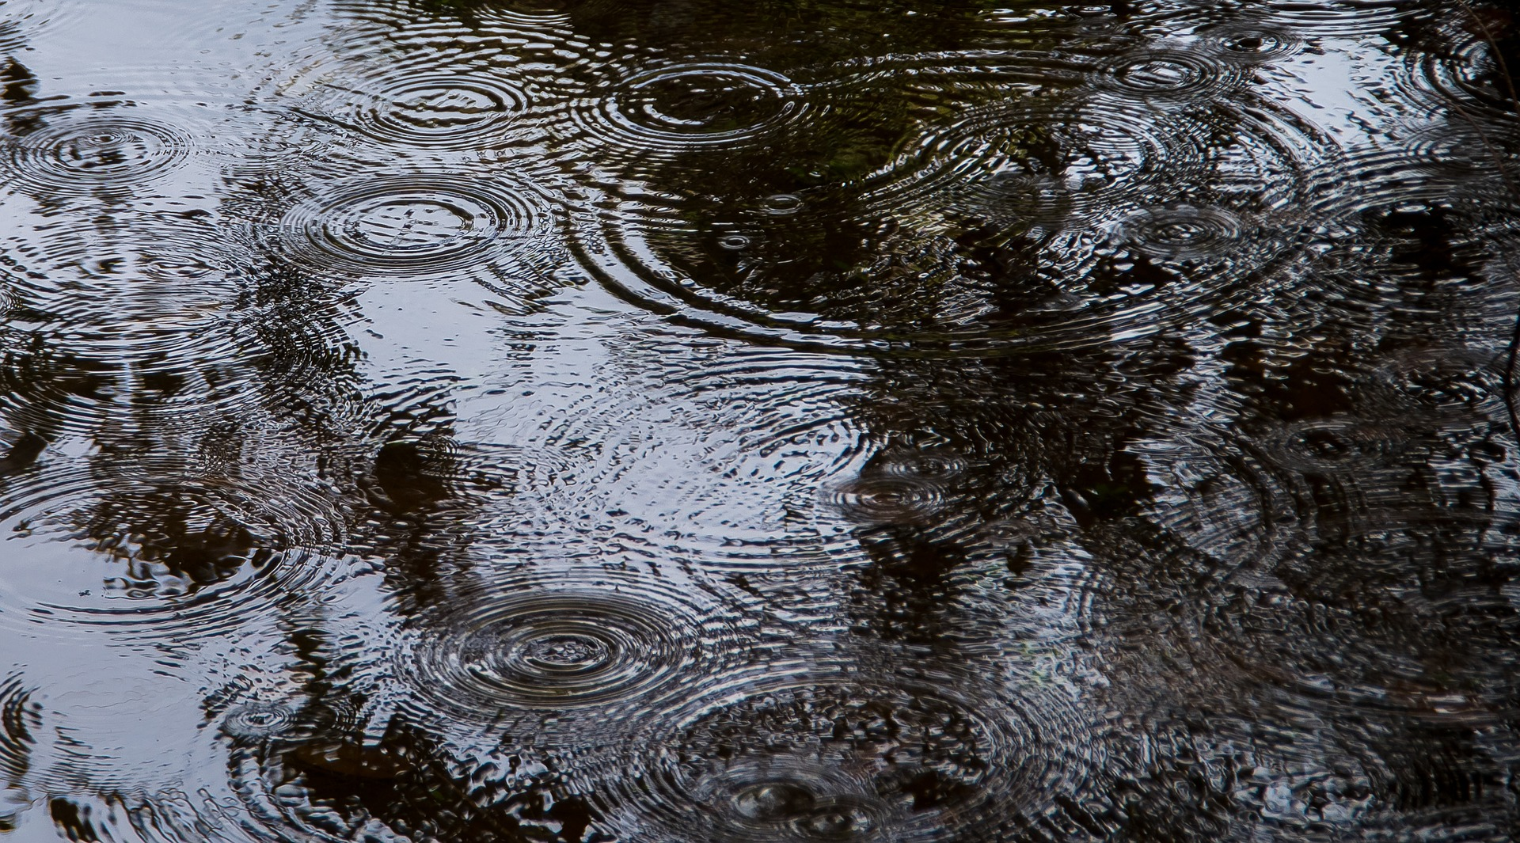
Reflection | When a wave bounces off a barrier and changes direction of travel. A wave that encounters a hard barrier is flipped on itself.
Phase | The position of one wave in relation to another.
In Phase | Peaks and troughs directly line up.
Out of Phase | Peaks and troughs do not line up.
180° Out of Phase | Peaks and troughs are exactly opposite.
Resonance | When a system vibrates at a single frequency, we call this a standing wave. Only wavelengths that fit within an object will resonate.
Refraction | The fact or phenomenon of light, radio wave, etc. being deflected in passing obliquely through the interface between one medium and another through a medium of varying density.
Word | Definition | Examples
Absorption | The process or action by which one thing soaks up or blots out another.
Emission | Something that has been emitted, released, or discharged.

