from horses to airplanes

Image Set 1
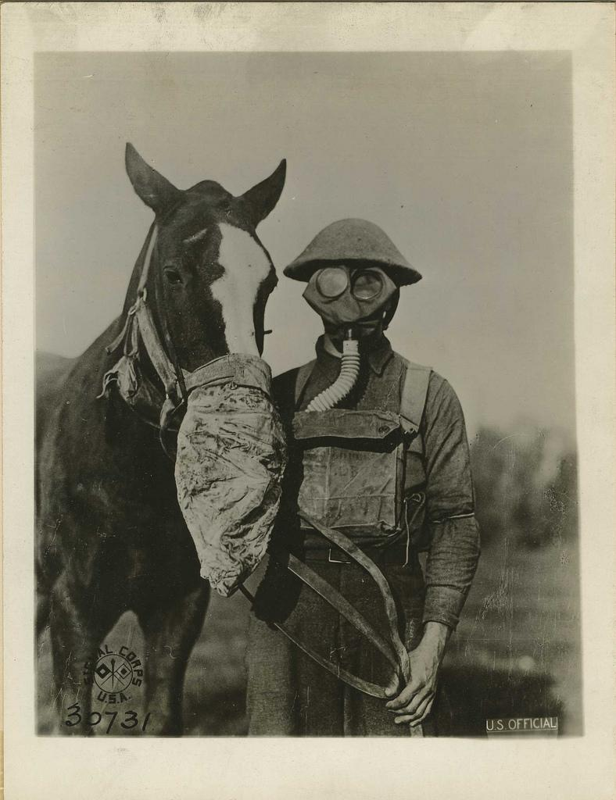
Wikimedia Commons. (2009, Feb 22). Gas masks for man and horse. [Digital image]. Retrieved July 29, 2021, from https://commons.wikimedia.org/wiki/File:Gas_masks_for_man_and_horse_(Reeve_017408),_National_Museum_of_Health_and_Medicine_(3300098220).jpg

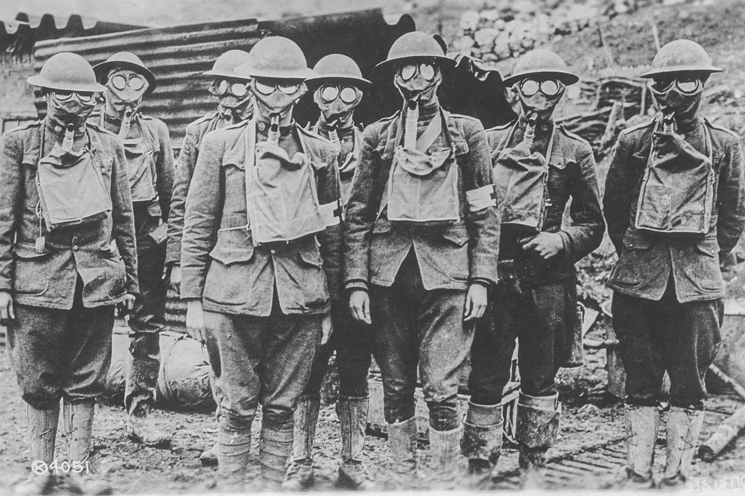
National Museum of Health and Medicine. (n.d.). American soldiers in presence of GAS during World War I. [Digital image]. Retrieved July 28, 2021, from https://www.rawpixel.com/image/2298583/free-photo-image-war-vintage-soldier

Image Set 2

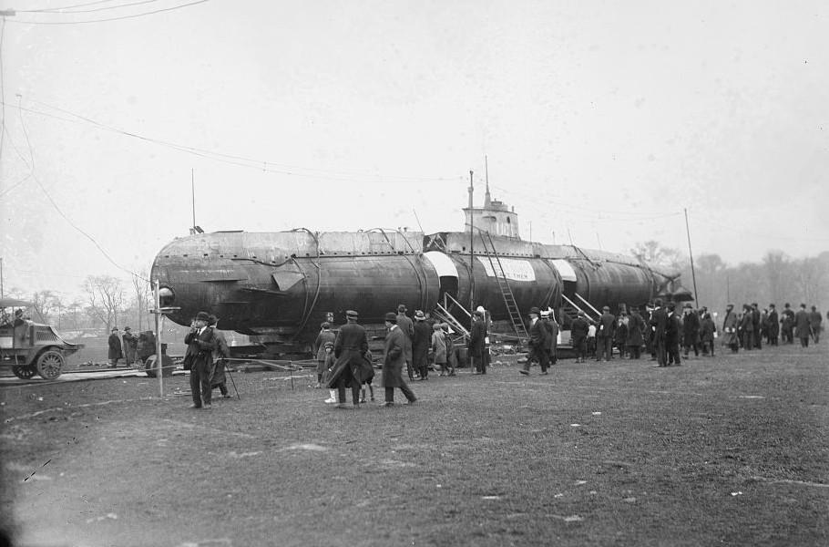Wikimedia Commons. (2009, Jan 28). US 5 sub at NY1. [Digital image]. Retrieved July 29, 2021, from https://commons.wikimedia.org/wiki/File:UC_5_sub_at_NY1.jpg

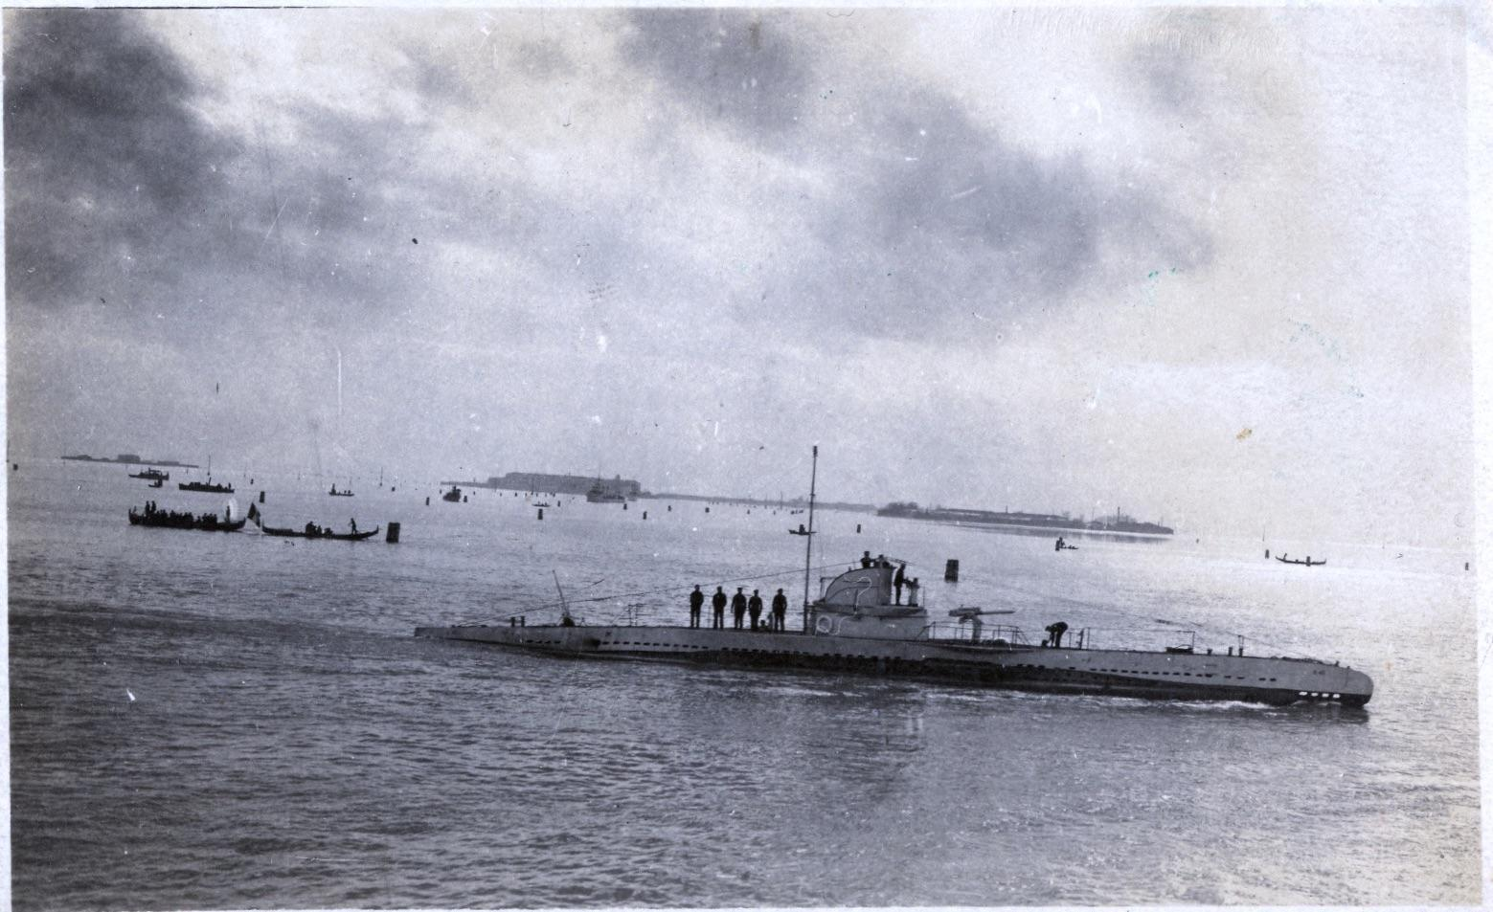
Wikimedia Commons. (2020, Feb 20). U40 submarine in Venice, 1919. [Digital image]. Retrieved July 29, 2021, from https://commons.wikimedia.org/wiki/File:U40_Submarine_in_Venice,_1919.jpg

Image Set 3

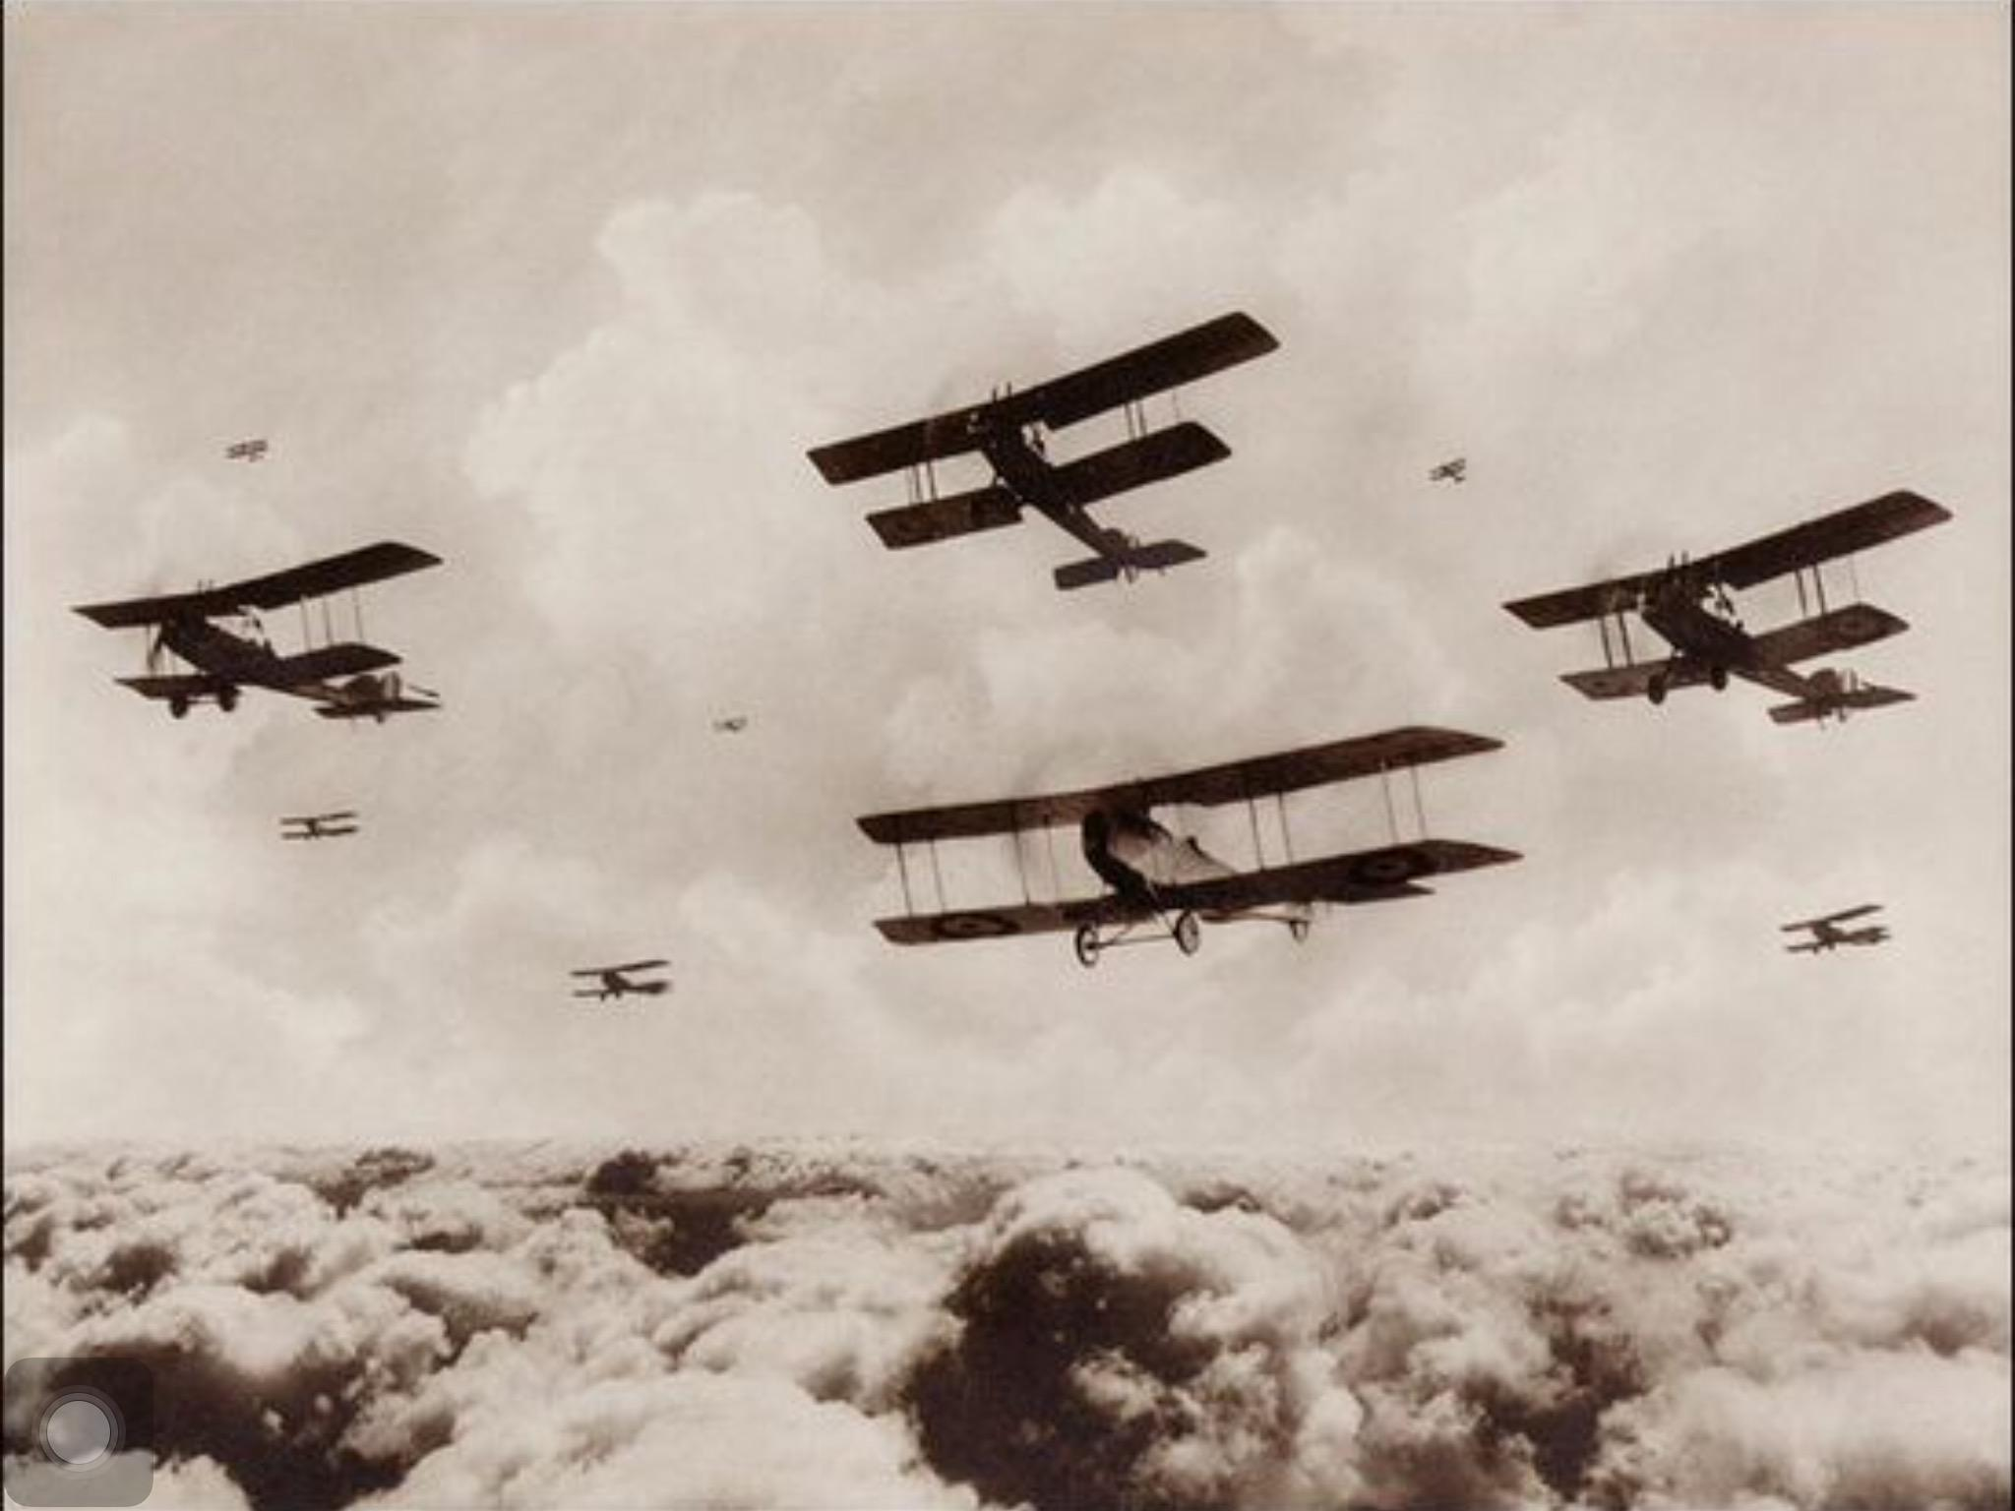Wikimedia Commons. (2016, Apr 28). Aviation in World War I. [Digital image]. Retrieved July 29, 2021, from https://commons.wikimedia.org/wiki/Category:Aviation_in_World_War_I

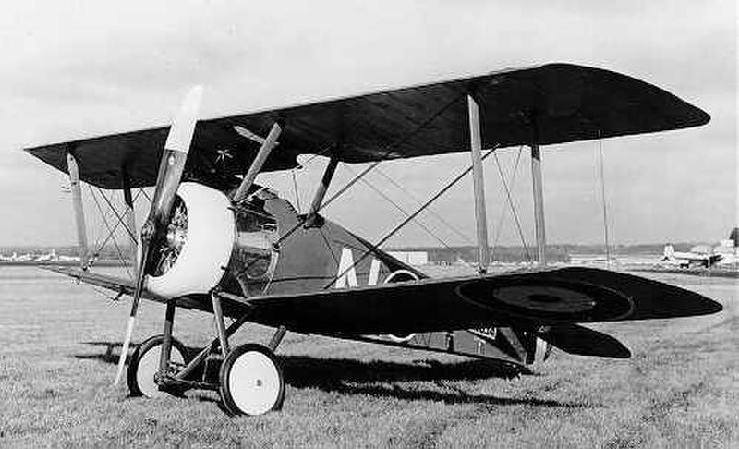Public Domain. (n.d.). World War I Sopwith Camel Fighter Plane. Retrieved July 29, 2021, from https://www.goodfreephotos.com/historical-battles/world-war-i/world-war-i-sopwith-camel-figher-plane.jpg.php

Image Set 4

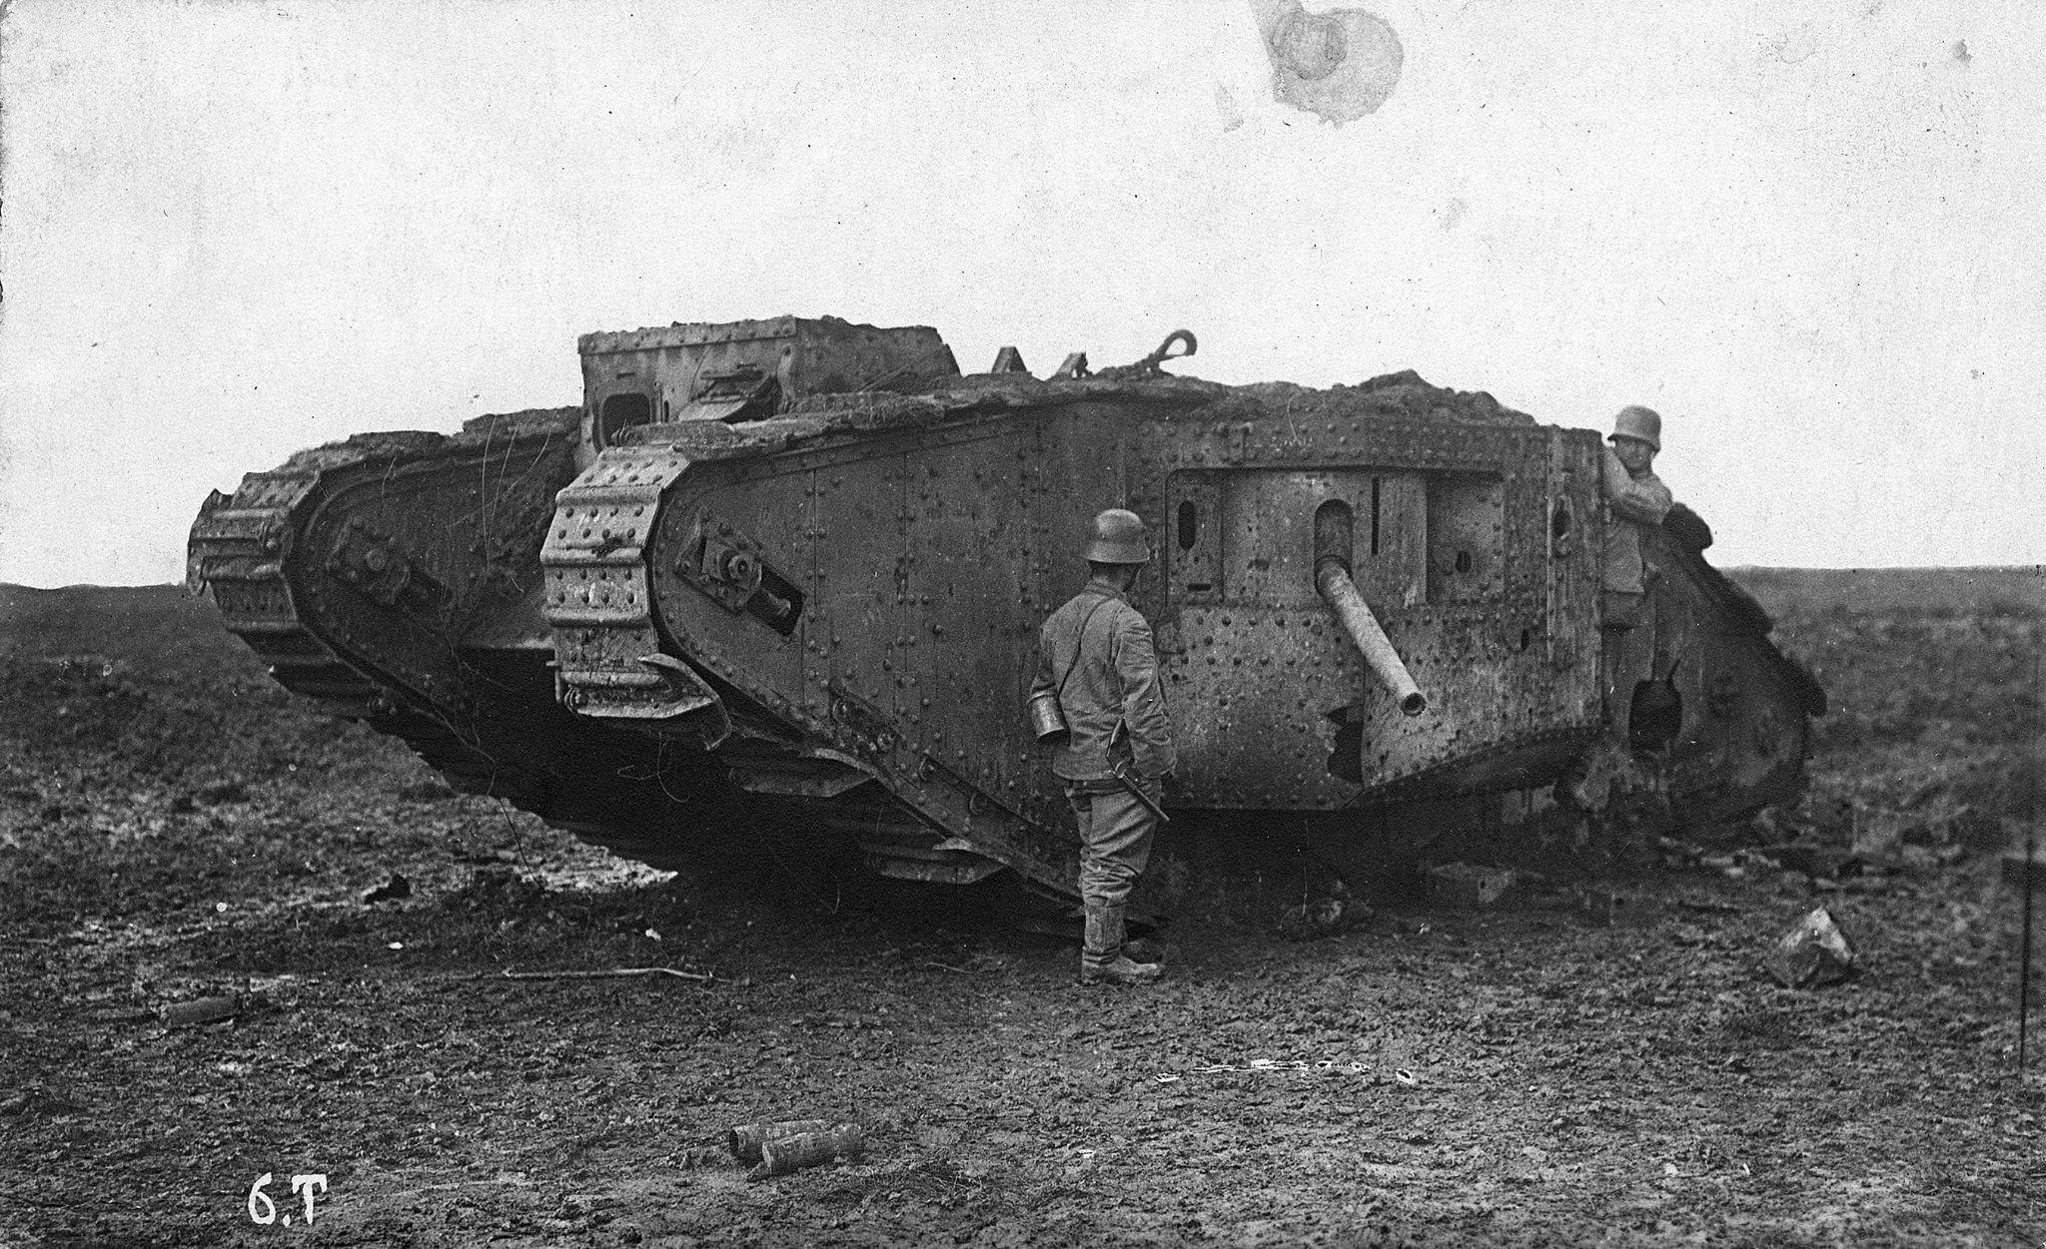Wikimedia Commons. (2016, Aug 5). Tank, British brand, first world war Fortepan. [Digital image]. Retrieved July 29, 2021, from https://commons.wikimedia.org/wiki/File:Tank,_British_brand,_First_World_War_Fortepan_76741.jpg

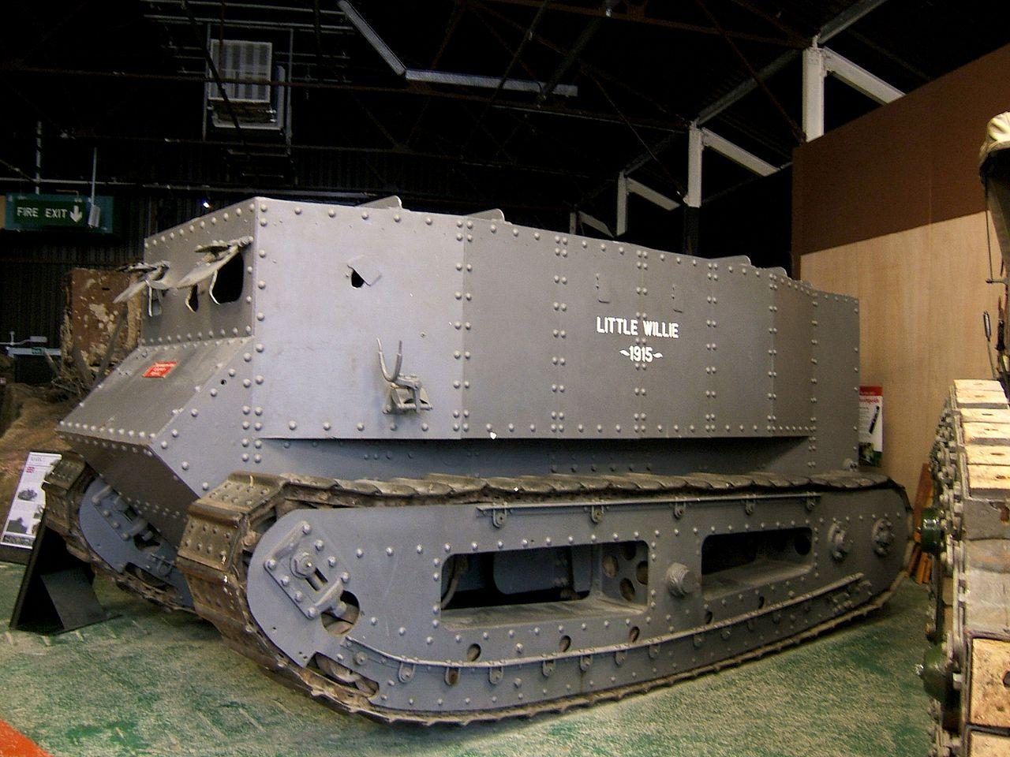
Skudder, A. (2006, August 22). Little Willie. [Digital image]. Retrieved July 29, 2021, from https://commons.wikimedia.org/wiki/File:Little_Willie.jpg

Image Set 5

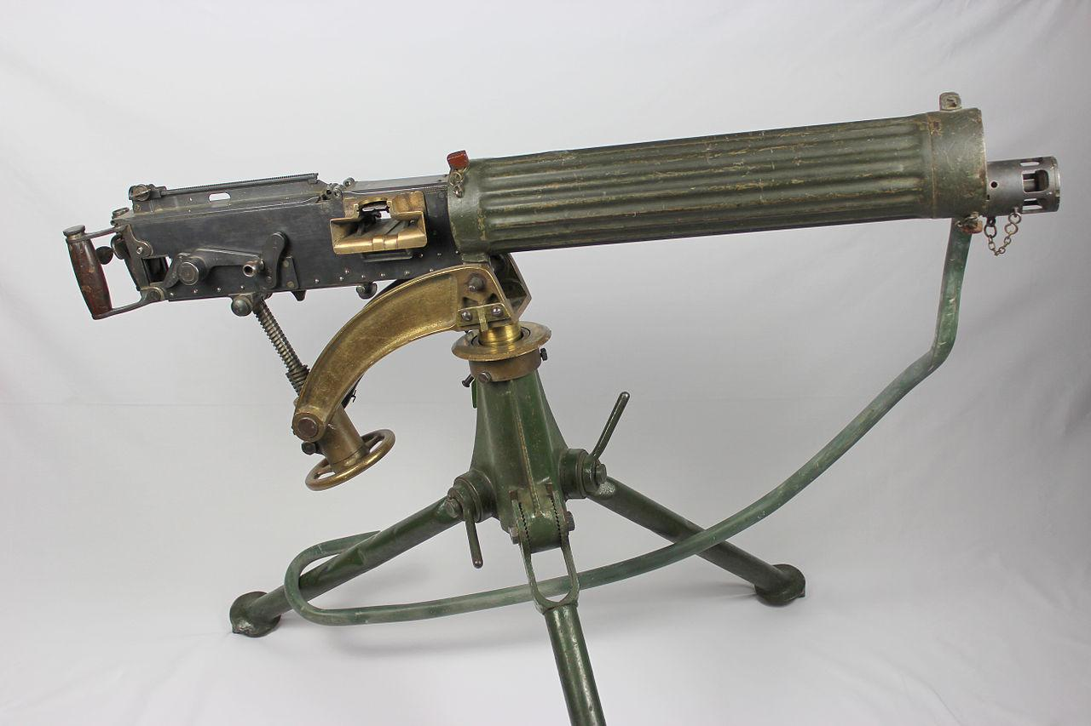Veterans of WW I. (n.d.). Machine gun. [Digital image]. Retrieved July 29, 2021, from https://wwvets.org/veterans-of-world-war-1/machine-gunner-battalions-in-ww1/

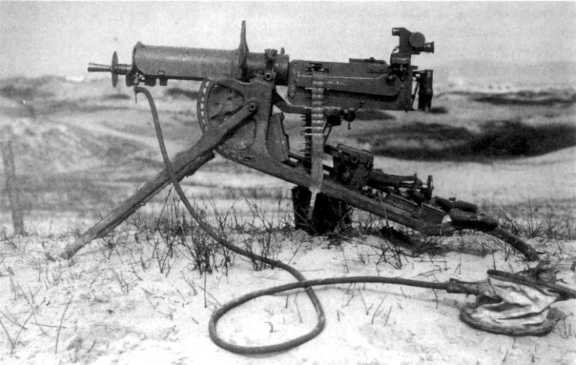Wikimedia Commons. (2011, Dec 28). Maschinengewehr. [Digital image]. Retrieved July 29, 2021, from https://commons.wikimedia.org/wiki/File:Maschinengewehr_08_1.jpg

Image Set 6

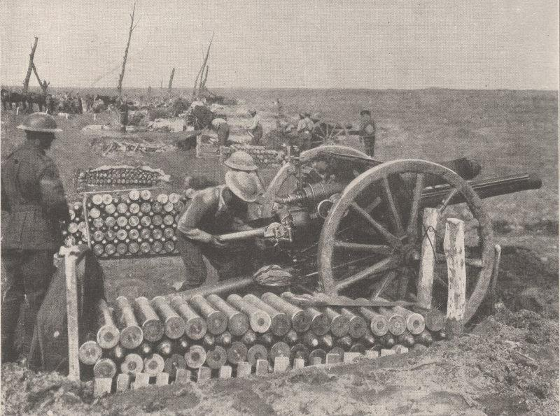Wikimedia Commons. (2007, Oct 7). 18 Pounders 3rd Ypres. 1917. [Digital image]. Retrieved July 29, 2021, from https://commons.wikimedia.org/wiki/File:18pounders3rdYpres1917.jpg

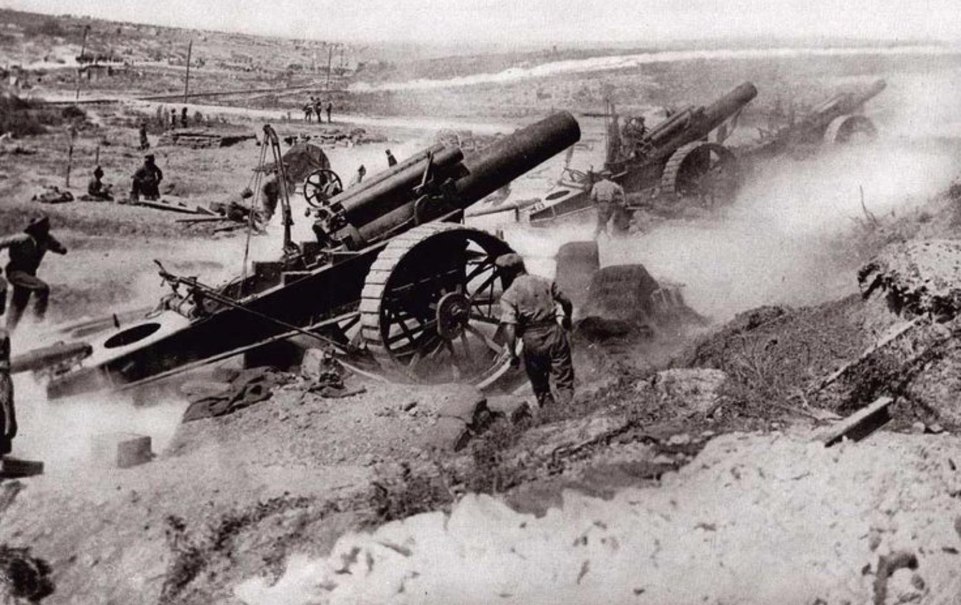Ztaylor21. (2016, April 28). Artillery of world war I. [Digital image]. Retrieved July 29, 2021, from https://commons.wikimedia.org/wiki/File:Artillery_of_World_War_I.jpg

