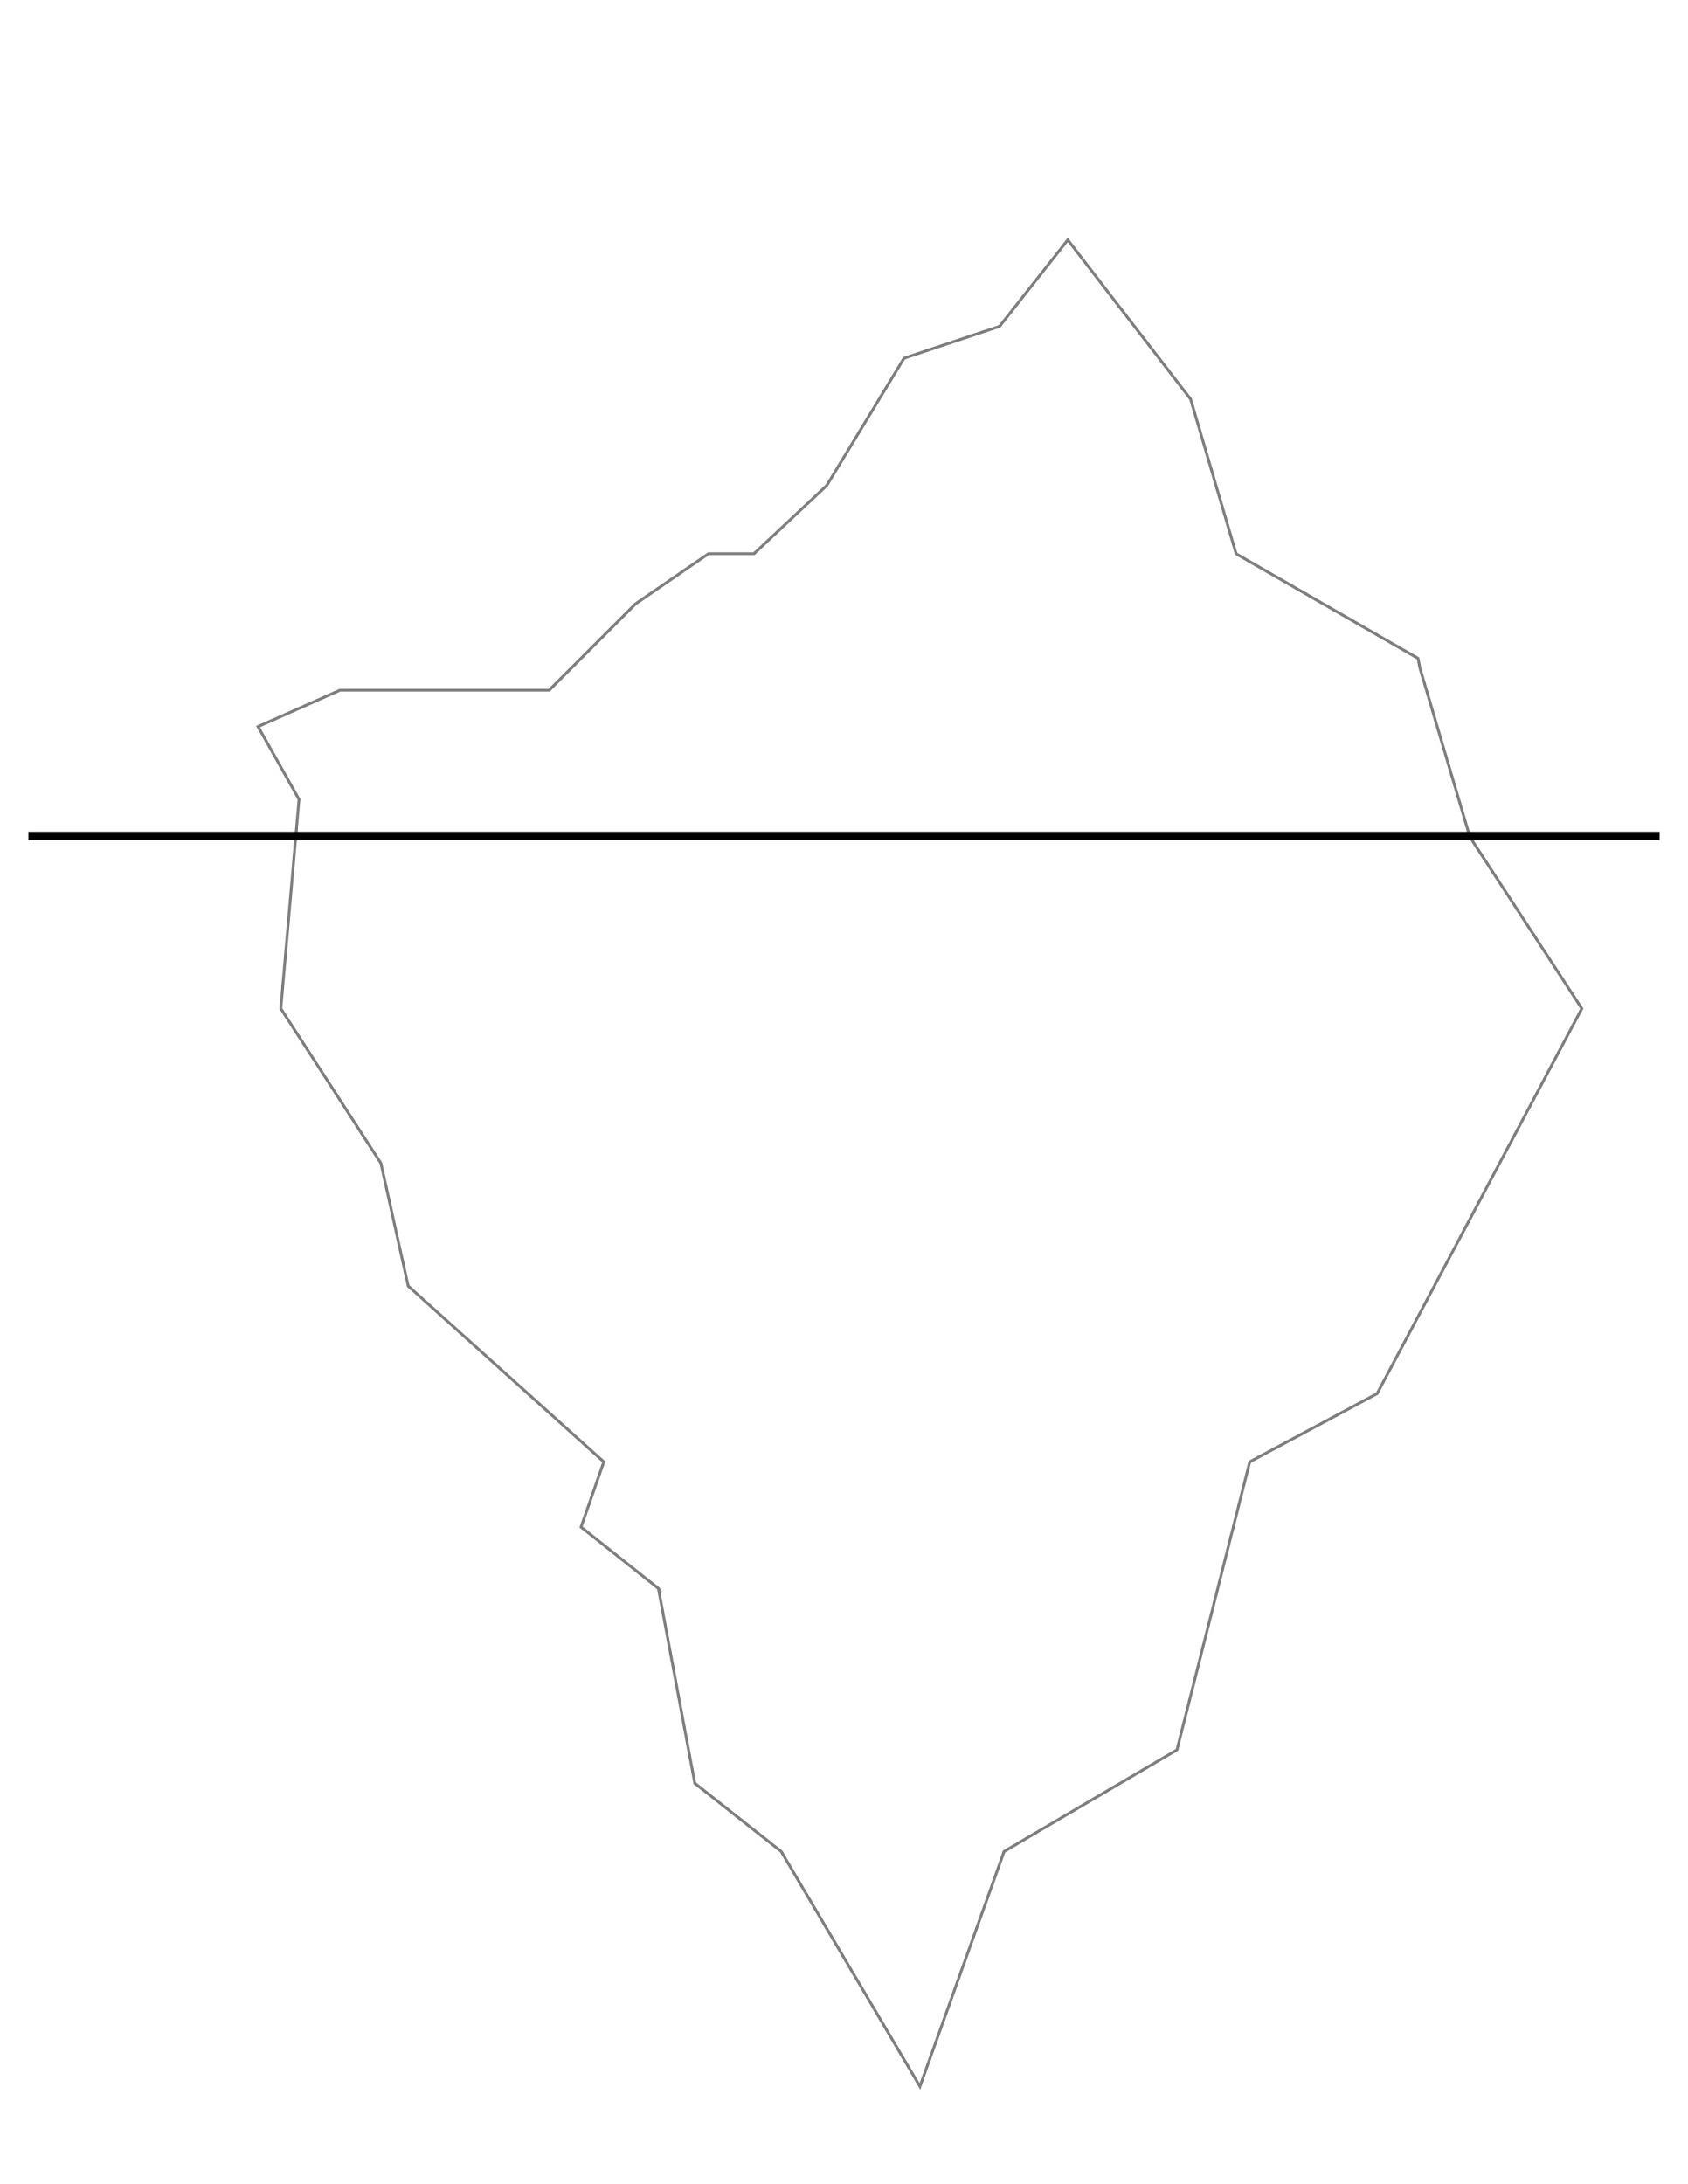
TIP OF THE ICEBERG

