MOON AND SKY CARD SORT
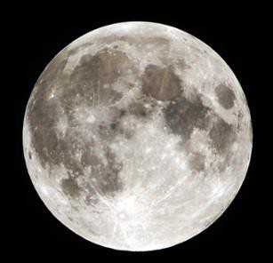 | 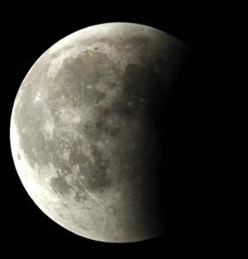 | 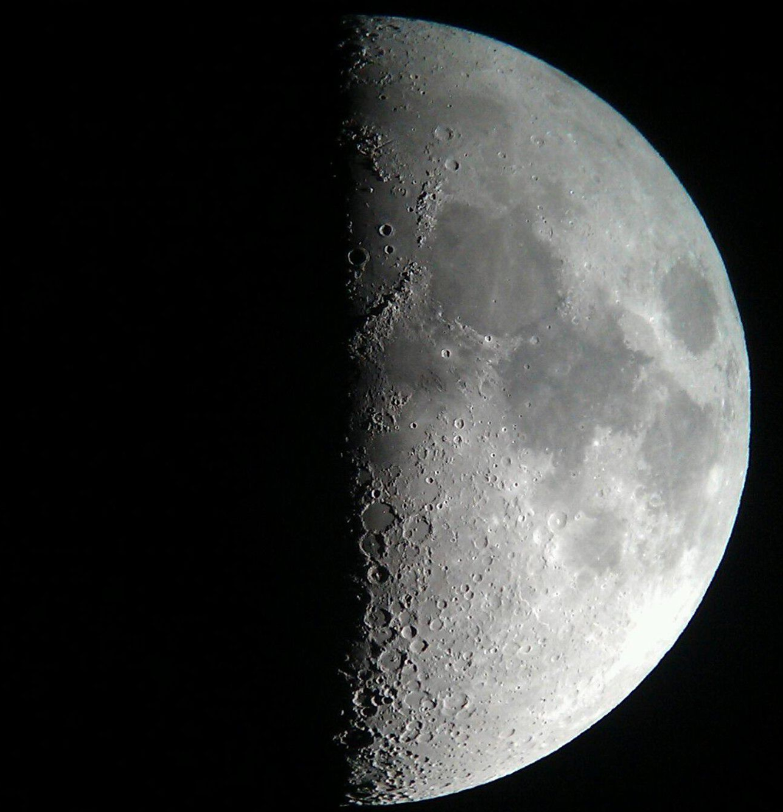 | 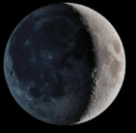
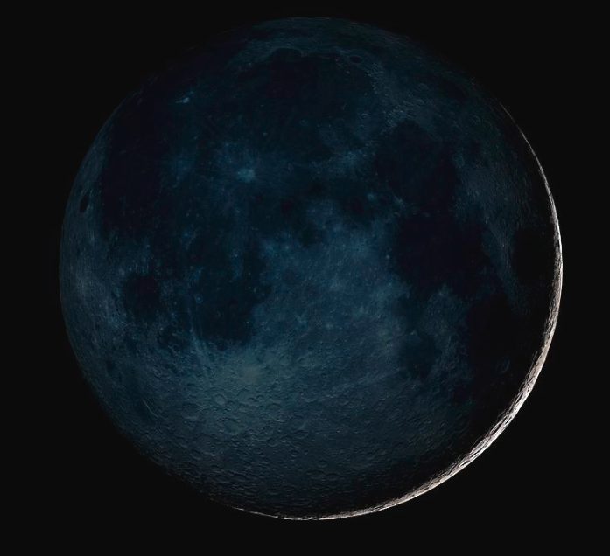 | 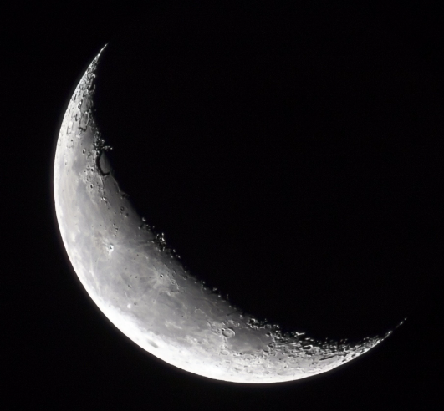 | 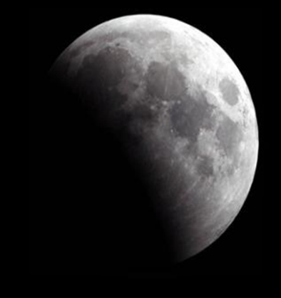 | 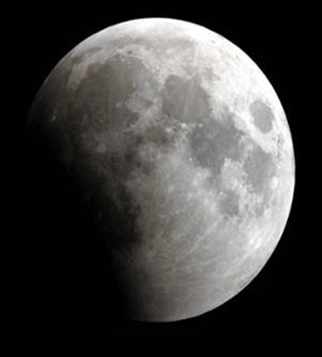

MOON AND SKY CARD SORT
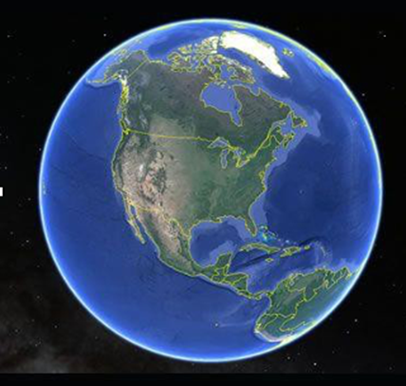 | 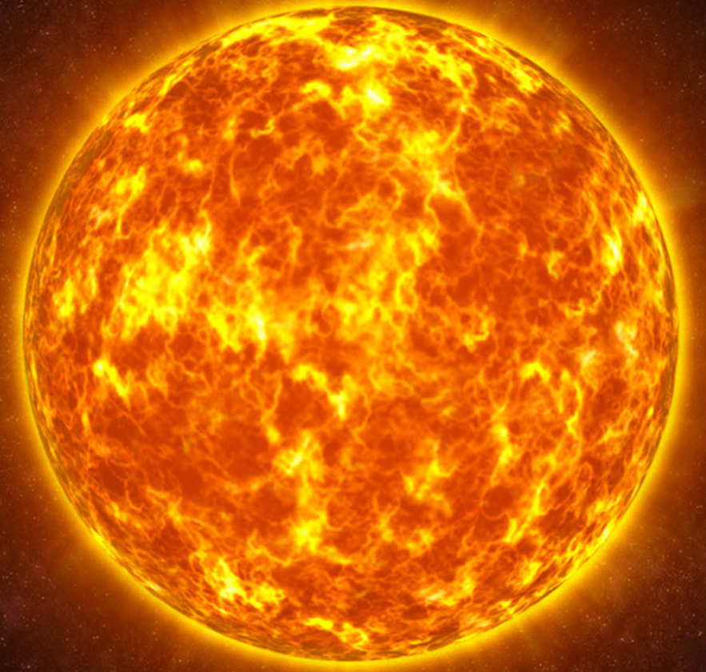 |  | 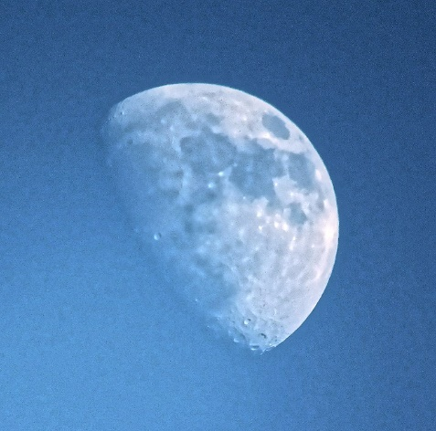
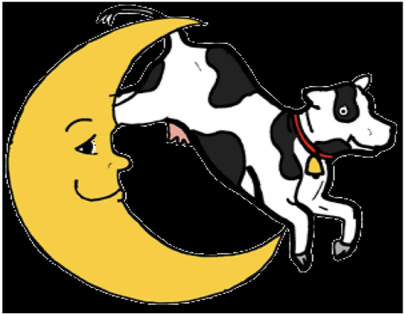 |  |  | 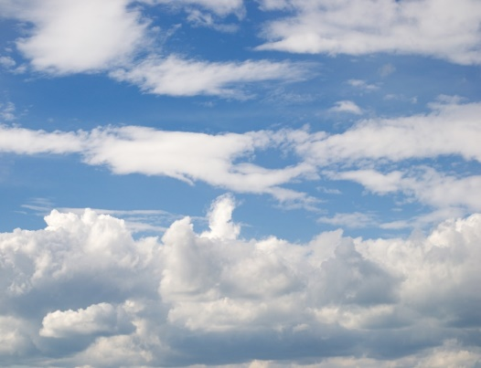

- Full moon: https://live.staticflickr.com/3469/5836482263_0d68a1dc74_b.jpg
- Waxing Gibbous moon: https://api.openverse.engineering/v1/images/80bb41a3-6024-4a89-baaf-c468312aa9cc/thumb/
- Half moon: https://jooinn.com/images/half-moon-8.jpg
- Waxing Crescent moon: https://live.staticflickr.com/3376/3484187499_cf0fff1a9a_b.jpg
- New Moon: new-moon-nasagsfc-svsscience-photo-library.jpg (900×900) (fineartamerica.com)
- Waxing Crescent moon: 54_moon_phases.png (3728×3728) (nasa.gov)
- Third Quarter moon: https://moon.nasa.gov/system/resources/detail_files/54_moon_phases.png
- Waxing Gibbous moon: https://moon.nasa.gov/system/resources/detail_files/54_moon_phases.png
- Earth: https://live.staticflickr.com/7198/6956567565_6e11eef64a_b.jpg
- Sun: https://2.bp.blogspot.com/-Cr-6rJ_dCdM/UFCytO5yTHI/AAAAAAAAJz8/V5wLbZc0AlY/s1600/Sun+Wallpapers+1.jpg
- Smile moon: https://cdn.dailyclipart.net/wp-content/uploads/medium/Full_Moon.jpg
- Daytime moon: https://upload.wikimedia.org/wikipedia/commons/thumb/1/16/Daytime_moon_over_London%2C_England.jpg/768px-Daytime_moon_over_London%2C_England.jpg
- Cow jumps over moon: https://img00.deviantart.net/4e95/i/2017/049/d/5/cow_jumped_over_the_moon_by_halloranillustration-dazj113.png
- Crazy Moon: https://publicdomainvectors.org/en/free-clipart/Crazy-Moon-vector-illustration/8474.html
- Happy Moon: https://publicdomainvectors.org/en/free-clipart/Happy-moon-vector-image/14613.html
- Clouds https://pxhere.com/en/photo/457012?utm_content=shareClip&utm_medium=referral&utm_source=pxhere

