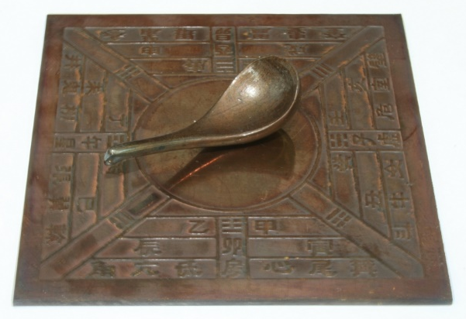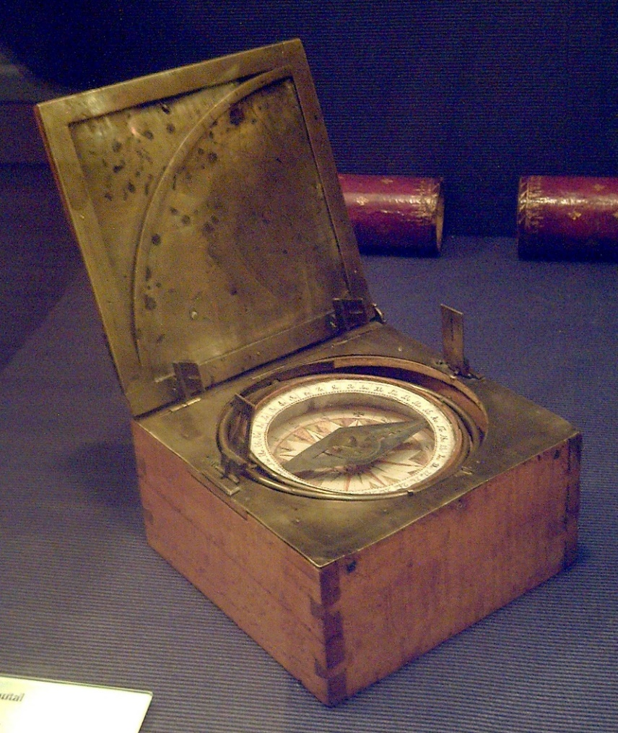

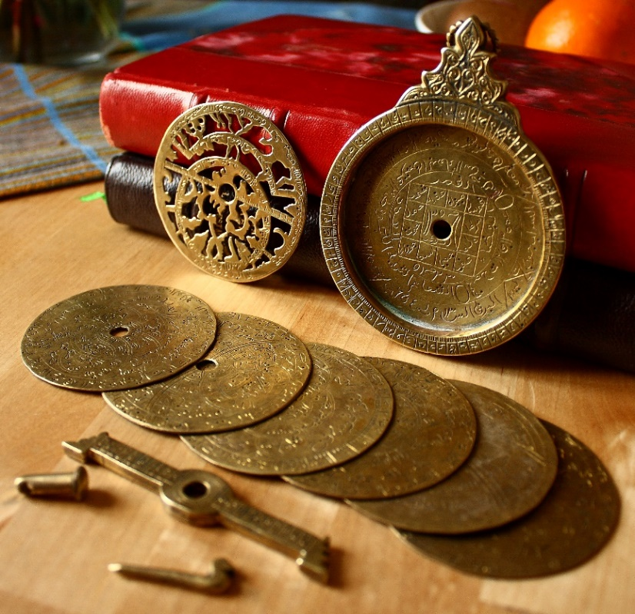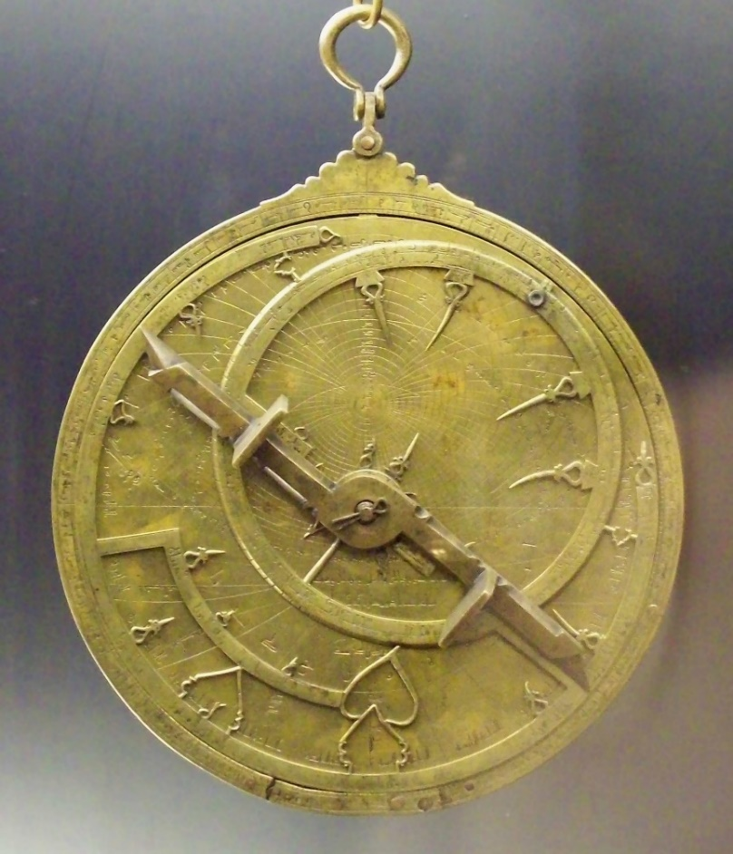

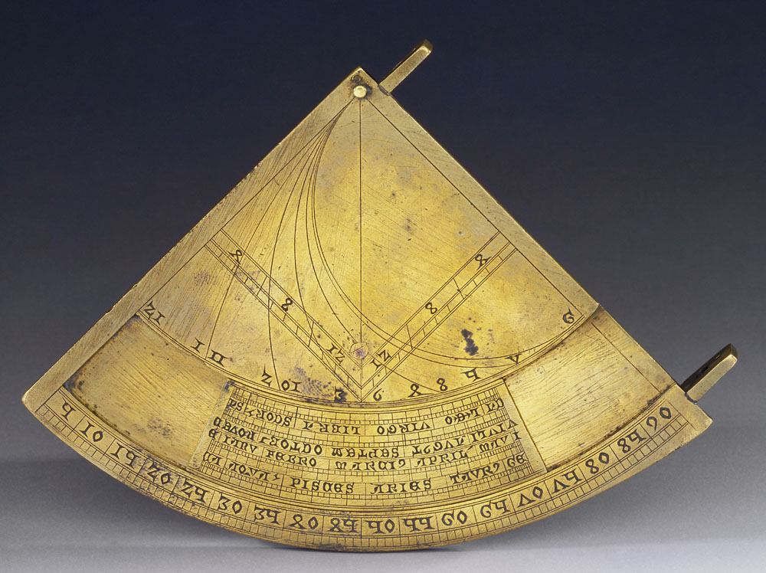 | 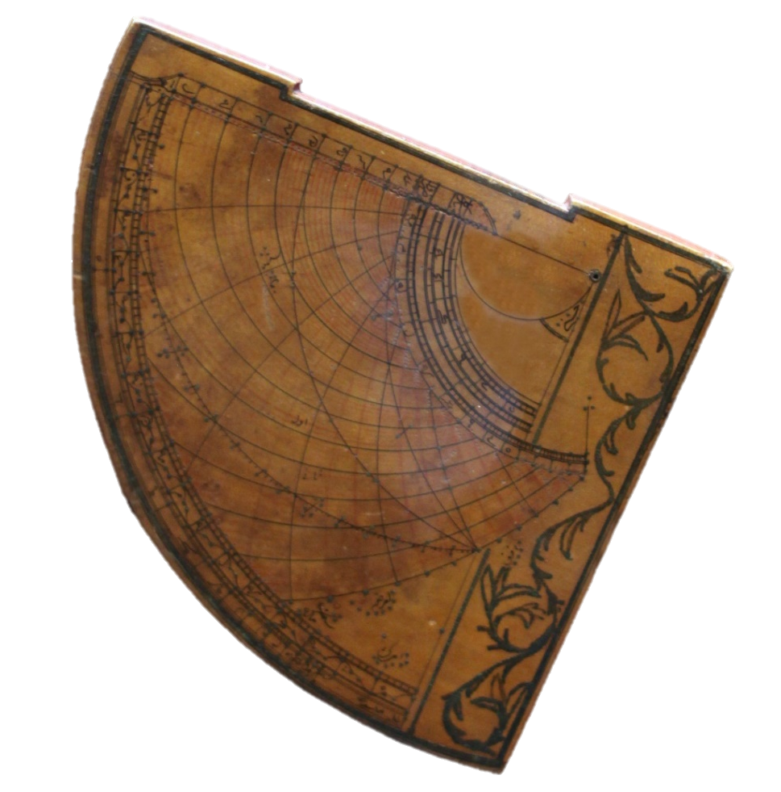

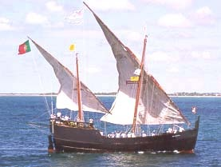 | 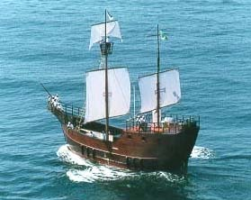

Source Citations:
Unknown. (2006). Model Si Nan of Han Dynasty [Image]. Wikimedia Commons. https://commons.wikimedia.org/wiki/File:Model_Si_Nan_of_Han_Dynasty.jpg
Garcia, L. (2008). Azimuthal compass [Image]. Wikimedia Commons. https://commons.wikimedia.org/wiki/File:Br%C3%BAjula_azimutal_espa%C3%B1ola_s.XVIII_(M.A.N._Madrid)_01.jpg
Bench, E. (2009). Astrolabe parts [Image]. Flickr. https://www.flickr.com/photos/19762676@N00/3317031220
Garcia, L. (2008). Al-Sahli's Astrolabe [Image]. Wikimedia Commons. https://commons.wikimedia.org/wiki/File:Astrolabio_andalus%C3%AD_Toledo_1067_(M.A.N.)_04.jpg
Museo Galileo. (2010). Quadrans vetus [Image]. Wikimedia Commons. https://commons.wikimedia.org/wiki/File:Quadrans_Vetus_inv_662_IF_22256.jpg
Rama. (2016). Quadrant astrolabique ottoman [Image]. Wikimedia Commons. https://commons.wikimedia.org/wiki/File:Astrolabe-MnM_9_NA_61-IMG_6075-black.JPG

