Painting a Picture: Image Packet

Image Set 1
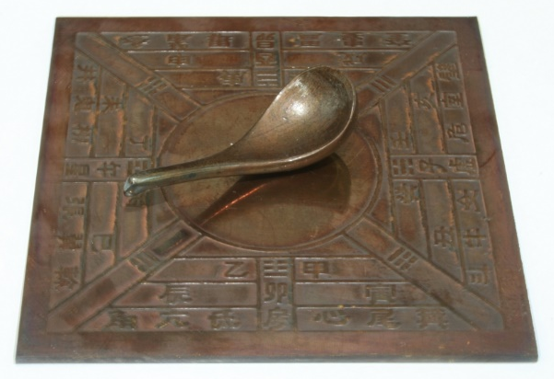
Source: Unknown. (2006). Model Si Nan of Han Dynasty [Image]. Wikimedia Commons. https://commons.wikimedia.org/wiki/File:Model_Si_Nan_of_Han_Dynasty.jpg

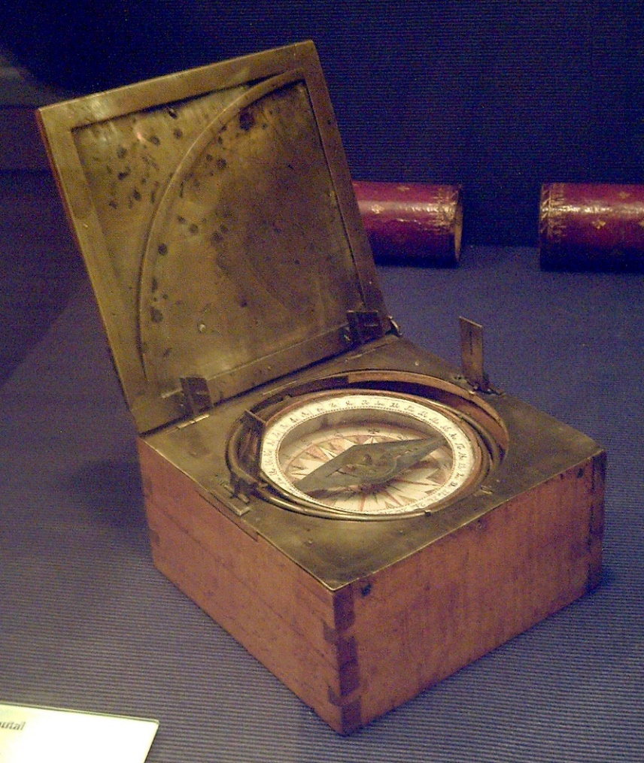
Source: Garcia, L. (2008). Azimuthal compass [Image]. Wikimedia Commons. https://commons.wikimedia.org/wiki/File:Br%C3%BAjula_azimutal_espa%C3%B1ola_s.XVIII_(M.A.N._Madrid)_01.jpg

Image Set 2
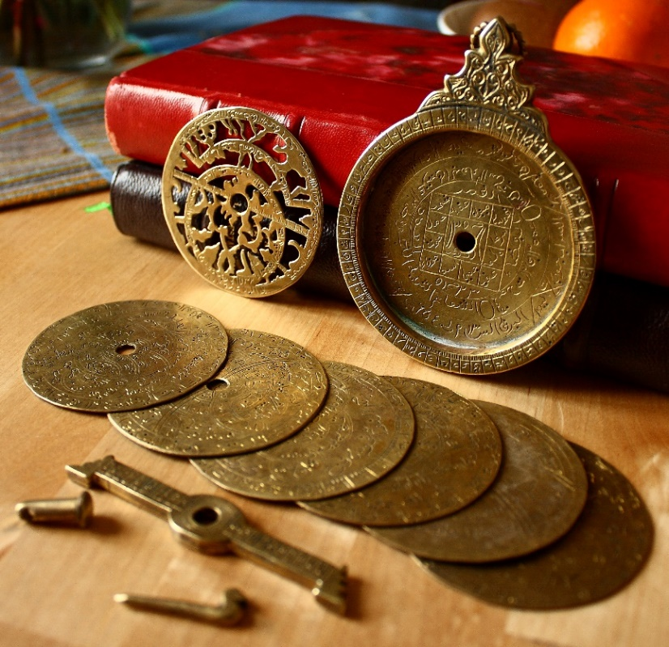
Source: Bench, E. (2009). Astrolabe parts [Image]. Flickr. https://www.flickr.com/photos/19762676@N00/3317031220

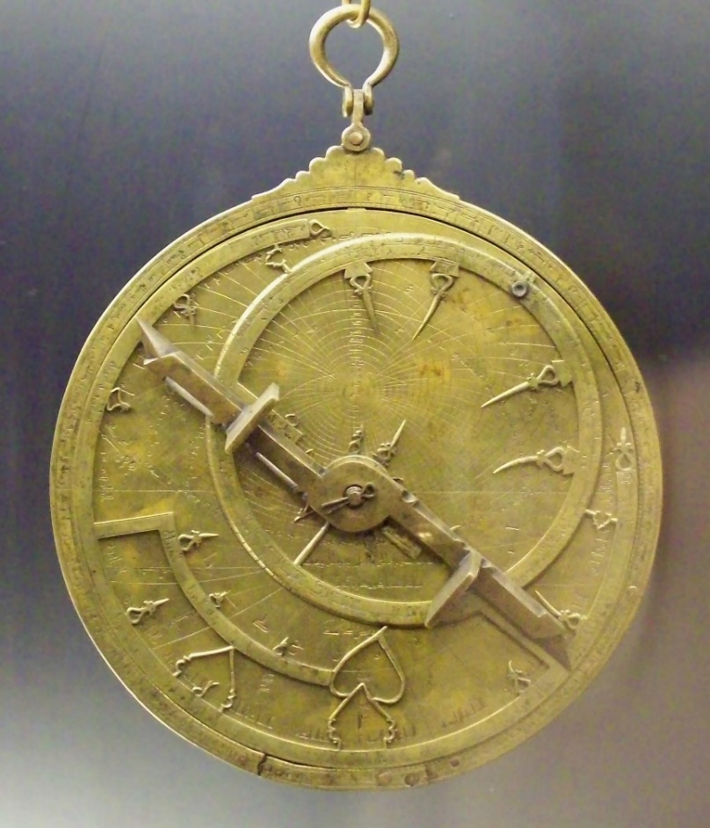
Source: Garcia, L. (2008). Al-Sahli's Astrolabe [Image]. Wikimedia Commons. https://commons.wikimedia.org/wiki/File:Astrolabio_andalus%C3%AD_Toledo_1067_(M.A.N.)_04.jpg

Image Set 3
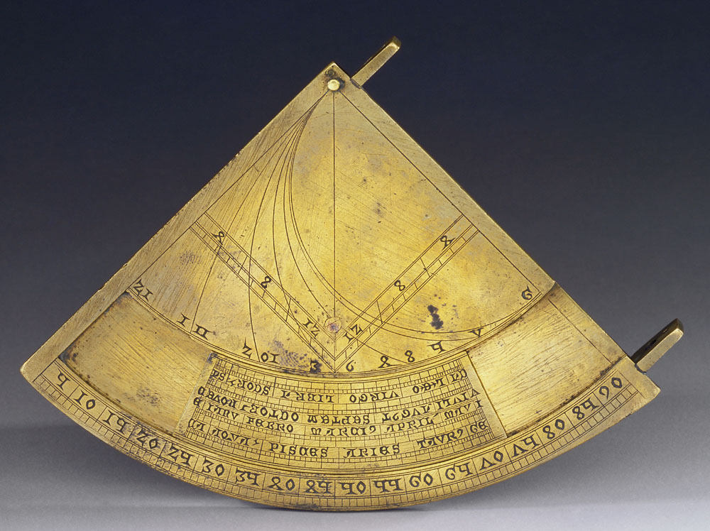
Source: Museo Galileo. (2010). Quadrans vetus [Image]. Wikimedia Commons. https://commons.wikimedia.org/wiki/File:Quadrans_Vetus_inv_662_IF_22256.jpg

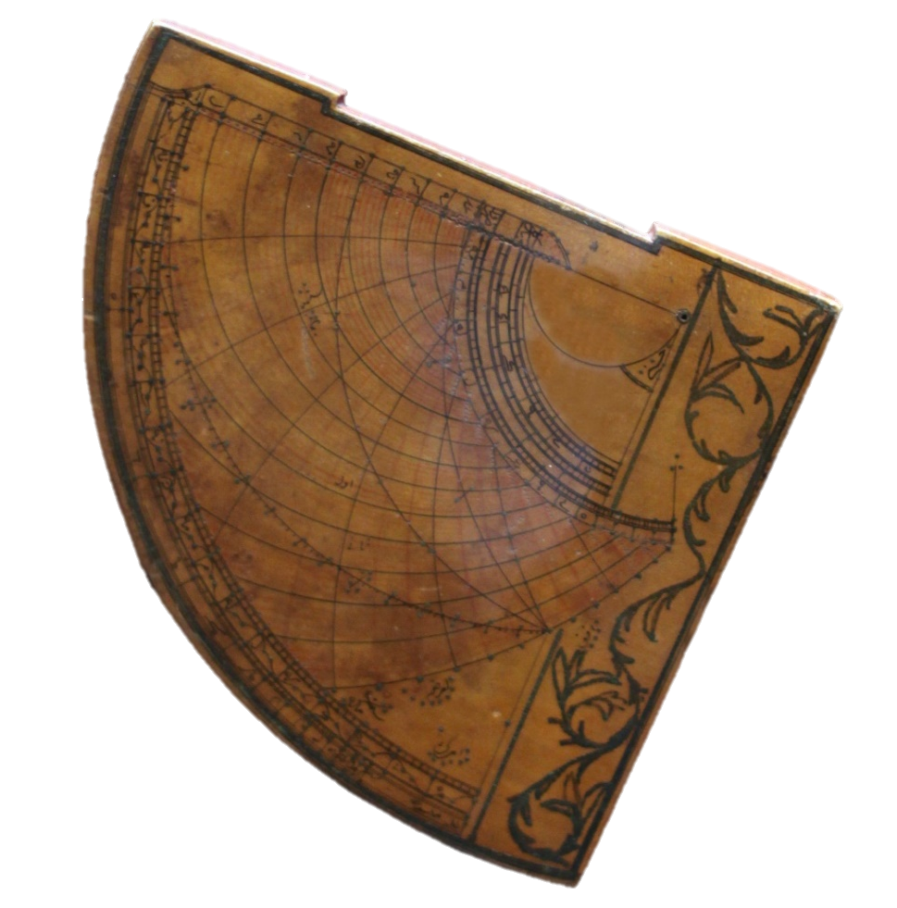
Source: Rama. (2016). Quadrant astrolabique ottoman [Image]. Wikimedia Commons. https://commons.wikimedia.org/wiki/File:Astrolabe-MnM_9_NA_61-IMG_6075-black.JPG

Image Set 4
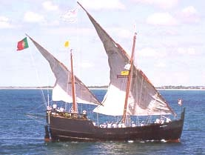
Source: Science, civilization, and society. (n.d.). Caravel [Image]. MT Oceanography. https://www.mt-oceanography.info/science+society/lectures/illustrations/lecture17/caravel.html

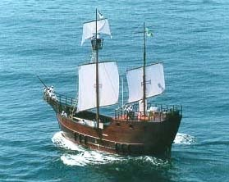
Source: Science, civilization, and society. (n.d.). Caravel [Image]. MT Oceanography. https://www.mt-oceanography.info/science+society/lectures/illustrations/lecture17/caravel.html

