Exploring Functions

Use the functions graphed below to answer the following questions.



 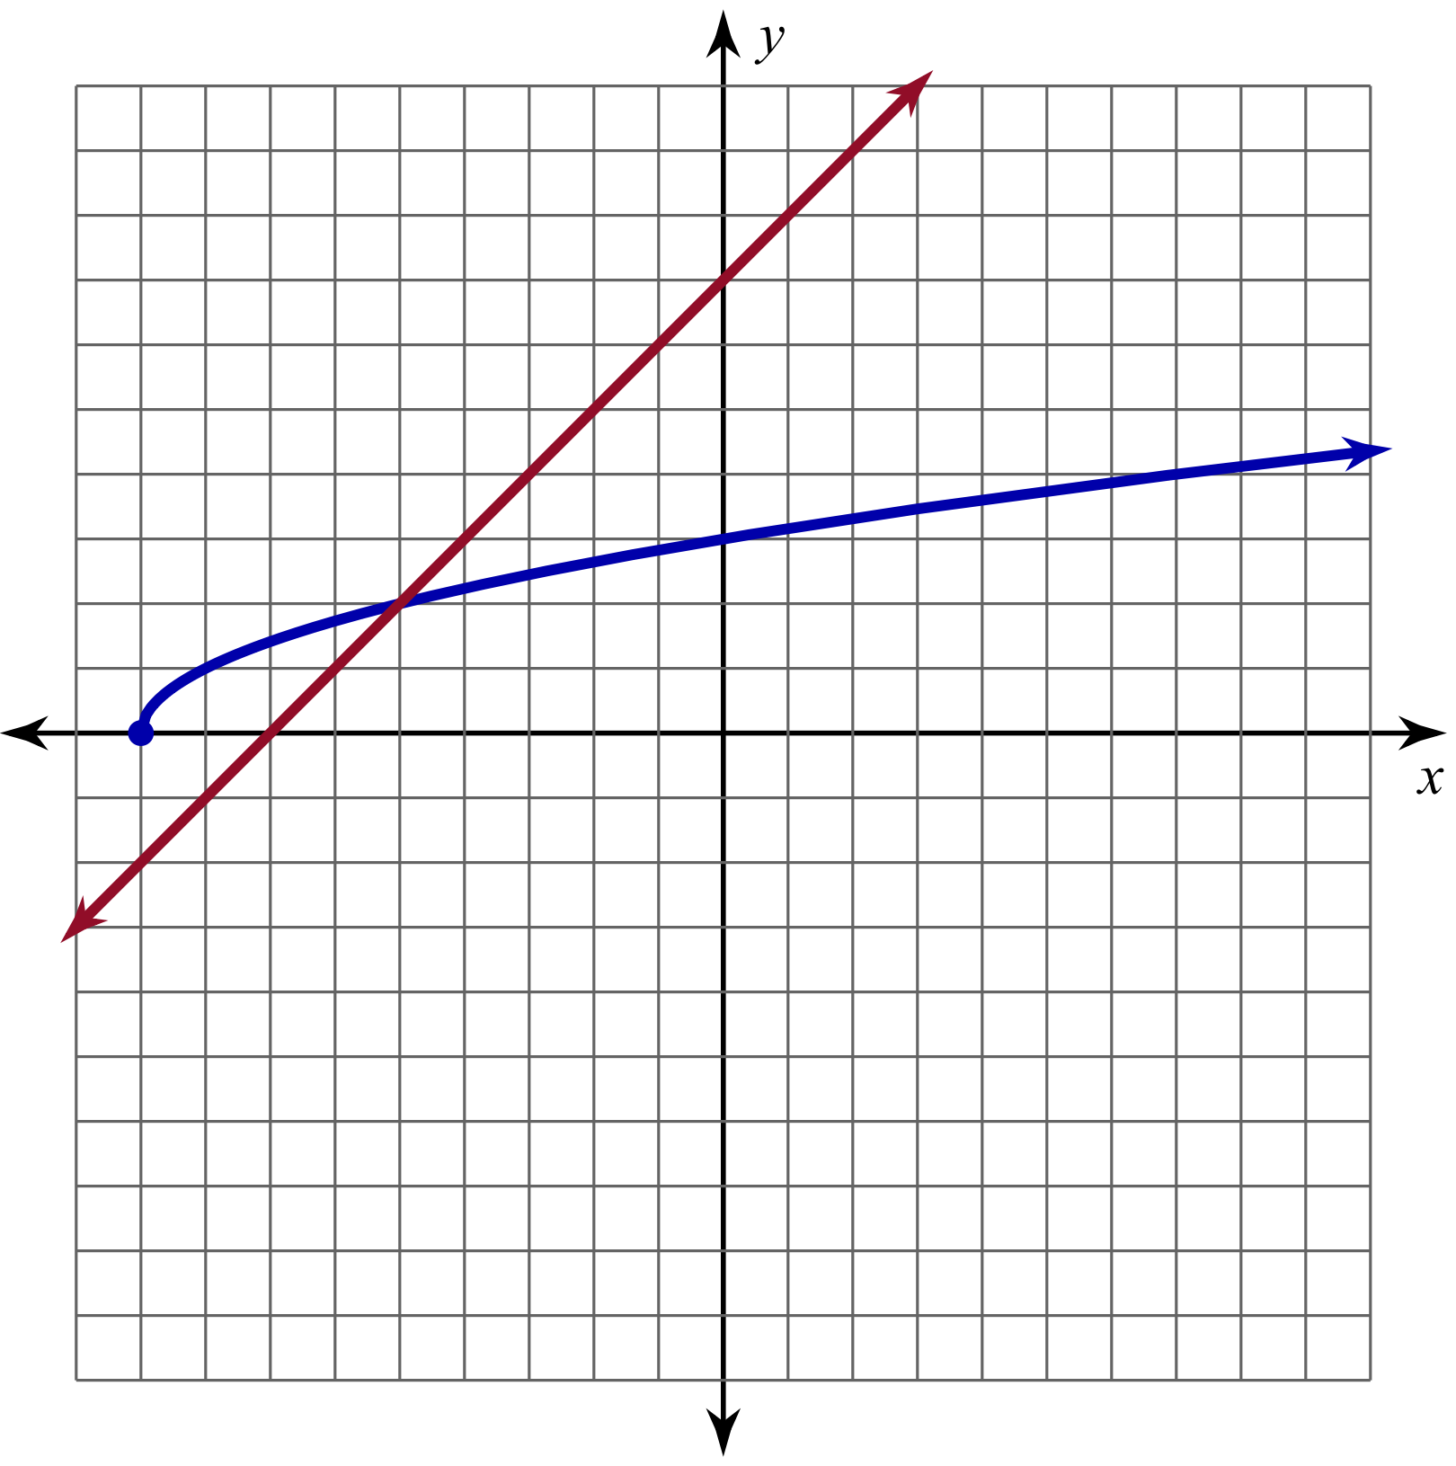

**1)** Evaluate .

**3)** Evaluate .

**5)** Find  when .

**7)** Find the point where .

**2)** Evaluate .

**4)** Evaluate .

**6)** Find  when .