Annumpa Luma: Code Talker
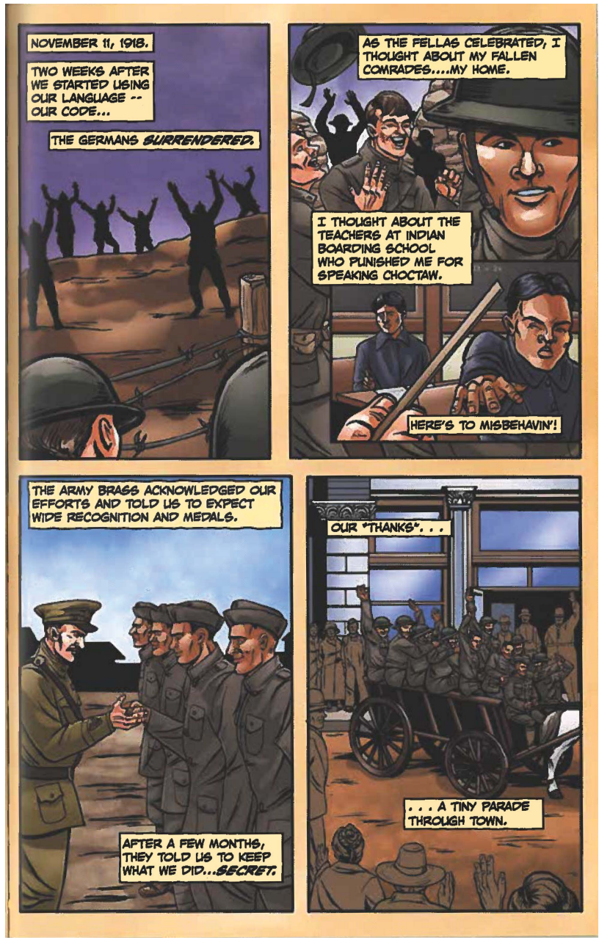
Starr, A. & Miner, J. (Eds.). (2016. Annumpa Luma: Code Talker. In Tales of the Mighty Code Talkers (Vol. I). Native Realities LLC. Adapted with permission.

