How to Twine
Twine is a tool for creating interactive fiction—a type of story that allows the reader to make choices on how the narrative unfolds. Professional game developers and storytellers use Twine to create whole interactive stories and games from scratch. If you’ve ever wanted to learn to write, code, or make your own games, this is the place to start.
By the end of this activity, you will have your own working Twine prototype. Twine is surprisingly flexible—keep your game simple or add lots of complex details. You can playtest your game, change it around, add pictures, and dive into HTML and CSS if you wish. If you keep at it, you will learn the ropes and create more games of your own!

Open Twine
- Navigate to twinery.org.
- In the top-right corner of the page, select “Use it online.”
- Select “Tell Me More” to learn more about how you will be using Twine in your browser. Select “OK” after each section to move on.
- Select “Go to the Story List.” When you open this page in Twine for the first time, the screen will be mostly blank. Let’s fix that!

Create Your Twine
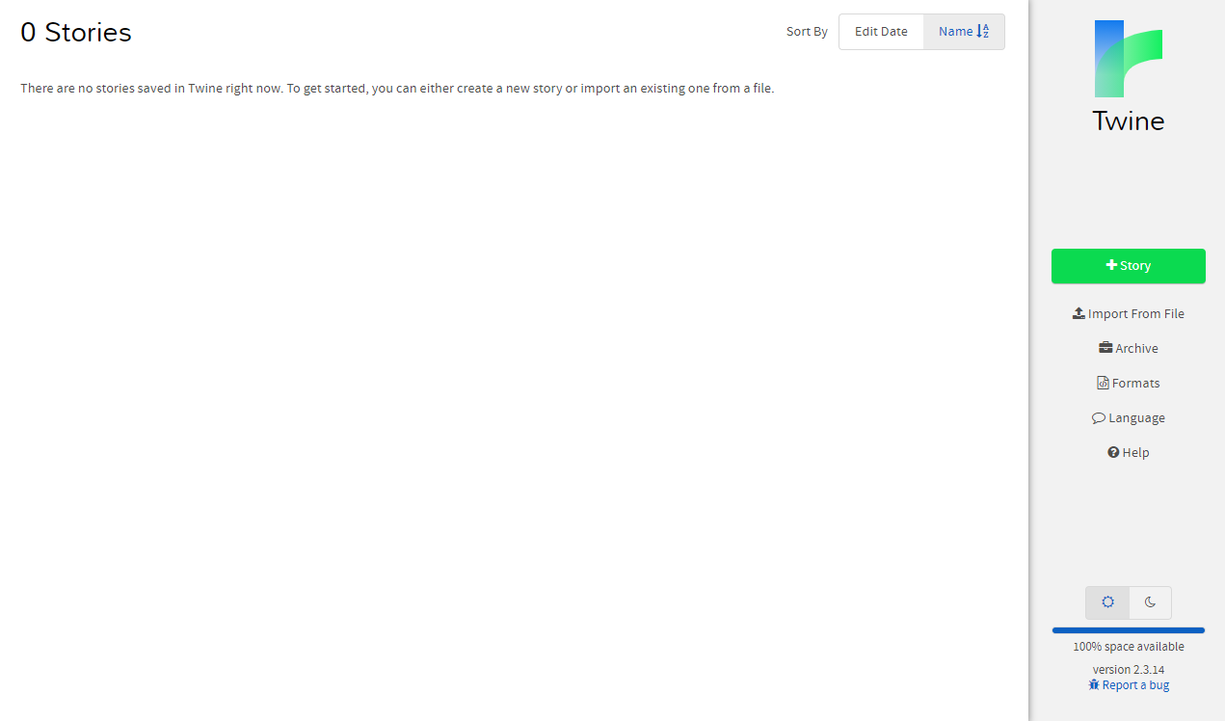

- First, select the button on the right labeled “+ Story.” Twine will ask what you’d like your story to be named. Name your story whatever you like—you can always change it later.
At this point, you must choose a difficult question prompt and confirm it with your teacher if you haven’t already.
- Consider what form you’d like to give your story. You can create your Twine in whatever style you like. You might write a choose-your-own-adventure short story, script a conversation between several characters through dialogue, create a demo-sized RPG, or use another form of interactive storytelling.
Once you have that in mind, you can move on to building your Twine in earnest. Keep in mind that your goal for this activity is to present your topic respectfully and from multiple angles. Remember your classroom norms!

The Story Menu
After naming your story, Twine immediately takes you to the story editor screen. Notice two things: the little box named “Untitled Passage” and the “▲” menu on the bottom left with your Twine’s name.

- Select the story menu (the ▲ menu) on the bottom left to open it. This menu allows you to toggle certain options that affect your story as a whole. You can also use this menu to archive and save local copies of your Twine.
- In the ▲ menu, select “Change Story Format.” Select “SugarCube 2.34.1.”
- Press the “x” in the top right corner of the pop-up window to return to the story editing screen.
Feel free to explore other options in the ▲ menu as you build. Keep in mind that changing the story format will change the programming language of your Twine, which may affect the mechanics addressed in this guide (as well as CSS elements, macros, and other styles).

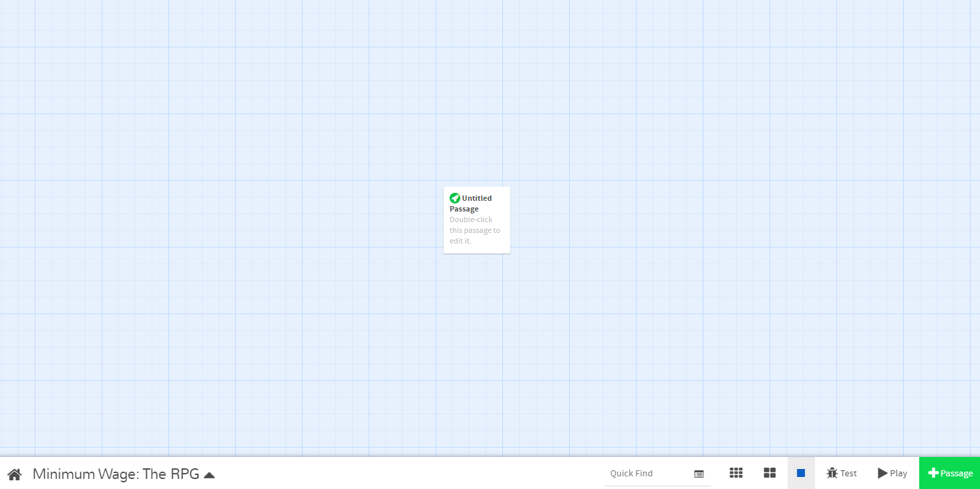

Sketch Your Twine
Remember the game you played earlier in this lesson? This is what the finished Twine looked like behind the scenes:
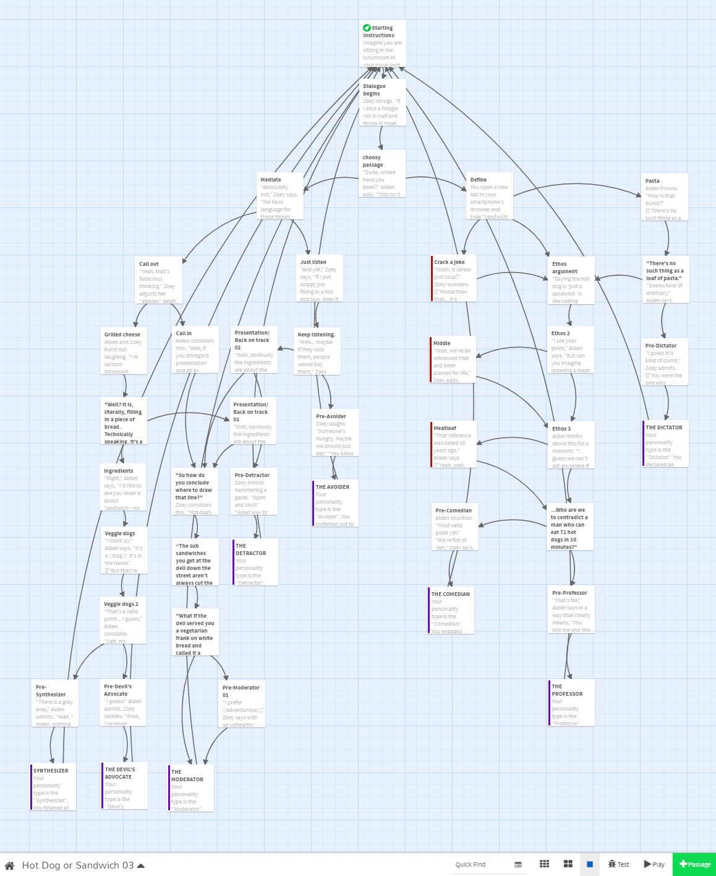

In Twine, each of these squares is called a passage. In the above Twine, each passage ends with a choice or selection for the player to make. You played by reading a passage and selecting a dialogue option, which linked you to the next passage based on your choice. You’ll create your full interactive story using passages and links.
- Hover your cursor over the box labeled “Untitled Passage,” then select the pencil icon that appears. (You can also double-click the box.)

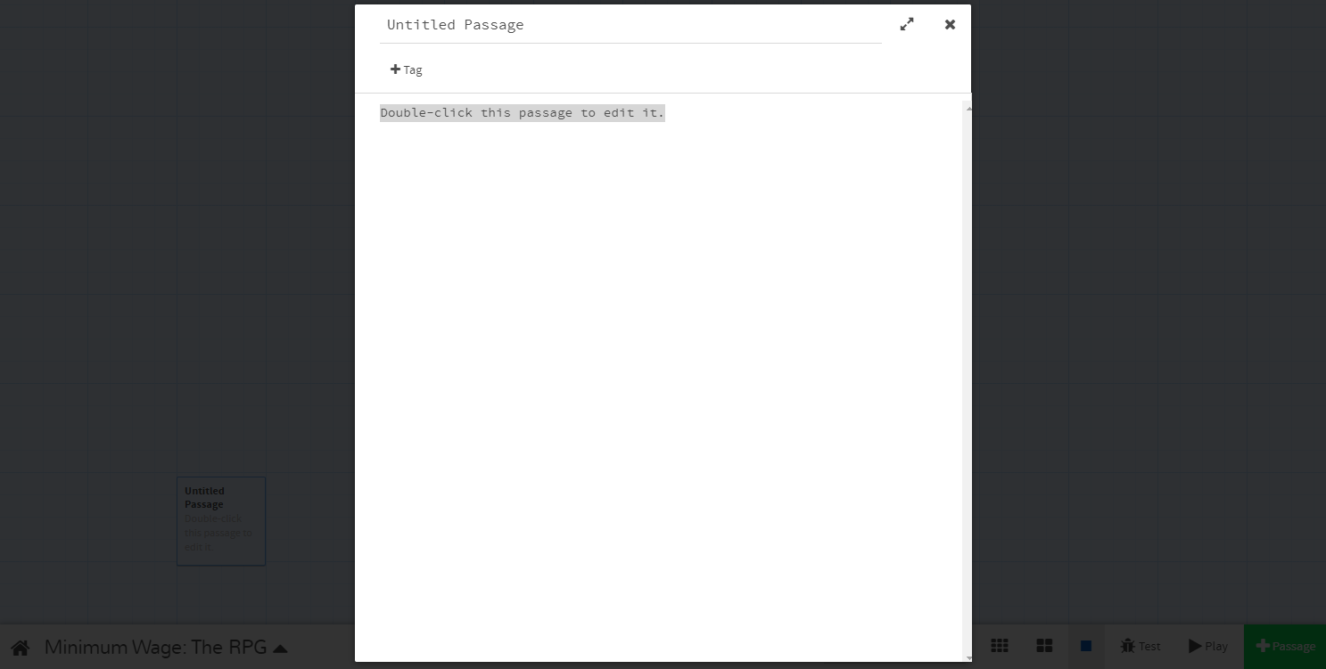

Let’s name our passage. Passage names won’t be visible when playing the game, but naming passages helps us remember their purposes and link them together. In the Twine you played before, the first passage was named “Starting Instructions.”
- Think about where you want to start your story and give your first passage a fitting name.
Next, let’s write some text we can work with. Consider the type of story you’d like to tell and start off with that format. For example, you might write some dialogue formatted like a script. You may also want to include instructions for players who haven’t played a game like this before.
Here are a few prompts to get you started. You can use one, all, or none of them.
- Introduce the player character: “Your name is ______. You are ______.”
- Ask an interesting question: “Have you ever wondered about ______?”
- Inform the player of their goal: “Your goal is ______.”
- Provide instructions for playing: “As you play, choose the best dialogue options for ______.”
Don’t worry about whether it sounds good. You can revisit any part of your Twine to edit later.
- Write a few lines of text for players to see when they first begin your story.

After you’ve verbally sketched out your passage, add two possible options for players to choose between. These might point towards two different arguments or perspectives of the difficult question you’ve selected.
- Add a first option.
- Add a second option.
- Be sure both of these options are on their own lines.
- Place each option in [[brackets]] to make the text selectable for players.

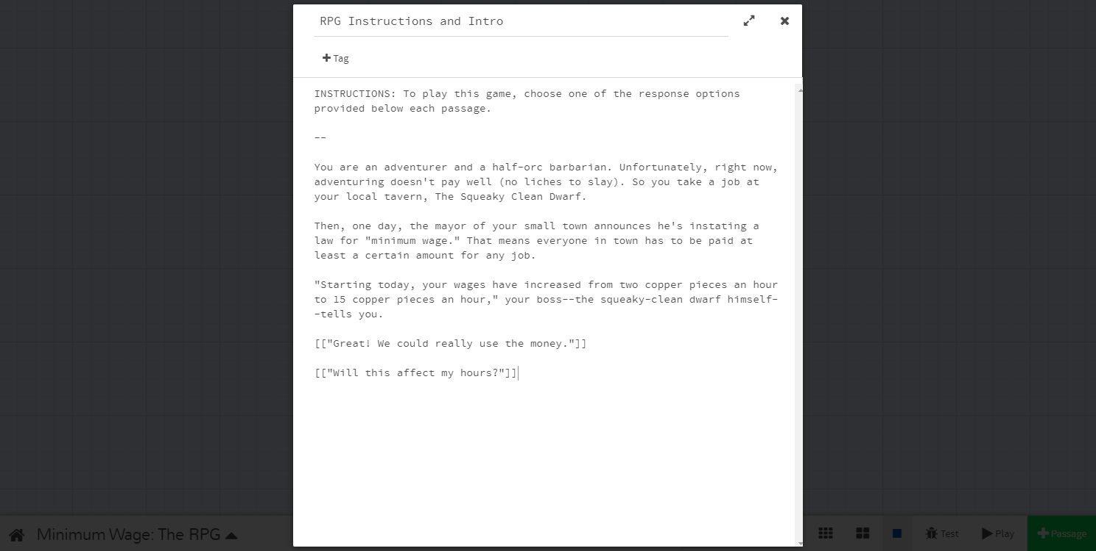

- Close out of the passage by pressing the “x” at the top right of the passage box. Whenever you do so, Twine automatically saves your writing.

Connecting Passages
See the two new passages in the story editor screen? Twine automatically created two linked passages based on the two lines of bracketed text you created. The names of these new passages are based on the text you placed inside the brackets.
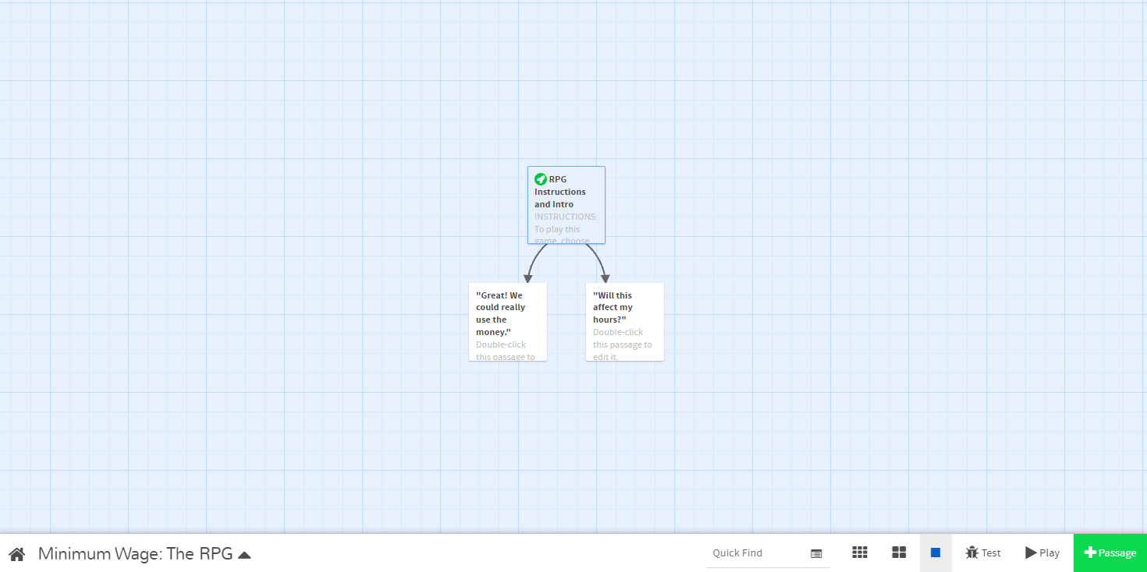

- Double-click one of your new passages.
- In the new passage’s window, write the text you’d like your player to see after selecting the previous dialogue option. For example, if the player chooses to move to a new location, describe that location in the new passage. For maximum effect, consider the consequences of the choice the player selected. What might the player want to see? What might they not expect?
Notice that Twine automatically creates lines and arrows between passages to track the story flow.
- Select a third passage and write your text. Return to the story editor screen. Repeat this with your other branch of passages.
Try creating a few more passages. You don’t have to have branching dialogue every time. Try including a passage with one option for the player to select that will simply take them to the next passage.

Modifying Linked Text and Passage Names
You can also link a dialogue option to an existing passage. To do so, open the passage with the text you’d like to link.
- Modify the text in brackets by adding a pipe symbol (|) after the text you intend for the player to see. After the pipe, insert the name of the passage you’d like that text to lead to: [[choice text|passage name]].

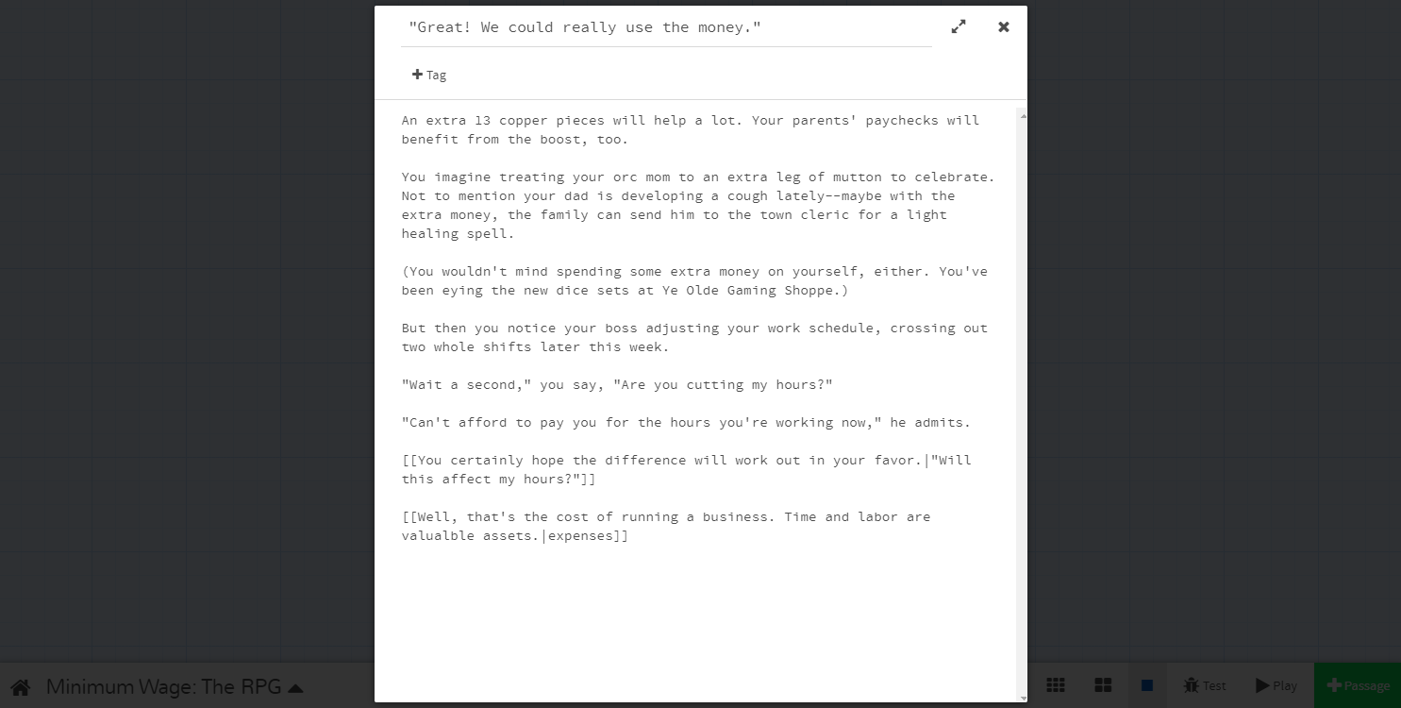

You can use this trick to separate in-game text from passage names. Notice the second option above—it has been created with a separate passage name, “expenses.” On the story editor screen, you’ll see this passage now links to the passage created previously as well as a newly created one.

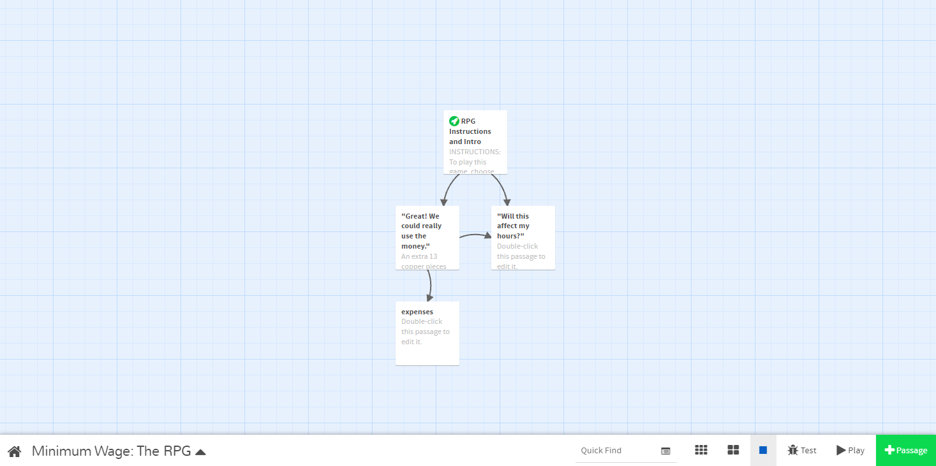

Keep in mind that changing the title of a passage will also change the corresponding text in the previous passage if you have not separated them with a pipe. (You can separate them at any time.)

Troubleshoot Connections
Next, let’s test our story.
- Hit the Play button in the lower right-hand corner of the story editor screen.
- Playtest your Twine.
You should now have a story where you, the player, view a passage and pick between two choices. If your story doesn’t work the first time, that’s okay! We can fix that by troubleshooting, a type of problem-solving where we run our own tests to identify issues.
- If you encounter issues, return to the story editor screen. Go over the following.
- Are your [[brackets]] typed correctly, with opening and closing double brackets?
- Does the choice text inside the [[brackets]] match the connecting passage’s name?
- Is the capitalization consistent between choice text and passage names?
- Continue troubleshooting and playtesting until your Twine plays as intended.

Continue Writing Your Twine
With what we’ve learned so far, you can create a full story with multiple branches and endings. Continue working on creating and linking passages. Build up a branching narrative for your story that helps to flesh out your difficult question.
Consider working towards two different endings. Think about how you might tailor a few passages to “branch” toward a satisfying conclusion. Your endings might vary between “good” or “bad,” or they might be ambiguous. Remember to be respectful of your subject matter!
- Draft at least two endings.
- For each ending, create a restart or “Try again?” option and link it to the starting passage.
If you want to go above and beyond, you can learn more about the sophisticated tools Twine provides to infuse your story with complex logic.
- Optional: For information on more complicated logic and other features, reference the Twine Cookbook or the Interactive Fiction Community Forum.

“Publish” or Back Up Your Twine
Twine automatically saves your work to your browser. However, you should consider exporting yours as a playable HTML file periodically. You can save this file as a backup. You can also send it to your friends. Try exporting your Twine as a backup now.
- From the story editing screen, select the ▲ menu on the bottom left.
- Select “Publish to File.”
- If desired, save or email the resulting file elsewhere.

Customize Through Code
Many excellent Twine stories have been made with only links and passages. If you prefer to go a step further, you can also use simple CSS (Cascading Style Sheets) to infuse your interactive story with visual elements to further enhance your story.

Change the Default Appearance
By default, your story’s text appears in white on a black background. You can easily change these colors as well as your font’s style and size.
- Open the ▲ menu (the arrow at the bottom left of the story editor screen). Select “Edit Story Stylesheet.
The stylesheet is blank. Copy the simple CSS codes below the following screenshot into your stylesheet to start changing your story’s colors and fonts. Be sure to copy brackets, punctuation, and line breaks as typed.
- Copy and paste the CSS below. This will change the background color, text color, font, and text size of every passage in your story.
- Change at least one color from the example text to fit the vision you have for your Twine. There are a variety of colors that can be used in CSS and HTML programming. W3Schools’ HTML Colors page lists colors by name.
- Change or add a font from the example text. W3Schools CSS Fonts page lists a few fonts and font families.
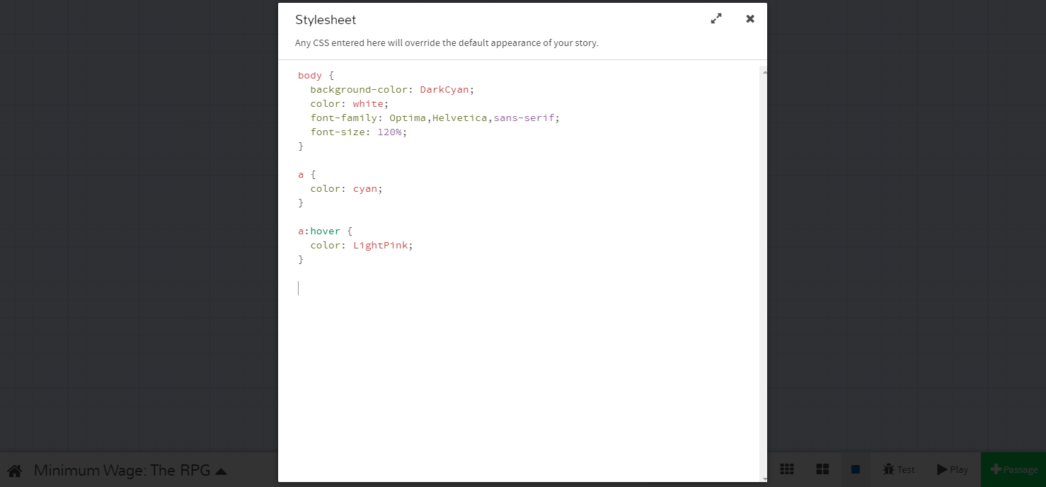
body {
background-color: DarkCyan;
color: white;
font-family: Optima,Helvetica,sans-serif;
font-size: 120%;
}

In CSS, the “body {}” tag serves to apply every code inside its brackets to the body of the story.
Line 2 (background-color: DarkCyan;) changes the background color to dark cyan.
Line 3 (color: white;) changes the color of the text to white.
Line 4 (font-family: Optima,Helvetica,sans-serif;) sets the fonts, prioritizing fonts starting on the left. Select multiple fonts to accommodate computers that may not have all these fonts. For example, computers without the font “Optima” will use “Helvetica” instead; computers with neither will use a default sans-serif font.
Line 5 (font-size: 120%;) makes the font size a little larger.
The below script changes the color of links to cyan. In CSS, the “a” tag changes the appearance of links.
a {
color: cyan;
}
The below script changes the color of the links when you hover over them to light pink.
a:hover {
color: LightPink;
}

Change the Appearance of an Individual Passage
You changed the appearance of your story as a whole. It is possible to customize individual passages, too.
To change the appearance of an individual passage, you need to add a tag to that passage. To add a tag, double click the passage and select “+Tag” under the passage title. Name the tag something that relates to the passage. For example, the below tag reads “outside” because it will be applied to passages where the player character walks outside. Tags can be added to as many passages as needed.
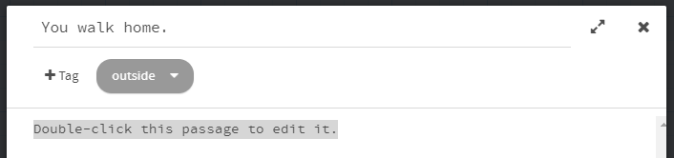
- Add a tag to at least one passage.
- From the story editing screen, select the ▲ menu on the bottom left. Select “Edit Story stylesheet.”

- On a new line in the stylesheet, type the name of your tag and place a period in front like this:
.yourtag {
background-color: YourColorHere;
color: YourColorHere;
}
- Change “yourtag” to the name of your tag. Be sure not to erase the period at the start of the line.
- Customize the background color and text color as you did before. The formatting works the same way customizing your default appearance.
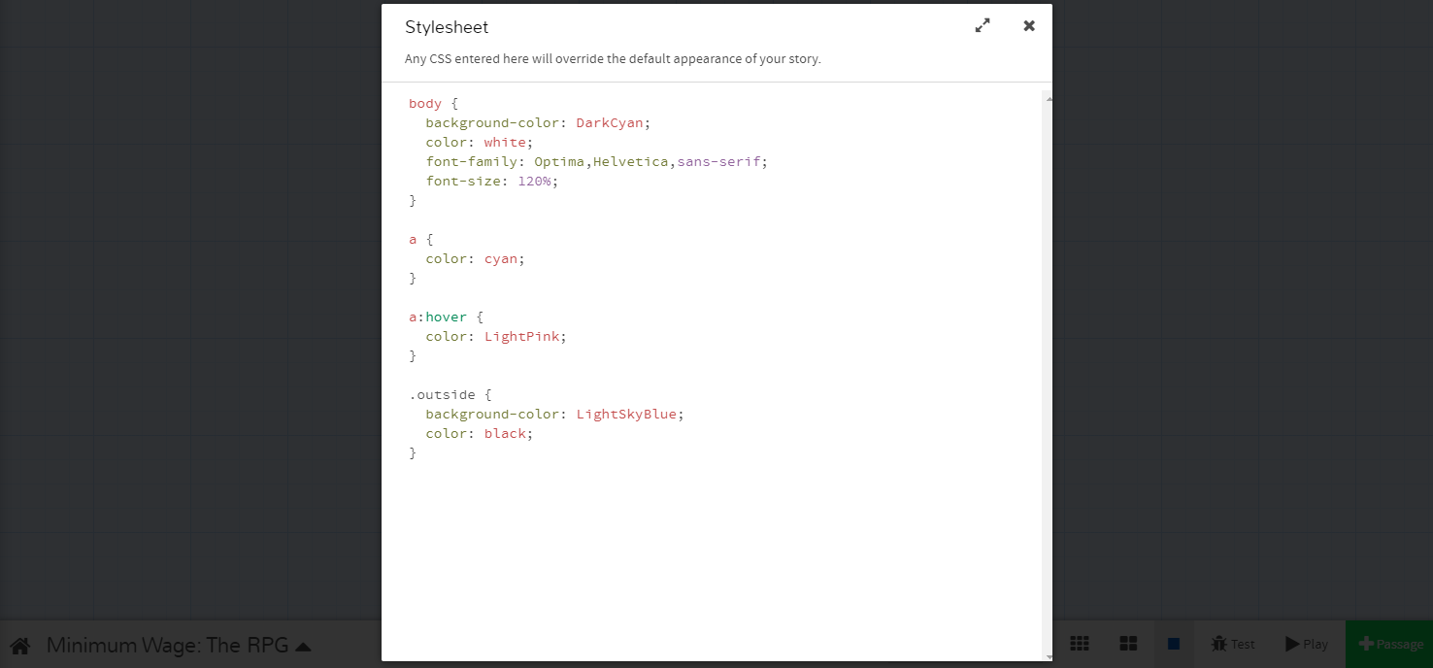
The above script changes passages tagged with “outside” to the background color “light sky blue” with black text.

Add Images
There are two different ways to add images to a story:
- By URL: Add the URL of the image to your script inside an “img src” tag (see below). An issue with this method is that you are limited to the images on the internet. You also have no control over the sites where these images were found. If the site is removed, your image will disappear.

- In the passage by which you want your image to appear, insert the following tag and add the URL of the picture inside the quotes: <img src="">
<img src="https://upload.wikimedia.org/wikipedia/
commons/thumb/1/17/A_Tavern_Scene_1883.jpg/513px-A_Tavern_Scene_1883.jpg">
This script inserts the image (“A_Tavern_Scene_1883.jpg”) found at the URL (“https://upload.wikimedia.org...”).
- From a folder on your computer: Create a folder where you will save the HTML file of your Twine story, and any images you plan on using. Then add these images to the folder. Insert the filename of an image in an “img src” tag (see below) wherever you want it to appear.
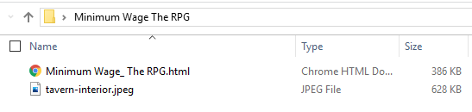
- In the passage by which you want your image to appear, insert the following tag and add the URL of the picture inside the quotes: <img src="">
<img src="tavern-interior.jpeg">
This script inserts the image (“tavern-interior.jpeg”) found in your Twine’s folder.
If you test your story without first publishing it, your image may not appear correctly. To properly view your story, you need to “publish to file,” then open the resulting HTML file in a web browser. This will allow you to see how your story looks and judge whether any of your images need to be resized. If they need to be resized, insert the following tag and adjust the “width” value.
<img src="tavern-interior.jpeg" width="50%">
As written, this tag sets the size of the image to 50% of the original.

Add Video
There are three ways to add videos to your story. As with an image, you can use a URL or insert a file saved on your computer. The other way to display a video is to embed it. To do this from YouTube, click the “Share” icon and select “Embed.” Copy the text that appears and paste it where you want the video to appear in your passage.
With any of these methods, you can adjust the dimensions of the file as in the following example:
<video src=“https://www.nfb.ca/film/maq_spirit_woods/” width=“640” height=“480”>
</video>
Again, “publish to file” to test your video by opening the HTML file in a browser.

Conclusion
Congratulations! In addition to creating full interactive stories, troubleshooting potential problems that come up, and exporting the story to its own file, you can now customize your story’s colors, fonts, and lots of other visuals. Have fun finishing your Twine!
- Done!

Adapted from:
Snow, K. (July 2021). Introduction to Twine. Pinnguaq. https://pinnguaq.com/learn/introduction-to-twine/
Jilesen, M. (July 2021). Mythology Using Twine. Pinnguaq. https://pinnguaq.com/learn/mythology-using-twine/

