Shark Tank Instructions and Rubric
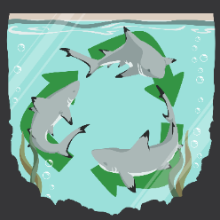
Your group will create a “Shark Tank” presentation about your chosen product. Your model may be 3D printed on a smaller scale, but you should explain in your presentation how it would work on a larger scale. You need to create a minimum of four slides and include at least one image. Each slide should cover the following:
- Introduction: Create an introductory slide that includes the product’s name and what it does.
- Talking Points: What is the science behind the problem? And how did you solve it?
- Cost: How much will it cost to make the product? How much will you sell the product for?
- Potential Risks: What are the potential risks associated with making and/or using the product?
 | Exceeds | Meets | Needs Improvement | No Marks | Points
Cost and Risk | Went above and beyond in researching and presenting the potential cost and risk associated with the product. | Researched and presented the potential cost and risk associated with the product. | Shows some understanding of the potential cost and risk associated with the product. | Incomplete/  Missing | ________
Depth of Coverage/ Knowledge | Shows a solid grasp of all content covered. Provided information above and beyond what was required, and all facts that were reported about the topic were accurate. | Shows a solid grasp of most of the content. Provided all required information, and all facts that were reported about the topic were accurate. | Shows a basic level of coverage of key ideas only. Facts were accurate for at least 60% of the information reported about the topic. | Incomplete/  Missing | ________
Visual Representation | Presentation included a balance of both images and text. Text was an appropriate size and contrasted with the chosen background, making it easy to read. | Presentation included both images and text, but it relied more heavily on one over the other. Text was an appropriate size and contrasted with the chosen background, making it easy to read. | Presentation included few or no images. Text was either not appropriately sized or did not contrast with the background, making it difficult to read. | Incomplete/  Missing | ________

