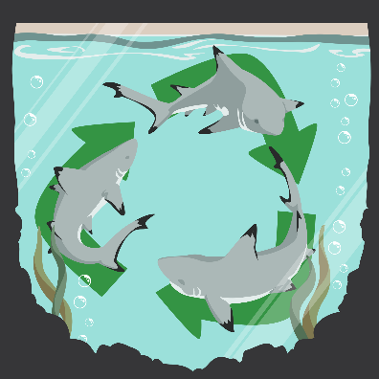
Shark Tank Presentations
As you watch your classmates’ presentations, consider the following information:
- Cost: How much will it cost to make the product? How much will they sell the product for?
- Potential Risks: What are the potential risks associated with making and/or using the product?
- Talking Points: What were their best talking points related to the science behind the problem?
- Improvements: What improvements could be made to the product (or the points presented)?

Product Name | Notes

