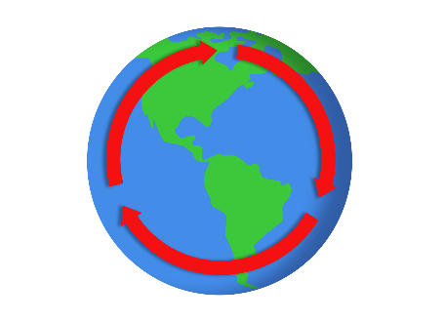
Carbon Cycle Cornell Notes

Section | Key Information | Questions
The Rates of Cycling Carbon, Part A
The Rates of Cycling Carbon, Part B
Atmosphere,
Part A
Atmosphere,
Part B
Ocean,
Part A
Ocean,
Part B
Land,
Part A
Land,
Part B
Summary

