Carbon Cycle Slide Instructions and Rubric
Based on the section of the article you’re assigned to read, you and your group will create a slide about the carbon cycle. After your group has read and discussed your section, create a slide summarizing that section and include at least one image that depicts your group’s topic. Your group’s slide will be added to our class’s slide presentation and presented to the class.

Article Sections (Circle Your Assigned Section)
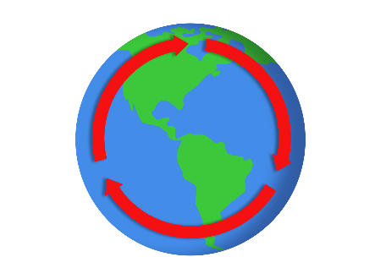
- The Rates of Cycling Carbon, Part A
- The Rates of Cycling Carbon, Part B
- Atmosphere, Part A
- Atmosphere, Part B
- Ocean, Part A
- Ocean, Part B
- Land, Part A
- Land, Part B
 | Accuracy | Visual Representation
Exceeds | Provided information above and beyond what was required. All facts that were reported about the topic were accurate. | Included a balance of both images and text. Text was an appropriate size and contrasted with the chosen background, making it easy to read.
Meets | Provided all required information. All facts that were reported about the topic were accurate. | Included images and text but relied more heavily on one over the other. Text was an appropriate size and contrasted with the chosen background, making it easy to read.
Approaching | Facts were accurate for at least 80% of all information that was reported about the topic. | Included images and text. Text was either not appropriately sized or did not contrast with background, making it difficult to read.
Needs Improvement | Facts were accurate for at least 60% of the information that was reported about the topic. | Included few or no images. Text was either not appropriately sized or did not contrast with background, making it difficult to read.
No Marks | Incomplete/missing | Incomplete/missing
Points

