Create Your Own Terrarium
Just like the eight researchers who experimented with creating a self-sustaining environment, we will attempt to create our own self-sustaining ecosystem that thrives on the cycling of energy and other materials, such as carbon.

Purpose
To create a self-sustaining closed ecosystem.

Materials
- Mason jar (or any clear jar with a lid)
- Cactus potting soil
- Aquarium sand/gravel
- Water
- Plants
- Activated charcoal (you can get this from a pet store)

Procedure
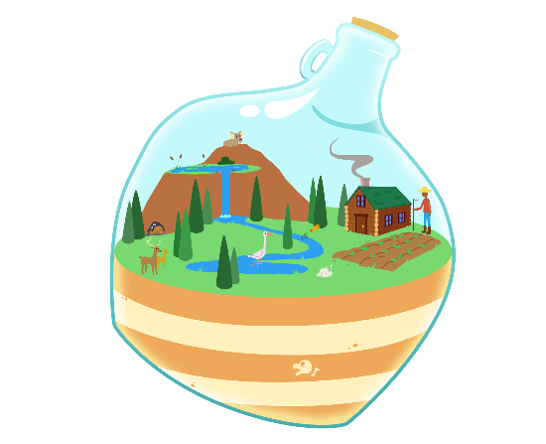
- Wipe out the jar to ensure that it is clean.
- Place 2–5 cm of aquarium sand at the bottom of the jar.
- Add 1–2 cm of activated charcoal.
- Next, add 5–10 cm of cactus potting soil.
- You may choose to add in some rocks and/or a small
piece of wood.
- Insert your living organisms (plants).
*Optional: You may add a couple of bugs to your
ecosystem if you’d like.
- Add enough water to make sure the sand is wet (not drowning in water, just wet).
- Seal your jar with the lid. Place the ecosystem near the window or under a light source.

Adapted from Kenney, J. (2013). How to Make a Mason Jar Terrarium. The Science Classroom. https://thescienceclassroom.org/how-to-make-your-own-self-contained-ecosystem-biosphere/

