The Effects of Changing the Carbon Cycle

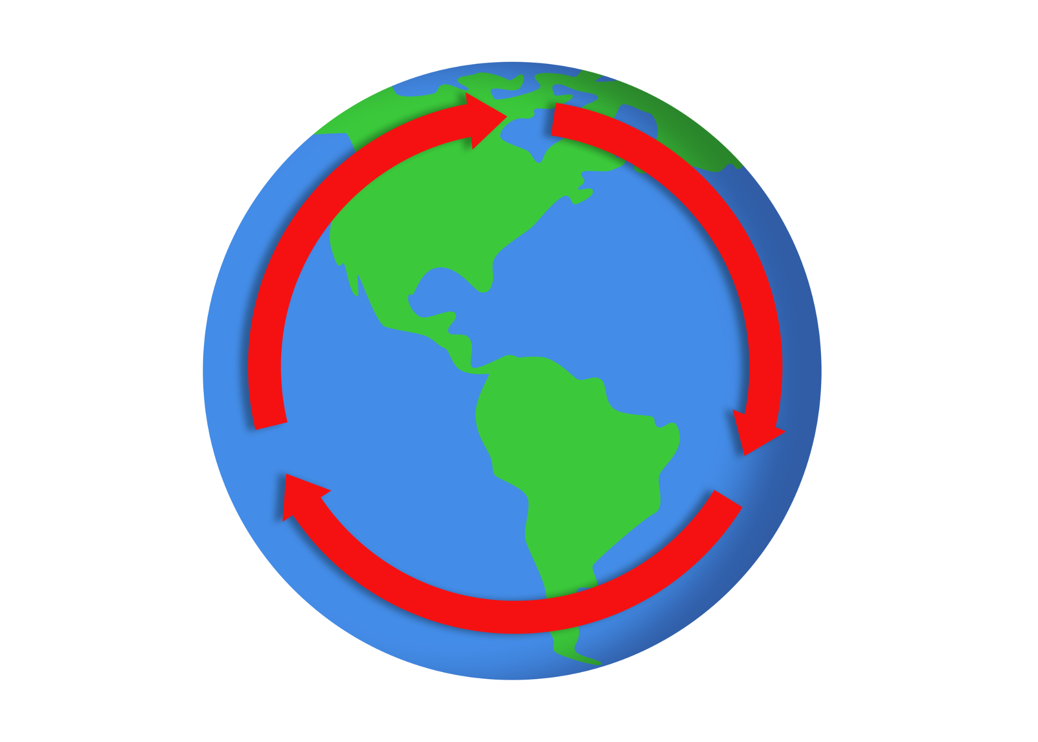

The Rates of Cycling Carbon, Part A
Carbon is essential to life because it can form many bonds to create a variety of complex organic molecules, including chains and rings. Carbon chains and rings are the basis of living cells, and their bonds contain a lot of energy. When these bonds break apart, the stored energy is released. This energy makes carbon molecules an excellent source of fuel for all living things.
The fast way in which carbon is cycled through our world occurs through the two main processes of photosynthesis and respiration. In photosynthesis, plants and phytoplankton (microscopic organisms in the ocean) drive the process. Phytoplankton and plants “breathe in” carbon dioxide into their cells from the air. With the help of solar energy, they use CO₂ and water to produce sugar (CH₂O) and oxygen. This is the equation for photosynthesis (typically represented using the sugar glucose): CO₂ + H₂O + energy (sunlight) → C₆H₁₂O₆ + O₂.
Instead of building sugars, plants can do the opposite through the process of respiration. After breaking down sugars, plants use energy from the bonds to help them grow. Living organisms that feed on plants or phytoplankton can break down the sugars within a plant to obtain the energy for themselves. When plants and phytoplankton die and are broken down by bacteria or destroyed by fires, the oxygen and sugars within them are converted and broken down to produce water, carbon dioxide, and energy. Each of these reactions are centered around the equation for respiration: C₆H₁₂O₆ + O₂ → CO₂ + H₂O + energy (ATP). You may notice this is the complete opposite of the equation for photosynthesis.
About 55% of human-emitted carbon has been taken in by plants and by the ocean, and the remaining 45% circulates in the atmosphere. While the additional carbon helps plants grow, it raises the Earth’s temperature. It also harms marine life by increasing acidity in the ocean.

The Rates of Cycling Carbon, Part B
The slow way in which carbon is cycled occurs through its storage in rocks, soil, the ocean, and the atmosphere, taking between 100–200 million years to cycle through all four. In the atmosphere, carbon atoms—some of which are human emitted—combine with water to make carbonic acid that falls to the ground when it rains. The acid weathers (dissolves) rocks and releases calcium, magnesium, potassium, or sodium ions. In rivers and oceans, the calcium ions join with bicarbonate ions to form calcium carbonate (which you may have seen before—it is a dry, chalky white substance that can be found near faucets in areas with hard water). Calcium carbonate is also created when shell-building organisms, such as coral and plankton, die and sink to the ocean floor. As time passes, layers of those calcified shells and sediment are compressed to form rocks that store carbon. The same occurs with organisms on land, whose remains after death sometimes become buried in the soil and compressed into rock formations.

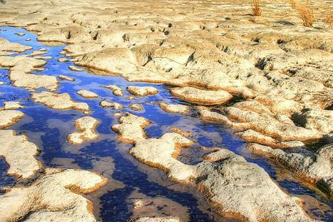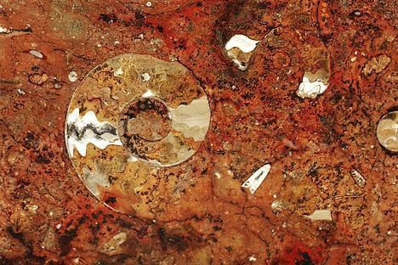
Left: Rivers carry calcium ions into the ocean, where they react with bicarbonate ions dissolved in the water. The product of that reaction, calcium carbonate, is then deposited on the ocean floor, where it becomes limestone.
Image source: Carley, G. (2009, January 18). San Gabriel River Bottom [Image]. Flickr.
Right: Limestone is rock made primarily of calcium carbonate. This rock type is often formed from the bodies of marine life, and these shells, skeletons, and plant remains can be preserved as fossils. Carbon that is locked up in limestone can be stored there for millions of years.
Image source: Rookuzz. (2008, May 1). Untitled – Marokko [Image]. Flickr.

Sometimes, decaying plants and other organisms get buried deep underground and transform under heat and pressure over millions of years, producing oil, coal, or natural gas. When these fossil fuels are burned by humans, wildfires, or volcanoes, CO₂ is released back into the atmosphere. During a volcanic eruption, CO₂ is emitted as a gas while carbon-containing rocks melt and release CO₂. For comparison, volcanoes emit between 130 and 380 million metric tons of CO₂ per year, whereas humans emit about 30 billion tons per year by burning fossil fuels—that’s 100 to 300 times more than volcanoes. To rebalance the slow carbon cycle through chemical weathering, it generally takes a few hundred thousand years as volcanic activity leads to rising temperatures and acidic rain, which creates carbonic acid that weathers rocks, which then creates buildup of calcium carbonate on the ocean floor.

The Effects of Changing the Carbon Cycle

Atmosphere, Part A
Carbon dioxide, methane, and halocarbons are referred to as greenhouse gases, and they are essential compounds that absorb and release energy in our atmosphere, including infrared energy (heat). The energy released by these gases radiates in all directions, and some of it returns to Earth’s surface and warms it. Without these greenhouse gases, Earth would be a big block of ice at −18 degrees Celsius (0 degrees Fahrenheit). However, with an overabundance of greenhouse gases, Earth would be around 400 degrees Celsius (750 degrees Fahrenheit) like Venus. Thus, carbon dioxide and other greenhouse gases play a significant role in maintaining temperatures that support life on Earth.

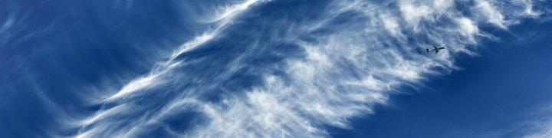
Rising concentrations of carbon dioxide in the atmosphere are warming the planet. Increased temperatures result in higher evaporation rates and a wetter atmosphere, which leads to further warming.
Image source: Wilken, P. (2011, May 25). Cirrus [Image]. Flickr.

Since scientists know the amounts of each type of greenhouse gas in the atmosphere and which wavelengths of energy they each absorb, scientists can calculate how much each gas contributes to the warming of Earth. CO₂ contributes about 20% of Earth’s greenhouse effect, water vapor contributes 50%, and clouds contribute 25%. The remainder is from small particles (aerosols) and minor greenhouse gases like methane.

Atmosphere, Part B
Water vapor concentrations in the atmosphere are controlled by Earth’s temperature. Rising temperatures increase the amount of water that evaporates into the air from plants or bodies of water, causing a rise in humidity. When temperatures are cooler on Earth, condensation occurs in the atmosphere and water falls back down as precipitation (rain, sleet, or snow).
Unlike water vapor, carbon dioxide can stay in the atmosphere at low and high temperatures, and it helps regulate the amount of water vapor in the atmosphere. If CO₂ levels go down, temperatures fall and so does water in the form of precipitation. If CO₂ levels go up, temperatures rise and water evaporates. Though the water cycle has the largest impact on the greenhouse effect, it is driven by the levels of CO₂ regulating Earth’s temperature.
Due to recent increases in CO₂ and other greenhouse gases in the atmosphere, scientists have measured parallel changes in temperature. Since 1880, there has been an average global temperature increase of 0.8 degrees Celsius (1.4 degrees Fahrenheit). Further warming largely depends on how much more CO₂ is released into the atmosphere by human activity.

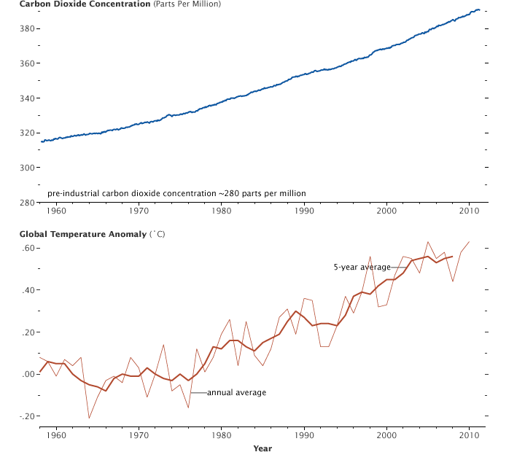
With the seasonal cycle removed, the atmospheric carbon dioxide concentration measured at Mauna Loa Volcano, Hawaii, shows a steady increase since 1957. At the same time, global average temperatures are rising due to heat trapped by additional CO₂ and increased water vapor concentration. (Graphs by Robert Simmon, using CO₂ data from NOAA Earth System Research Laboratory and temperature data from Goddard Institute for Space Studies.)

The Effects of Changing the Carbon Cycle

Ocean, Part A
At the surface of the ocean, carbon dioxide is exchanged between the ocean and the atmosphere. Roughly 30% of human-emitted CO₂ has been absorbed by the ocean. Once absorbed, carbon dioxide reacts with hydrogen ions in the water. This results in carbonic acid, which makes ocean water (which is naturally slightly alkaline, or basic) more acidic.
A rise in the ocean’s acidity level has several negative impacts on marine organisms. For example, shell-dwelling organisms use carbonate ions to make their calcium carbonate shells, but the addition of carbonic acid in the ocean combines with carbonate ions to create bicarbonate instead. Due to the decrease in carbonate ion availability, shell-dwelling organisms must work harder to create their shells with what little amount of carbonate ions is available, resulting in thinner and weaker shells.
Additionally, increased acidity weathers (dissolves) rocks and shells that are made of calcium carbonate. While this process releases carbonate ions back into the ocean in the short term, it also causes the ocean to absorb more CO₂ in the long term, which further weakens shells.

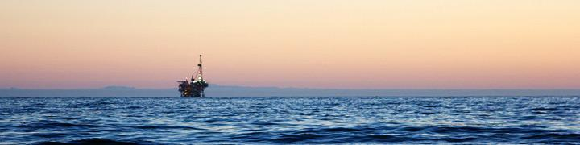
Some of the excess CO₂ emitted by human activity dissolves in the ocean, becoming carbonic acid. In this way, increases in carbon dioxide lead to not only warmer oceans but also more acidic oceans.
Image source: Way Out West News. (2010, August 14). Santa Barbara’s Offshore Drilling [Image]. Flickr.

Ocean, Part B
Phytoplankton (microscopic organisms in the ocean) are important producers in the ocean’s food web, and they help remove CO₂ from the Earth’s atmosphere. However, as a result of the greenhouse effect caused by carbon dioxide and other greenhouse gases, temperatures are rising not only in the atmosphere but also in Earth’s oceans and other bodies of water. With ocean temperatures increasing, there may be less phytoplankton in the future because they reproduce better in cooler waters.
One advantage of the increased availability of CO₂ for phytoplankton and plants is that they can use it to make sugars, such as glucose, that help them grow. However, most marine organisms are not helped by the overabundance of carbon dioxide.
Before the Industrial Revolution and the production of cars, factories, and other machine manufacturing, the ocean and atmosphere were able to balance the exchange of carbon between them. Due to increased carbon dioxide in the air, however, the ocean now absorbs more carbon than it emits.
In future millennia, the ocean could take in up to 85% of the carbon that humans have released by burning fossil fuels, but this process of absorption is very slow because it depends on the movement of water from the ocean’s surface to its depths. Increased global temperatures are also affecting glaciers, which are melting in the northern and southern hemispheres. As glaciers and ice caps melt, they contribute to rising sea water levels.

The Effects of Changing the Carbon Cycle

Land, Part A
On land, plants have absorbed about 25% of human-emitted carbon dioxide. Over time, the amount of CO₂ absorbed by the Earth’s plants has gone up since 1960. Plants, like phytoplankton (microscopic organisms in the ocean), can take carbon atoms and link them with other atoms to create complex carbohydrates, such as glucose (a type of sugar). These complex carbohydrates have bonds that, when broken down, release energy that all biotic (living) organisms can use as fuel. With CO₂ levels rising in the atmosphere and ocean, plants can use the extra carbon dioxide to grow bigger and more numerous through the process of photosynthesis. This increased growth is referred to as carbon fertilization.
As long as plants live in an environment where all the reactants they need are available—such as water, carbon dioxide, sunlight, and nutrients like nitrogen—they will continue to grow abundantly. However, if a plant lacks access to one of these essential nutrients or environmental factors, then it will not thrive and may even die. As of now, plants are thriving with more CO₂ in the atmosphere, but if water or nitrogen becomes unavailable due to drought or poor land management, then the amount of CO₂ available will not matter; plants will struggle to grow and reproduce.
Plants’ carbon absorption can be affected by human activity, including our agricultural choices and growing methods. Because forests’ vegetation and soil are much better at absorbing CO₂ from the atmosphere than crops are, it is important to rotate farmland. However, to keep up with demand for crops, some farmers try to grow more food in the same land area year after year, instead of alternating land plots or crop type and allowing farmland that is no longer used to return to a forest state. To combat rising CO₂ levels in the atmosphere, preventing wildfires also can help ensure carbon remains stored in plants rather than being released into the air.

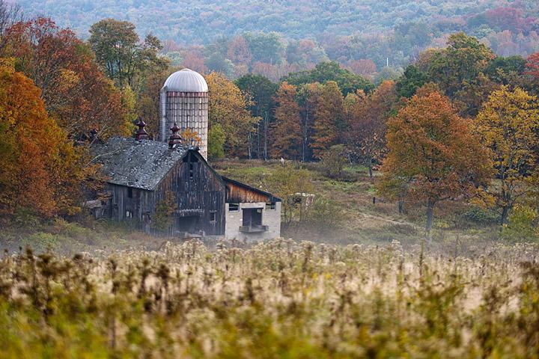
Changes in land cover—when forests are converted to fields and vice versa—have a corresponding effect on the carbon cycle. In some northern-hemisphere countries, many farms were abandoned in the early 20th century, and the land then reverted to forest. As a result, carbon was drawn out of the atmosphere and stored in trees on land.
Image source: Kadribegic, H. (2007, September 30). Abandoned Farm [Image]. Flickr.

Land, Part B
In the tropics, carbon dioxide is released when rainforests are destroyed, sometimes by fires that are started deliberately to clear the land for farming. As of 2008, deforestation (the removal of trees) contributed to about 12% of human-emitted CO₂ in the atmosphere.
The greatest changes to the carbon cycle on land are expected to come from climate change. Warmer temperatures result in a longer growing season and more humidity. While this can help plant growth initially, a warmer and longer growing season also means that plants need more water to stay alive. Scientists are already seeing evidence that plants slow their growth in the summer due to water shortages caused by this phenomenon. Because of warmer weather and water shortages, grass and forest wildfires have increased, and dry, water-stressed plants are more susceptible to insects. Even tropical rainforests may experience a stunt in growth or vegetation death if they don’t get enough water, which releases even more carbon into the air.
Another concern is the melting of permafrost, which is a permanent layer of carbon-containing ice on or just under Earth’s surface. When it melts, it can seep into the ocean or the soil and evaporate back into the atmosphere in the form of methane and CO₂. Research predicts that permafrost in the northern hemisphere contains 1,672 billion tons (Petagrams) of organic carbon. If 10% of this permafrost were to thaw, it could release enough extra CO₂ to raise global temperatures an additional 0.7 degrees Celsius (1.3 degrees Fahrenheit) by 2100.

Adapted from NASA. (n.d.). The carbon cycle. NASA Earth Observatory. https://earthobservatory.nasa.gov/features/CarbonCycle

