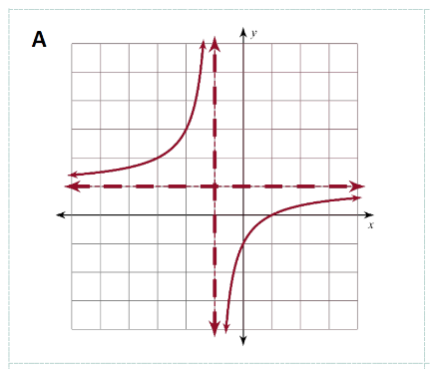
Card Matching Results
card label

After matching the cards, record the label from each card in the table below.
The label is in the top-left corner of each card.

Graph | Domain/Range | Asymptotes | Equation | Table | Intercepts
A
B
C
D
E
F

