Graphing Rational Functions: Guided Notes

# Definitions

Rational function: 

where  and  are polynomials, and 

Asymptote: A line (often dashed) that a curve approaches but does **not** cross

# How to Graph a Rational Function

**Step 1)** Find the asymptote(s).

* Since the denominator cannot equal zero, find the x-value(s) that cause this. These are the vertical asymptote(s).
* Rewrite the function so that the degree of the top and bottom of the fraction are the same, then write a ratio of the coefficients. This is the horizontal asymptote.

**Step 2)** Sketch the asymptotes with dashed lines.

**Step 3)** Make a table.

* Pick x-values based on the vertical asymptote.

**Step 4)** Plot points and connect dots.

* Be careful to ***not*** cross the asymptotes!

# Examples

Graph the function. Be sure to label the asymptotes.

**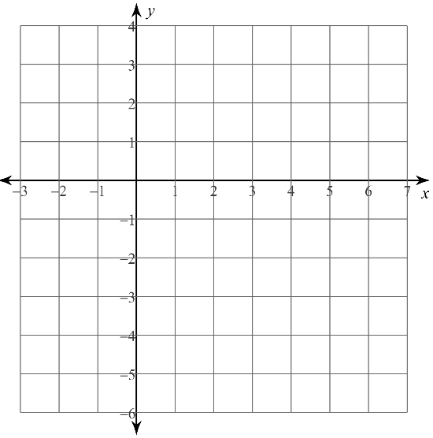1)** 

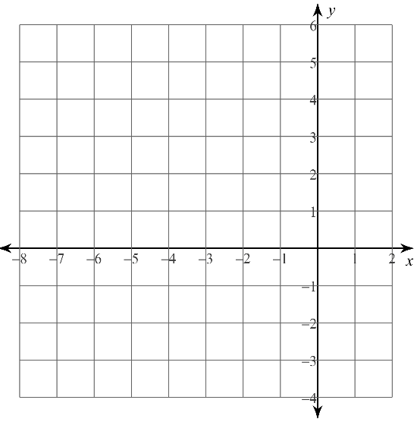

**2)** 