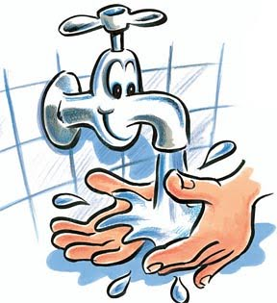  Wet your hands | 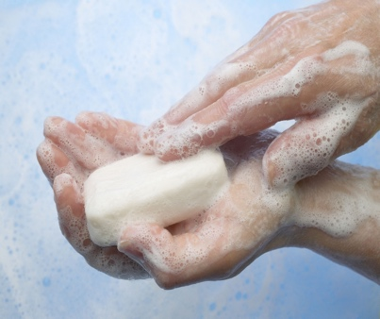  This Photo by Unknown Author is licensed under CC BY-SA-NC  Use soap | 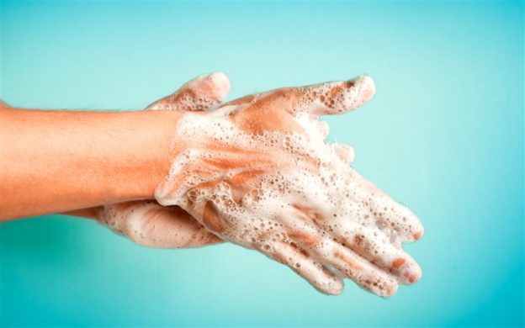  This Photo by Unknown Author is licensed under CC BY-SA-NC  Scrub your hands ---inside, outside, and in between.  Don’t forget your thumb.
Keep scrubbing for  at least 20 seconds | 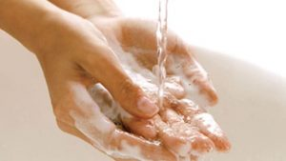  Rinse the soap off | 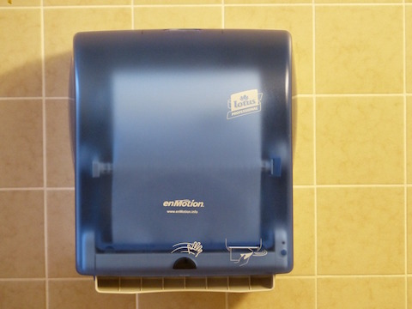Dry your hands with a clean towel

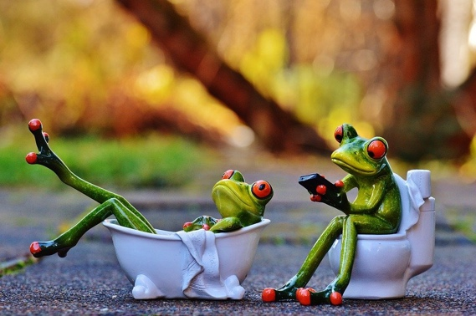  Using the bathroom | 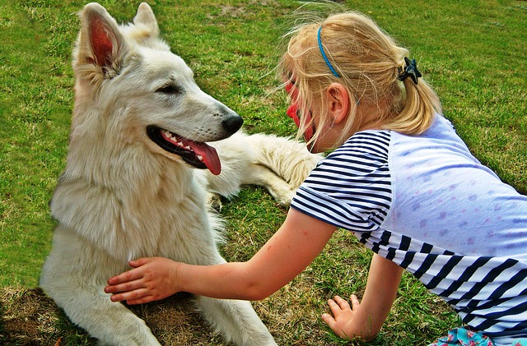  Touching animals | 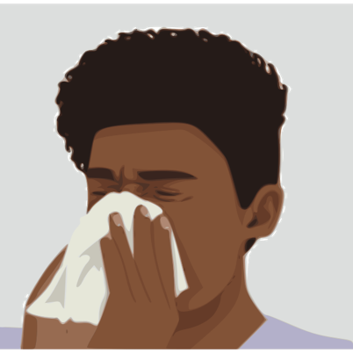  Blowing your  nose or coughing.
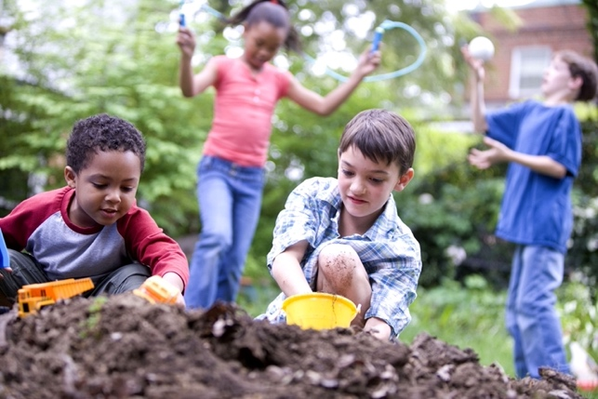  Touching  garbage or dirt | 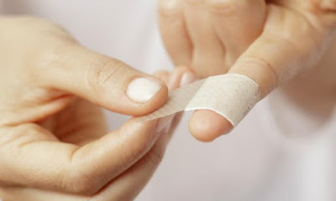  Cleaning and putting a Band-Aid on a cut | Playing outside

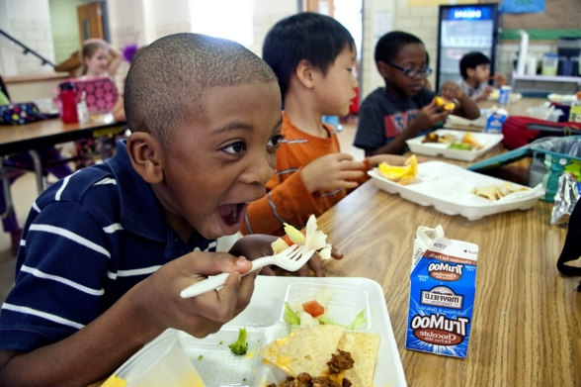  Eating | Touching food | Going to school
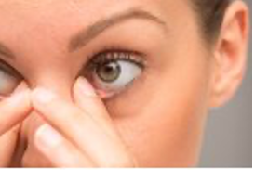  Touching your eyes | Visiting someone  who is sick | 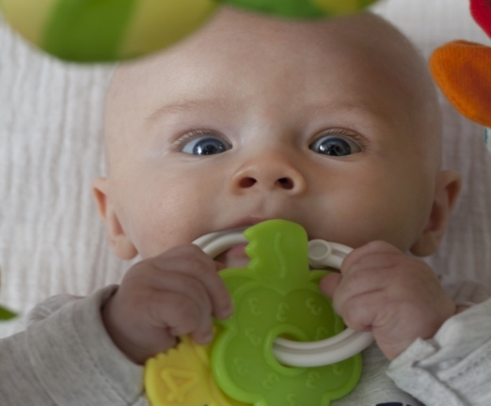  Playing with a baby

https://handwashing.commons.gc.cuny.edu/files/2018/10/handWashing-624x390.jpg
https://www.susanlebelyoung.com/wp-content/uploads/2020/04/A-person-washing-their-hands-show-personal-hand-hygiene-300x169.jpg
https://as2.ftcdn.net/jpg/03/11/57/69/220_F_311576947_GdWZvFkuBTk7GKBn1XACPChbqm0Z8SgE.jpg
https://upload.wikimedia.org/wikipedia/commons/thumb/f/f7/Wave_hand_and_tear.jpg/450px-Wave_hand_and_tear.jpg

https://cdn.pixabay.com/photo/2016/01/25/15/17/bath-1160828_960_720.jpg
https://cdn.pixabay.com/photo/2013/02/22/20/50/pets-85128_640.jpg
https://freesvg.org/img/1545405984.png
http://www.public-domain-image.com/free-images/people/children-kids/two-caucasian-and-two-african-american-children-playing-together.jpg

http://thumb7.shutterstock.com/thumb_large/3076664/643278739/stock-photo-girl-rubbing-her-eyes-643278739.jpg

https://1.bp.blogspot.com/-a6cjNoqWwpE/WcQvIp2dqHI/AAAAAAAADsQ/Ghe9rpTpOUEr_tRRrzhJTA3Pedks1v9RgCLcBGAs/s400/f9a9fcd467f16fa3ff04ed01c88ac7ed.jpg
https://bit.ly/3tJU2XL playing outdoors
http://thumb9.shutterstock.com/thumb_large/437/437,1287540493,2/stock-vector-illustration-of-a-kids-visiting-their-sick-friend-63377983.jpg
https://pixnio.com/free-images/people/children-kids/boy-eating-beef-chili-with-taco-chips-chocolate-milk-and-pudding.jpg
https://c1.staticflickr.com/9/8187/8412940480_cdbde0a65e_b.jpg
http://junior2.cumbresblogs.com/files/2014/06/TN_girl_going_to_school.jpg
https://get.pxhere.com/photo/person-play-boy-food-child-toy-baby-eating-nose-eyes-infant-toddler-skin-sweetness-rattle-voltage-590680.jpg

