i notice, i wonder
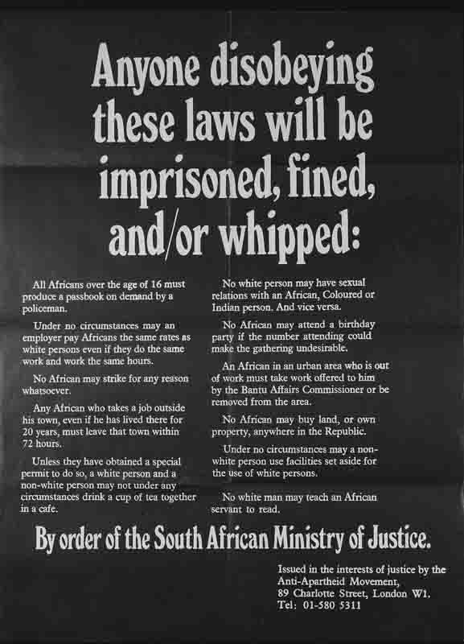
PO015. 'anyone disobeying these laws will be imprisoned, fined and/or whipped.'. Forward to Freedom. (n.d.). Retrieved September 16, 2021, from https://www.aamarchives.org/archive/history/apartheid/po015-anyone-disobeying-these-laws-will-be-imprisoned-fined-and-or-whipped.html.
I Notice | I Wonder

